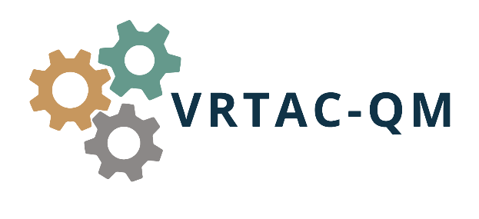

APPENDIX A

CONTRACT MANAGEMENT CHECKLIST
This checklist serves as an example and is not an exhaustive list. SVRAs must know their State procurement requirements and customize a checklist that ensures compliance with all State and Federal requirements. SVRAs should ensure staff members using a checklist are trained to assess the content and make consistent decisions related to whether contracts meet agency, State and Federal requirements, in particular when different individuals are using the checklist for reviewing different draft contracts for different programs. Please note the use of this checklist does not represent contract monitoring and reporting of performance (2 C.F.R. § 200.329). Additionally, a State granted exception to or exemption from a purchasing requirement does not supersede Federal purchasing requirements and proper determination of allowability and allocability of costs.

Purchasing Procedures
- Have the applicable Federal procurement laws, as well as State Regulations, policies and procedures been followed?
  - This includes adding the Stevens amendment required language to RFPs, etc.
- Were contract terms and conditions included in the procurement documents?
- If so, does the proposed contract conform to the procurement requirements?

Complete Contract
- Is the contract complete (i.e., are all pages accounted for and have all exhibits and attachments been provided)?

Contract Parties
- Are all parties referenced in the contract?
- Are all references to the parties, including the signature blocks, accurate, complete, and consistent?

Effective Date, Amendments, Term and Termination
- Does the contract clearly state the –
- Beginning and/or effective date?
- Ending and/or expiration date?
- Is the process for amending the contract clearly stated?
- Does the contract provide circumstances under which the contract can be terminated with or without cause and include default remedies?
- If the contract covers multiple years, is it broken down into budget periods to permit proper obligation to the correct Federal grant awards once they become available?

Vendor Qualifications
- Are vendor qualifications clearly identified within the contract or referenced elsewhere (i.e., contract provider manual)?
- Does the contract describe the process when vendor qualifications are not upheld?
- Does the contract address criminal background checks as applicable?

Goods and Services, Duties and Obligations
- Is a detailed Scope of Work included, which defines –
  - Who services are to be provided to (i.e., only applicants or recipients of VR services);
  - Specifically, how the services are defined and what services are to be provided and how;
  - The completion date for service provision; and
  - What constitutes an acceptable result (i.e., performance measures)?
- For a product or non-professional service, is a detailed list of specifications included providing the criteria for performance design, or in the case of goods, the quality, quantity, and any other details?
- Are all duties and obligations of the SVRA and the other party to the contract clearly stated so that all parties know –
- What the duties and obligation of each party are;
- How those duties and obligations will be performed; and
- When those duties and obligations will be performed?

Conflict of Interest
- Is the contract clear regarding expectations around conflict of interest for SVRA employees and the contractor?
- Does the contract state the process for notifying the SVRA when a conflict of interest arises during the contract period?

Consideration/Payment Terms
- Does the contract clearly and accurately state the maximum amount that the SVRA will be obligated to pay under the contract?
- Does the contract clearly establish place, time, and method of payment?
- Does the contract establish invoice and supporting documentation requirements the contractor must follow?
  - Does this include the contractor’s reporting of expenses for each service provided to each participant so the SVRA can report the required financial and program data on the Federal reports (i.e., RSA-17, SF-425, and RSA-911).
  - Is the contract clear regarding required invoice format and supporting documentation necessary for contractor payment?
  - Does the contract state how long the contractor has to submit an invoice to ensure the SVRA is able to liquidate contract in a timely manner?

Data Practices/Confidentiality
- Does the contract define safekeeping of Personally Identifiable Information (PII) and other sensitive information?
- In the event of a breach, does the contract outline the process the contractor must follow?

Indemnification
- Is any State-specific indemnification language included within the contract?

2 C.F.R. 200 Appendix II: Contract Provisions for Non-Federal Entities under Federal Awards
- Does the contract include the Uniform Guidance Appendix II contract requirements applicable to the contract?

Business Compliance
- Are all State insurance requirements included in the contract and provided by the vendor?
- Does the contract include nondiscrimination language?
- Does the contract include Force Majeure language if required by the State?

Contract Compliance
  - Does the contract state how non-compliance will be addressed?
  - Does the contract language identify when a corrective action plan may be required and what steps will be taken if correction is not achieved?
  - Is language included that requires contractor to repay misused funds or in the event contract outcomes are not achieved?

Other Ideas to Consider for Best Practices:
- Does the contract file include supporting documentation demonstrating how the –
- Contract cost was determined and documentation that the determination was made in accordance with the SVRA’s policy related to setting rates for payments; and
- Cost is proportional to the benefit received by the VR program?
- Have assigned SVRA staff reviewed the contract before signature to ensure all required language has been included?
- Does a written contract management checklist exist for the contract?
- Is the written contract management checklist completed?
- Have staff initialed and dated the contract management checklist to verify completion?
- Does the SVRA have a written contract monitoring process to evaluate and document contract compliance and performance throughout the life of the contract?
- Are the monitoring activities specific to the contract documented?
- Is a schedule in place for the specific monitoring activities outlining who is responsible, how the activities will be carried out, and when?
- Does the contract monitoring plan include provisions for timely action in the event contract deficiencies become known?
- Does the SVRA have a documented contract closeout process that ensures all deliverables are met and final payment has been made, maintaining all relevant documentation according to record retention requirements?

