Joint TAC Needs Assessment Survey Responses
Q2 - What is the name of the State, Territory or Commonwealth that your agency serves?
What is the name of the State, Territory or Commonwealth that your agency serves?
California
CT
Hawaii
Pennsylvania
California
California
Vermont
California
Michigan Rehabilitation Services
California
New Jersey
Illinois
Illinois
Michigan
Ohio
Nebraska
NC
WA
Delaware
Wyoming
California Department of Rehabilitation
NC
California
California
California
Florida
California
California
California
State of California - Department of Rehabilitation
California
California
Montana
Illinois
Maine
VA Department for Aging and Rehabilitative Services
Minnesota
Delaware
Massachusetts
Alabama
District of Columbia
New York
Ohio
South Dakota
Louisiana
Alaska
US Virgin Islands
North Carolina
Colorado
Maryland
New Hampshire
West Virginia
WY
Georgia
Virginia
Arkansas
American Samoa
Washington State
MN
West Virginia
Texas
Wyoming
Oklahoma
Massachusetts
Arizona
New Mexico Division of Vocational Rehabilitation
Iowa
Idaho
Missouri
Oregon
Indiana
Utah
South Carolina
Massachusetts
Arkansas
Nevada
Wisconsin
south dakota
Kentucky

Q3 - What is the agency type?
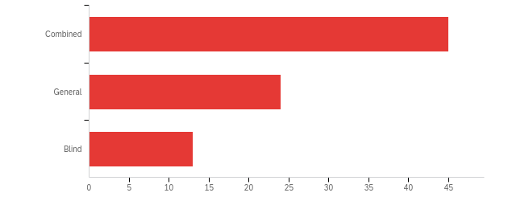

# | Field | Minimum | Maximum | Mean | Std Deviation | Variance | Count
1 | What is the agency type? | 1.00 | 3.00 | 1.61 | 0.75 | 0.56 | 82

# | Answer | % | Count
1 | Combined | 54.88% | 45
2 | General | 29.27% | 24
3 | Blind | 15.85% | 13
 | Total | 100% | 82

Q4 - The first set of questions applies to the VRTAC-QM. Do you wish to respond to these questions?
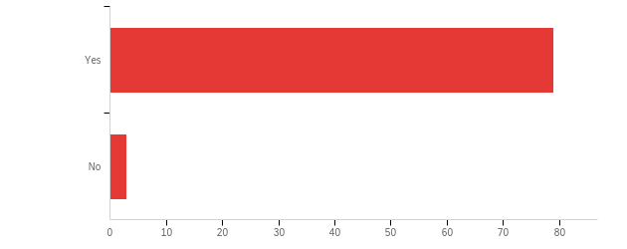

# | Field | Minimum | Maximum | Mean | Std Deviation | Variance | Count
1 | The first set of questions applies to the VRTAC-QM. Do you wish to respond to these questions? | 1.00 | 3.00 | 1.07 | 0.38 | 0.14 | 82

# | Answer | % | Count
1 | Yes | 96.34% | 79
3 | No | 3.66% | 3
 | Total | 100% | 82

Q6 - Please rate your level of need for technical assistance and/or training in the following areas related to quality program and performance management using the scale provided.
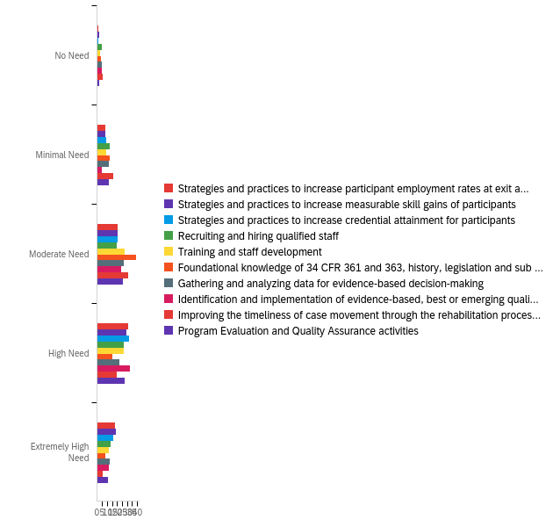

# | Field | Minimum | Maximum | Mean | Std Deviation | Variance | Count
1 | Strategies and practices to increase participant employment rates at exit and in the 2nd and 4th quarter after exit | 1.00 | 5.00 | 3.72 | 0.97 | 0.94 | 79
2 | Strategies and practices to increase measurable skill gains of participants | 1.00 | 5.00 | 3.70 | 1.02 | 1.05 | 79
3 | Strategies and practices to increase credential attainment for participants | 1.00 | 5.00 | 3.67 | 0.96 | 0.93 | 79
4 | Recruiting and hiring qualified staff | 1.00 | 5.00 | 3.41 | 1.14 | 1.30 | 79
5 | Training and staff development | 1.00 | 5.00 | 3.46 | 1.00 | 1.01 | 79
6 | Foundational knowledge of 34 CFR 361 and 363, history, legislation and sub regulatory guidance, and State Policies &amp; Regulations, including how they interact | 1.00 | 5.00 | 3.13 | 0.97 | 0.95 | 79
7 | Gathering and analyzing data for evidence-based decision-making | 1.00 | 5.00 | 3.33 | 1.11 | 1.23 | 79
8 | Identification and implementation of evidence-based, best or emerging quality management practices | 1.00 | 5.00 | 3.53 | 1.03 | 1.06 | 79
9 | Improving the timeliness of case movement through the rehabilitation process | 1.00 | 5.00 | 3.05 | 1.03 | 1.06 | 79
10 | Program Evaluation and Quality Assurance activities | 1.00 | 5.00 | 3.43 | 0.99 | 0.98 | 79

# | Question | No Need |  | Minimal Need |  | Moderate Need |  | High Need |  | Extremely High Need |  | Total
1 | Strategies and practices to increase participant employment rates at exit and in the 2nd and 4th quarter after exit | 1.27% | 1 | 10.13% | 8 | 26.58% | 21 | 39.24% | 31 | 22.78% | 18 | 79
2 | Strategies and practices to increase measurable skill gains of participants | 2.53% | 2 | 10.13% | 8 | 26.58% | 21 | 36.71% | 29 | 24.05% | 19 | 79
3 | Strategies and practices to increase credential attainment for participants | 1.27% | 1 | 11.39% | 9 | 26.58% | 21 | 40.51% | 32 | 20.25% | 16 | 79
4 | Recruiting and hiring qualified staff | 6.33% | 5 | 16.46% | 13 | 25.32% | 20 | 34.18% | 27 | 17.72% | 14 | 79
5 | Training and staff development | 3.80% | 3 | 11.39% | 9 | 35.44% | 28 | 34.18% | 27 | 15.19% | 12 | 79
6 | Foundational knowledge of 34 CFR 361 and 363, history, legislation and sub regulatory guidance, and State Policies & Regulations, including how they interact | 5.06% | 4 | 16.46% | 13 | 49.37% | 39 | 18.99% | 15 | 10.13% | 8 | 79
7 | Gathering and analyzing data for evidence-based decision-making | 6.33% | 5 | 15.19% | 12 | 34.18% | 27 | 27.85% | 22 | 16.46% | 13 | 79
8 | Identification and implementation of evidence-based, best or emerging quality management practices | 6.33% | 5 | 6.33% | 5 | 30.38% | 24 | 41.77% | 33 | 15.19% | 12 | 79
9 | Improving the timeliness of case movement through the rehabilitation process | 7.59% | 6 | 20.25% | 16 | 39.24% | 31 | 25.32% | 20 | 7.59% | 6 | 79
10 | Program Evaluation and Quality Assurance activities | 2.53% | 2 | 15.19% | 12 | 32.91% | 26 | 35.44% | 28 | 13.92% | 11 | 79

Q7 - Quality Program and Performance Management Questions Continued: Please rate your level of need for technical assistance and/or training in the following areas related to quality program and performance management using the scale provided.
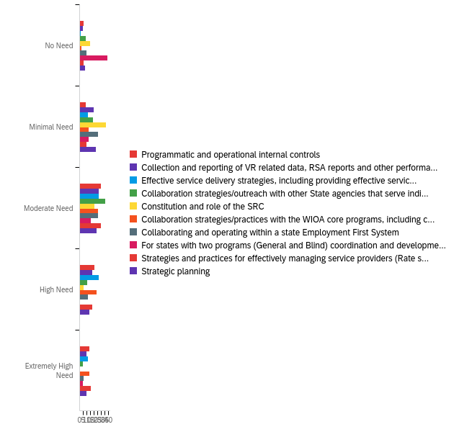

# | Field | Minimum | Maximum | Mean | Std Deviation | Variance | Count
1 | Programmatic and operational internal controls | 1.00 | 5.00 | 3.35 | 1.12 | 1.25 | 80
2 | Collection and reporting of VR related data, RSA reports and other performance data | 1.00 | 5.00 | 3.10 | 1.10 | 1.22 | 80
3 | Effective service delivery strategies, including providing effective services to traditionally unserved or underserved populations | 1.00 | 5.00 | 3.44 | 1.00 | 1.00 | 80
4 | Collaboration strategies/outreach with other State agencies that serve individuals with disabilities (e.g., DD, MH, Ed) | 1.00 | 5.00 | 2.80 | 1.02 | 1.03 | 80
5 | Constitution and role of the SRC | 1.00 | 5.00 | 2.26 | 0.89 | 0.79 | 80
6 | Collaboration strategies/practices with the WIOA core programs, including co-enrollment, alignment of definitions and policies, tracking and reporting, and effectiveness in serving employers | 1.00 | 5.00 | 3.41 | 1.07 | 1.14 | 80
7 | Collaborating and operating within a state Employment First System | 1.00 | 5.00 | 2.73 | 1.10 | 1.20 | 80
8 | For states with two programs (General and Blind) coordination and development of an agreement between the two entities (including WIOA performance requirements) | 1.00 | 5.00 | 1.92 | 1.18 | 1.40 | 74
9 | Strategies and practices for effectively managing service providers (Rate setting, CRP development, monitoring performance) | 1.00 | 5.00 | 3.35 | 1.15 | 1.33 | 80
10 | Strategic planning | 1.00 | 5.00 | 2.94 | 1.17 | 1.38 | 79

# | Question | No Need |  | Minimal Need |  | Moderate Need |  | High Need |  | Extremely High Need |  | Total
1 | Programmatic and operational internal controls | 7.50% | 6 | 11.25% | 9 | 37.50% | 30 | 26.25% | 21 | 17.50% | 14 | 80
2 | Collection and reporting of VR related data, RSA reports and other performance data | 6.25% | 5 | 25.00% | 20 | 33.75% | 27 | 22.50% | 18 | 12.50% | 10 | 80
3 | Effective service delivery strategies, including providing effective services to traditionally unserved or underserved populations | 2.50% | 2 | 15.00% | 12 | 33.75% | 27 | 33.75% | 27 | 15.00% | 12 | 80
4 | Collaboration strategies/outreach with other State agencies that serve individuals with disabilities (e.g., DD, MH, Ed) | 11.25% | 9 | 23.75% | 19 | 45.00% | 36 | 13.75% | 11 | 6.25% | 5 | 80
5 | Constitution and role of the SRC | 18.75% | 15 | 46.25% | 37 | 26.25% | 21 | 7.50% | 6 | 1.25% | 1 | 80
6 | Collaboration strategies/practices with the WIOA core programs, including co-enrollment, alignment of definitions and policies, tracking and reporting, and effectiveness in serving employers | 3.75% | 3 | 16.25% | 13 | 32.50% | 26 | 30.00% | 24 | 17.50% | 14 | 80
7 | Collaborating and operating within a state Employment First System | 12.50% | 10 | 32.50% | 26 | 32.50% | 26 | 15.00% | 12 | 7.50% | 6 | 80
8 | For states with two programs (General and Blind) coordination and development of an agreement between the two entities (including WIOA performance requirements) | 52.70% | 39 | 17.57% | 13 | 21.62% | 16 | 1.35% | 1 | 6.76% | 5 | 74
9 | Strategies and practices for effectively managing service providers (Rate setting, CRP development, monitoring performance) | 7.50% | 6 | 12.50% | 10 | 37.50% | 30 | 22.50% | 18 | 20.00% | 16 | 80
10 | Strategic planning | 10.13% | 8 | 29.11% | 23 | 30.38% | 24 | 17.72% | 14 | 12.66% | 10 | 79

Q8 - Please rate your level of need for technical assistance and/or training in the following areas related to quality fiscal and resource management using the scale provided.
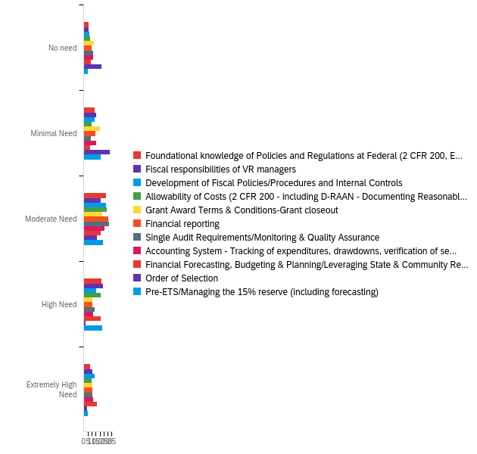

# | Field | Minimum | Maximum | Mean | Std Deviation | Variance | Count
1 | Foundational knowledge of Policies and Regulations at Federal (2 CFR 200, EDGAR, 34 CFR 361) and State Level, including how to apply to program. | 1.00 | 5.00 | 3.15 | 1.08 | 1.16 | 78
2 | Fiscal responsibilities of VR managers | 1.00 | 5.00 | 3.23 | 1.15 | 1.33 | 78
3 | Development of Fiscal Policies/Procedures and Internal Controls | 1.00 | 5.00 | 3.20 | 1.18 | 1.40 | 79
4 | Allowability of Costs (2 CFR 200 - including D-RAAN - Documenting Reasonable, Allowable, Allocable &amp; Necessary) | 1.00 | 5.00 | 3.19 | 1.13 | 1.28 | 78
5 | Grant Award Terms &amp; Conditions-Grant closeout | 1.00 | 5.00 | 2.83 | 1.27 | 1.60 | 78
6 | Financial reporting | 1.00 | 5.00 | 2.97 | 1.19 | 1.41 | 78
7 | Single Audit Requirements/Monitoring &amp; Quality Assurance | 1.00 | 5.00 | 3.04 | 1.21 | 1.47 | 78
8 | Accounting System - Tracking of expenditures, drawdowns, verification of services, applicable credits, record retention. | 1.00 | 5.00 | 2.95 | 1.26 | 1.59 | 78
9 | Financial Forecasting, Budgeting &amp; Planning/Leveraging State &amp; Community Resources/Return on Investment (ROI) | 1.00 | 5.00 | 3.38 | 1.27 | 1.60 | 76
10 | Order of Selection | 1.00 | 5.00 | 2.14 | 1.02 | 1.04 | 78
11 | Pre-ETS/Managing the 15% reserve (including forecasting) | 1.00 | 5.00 | 3.03 | 1.04 | 1.08 | 78

# | Question | No need |  | Minimal Need |  | Moderate Need |  | High Need |  | Extremely High Need |  | Total
1 | Foundational knowledge of Policies and Regulations at Federal (2 CFR 200, EDGAR, 34 CFR 361) and State Level, including how to apply to program. | 7.69% | 6 | 17.95% | 14 | 35.90% | 28 | 28.21% | 22 | 10.26% | 8 | 78
2 | Fiscal responsibilities of VR managers | 7.69% | 6 | 20.51% | 16 | 26.92% | 21 | 30.77% | 24 | 14.10% | 11 | 78
3 | Development of Fiscal Policies/Procedures and Internal Controls | 8.86% | 7 | 17.72% | 14 | 35.44% | 28 | 20.25% | 16 | 17.72% | 14 | 79
4 | Allowability of Costs (2 CFR 200 - including D-RAAN - Documenting Reasonable, Allowable, Allocable & Necessary) | 10.26% | 8 | 12.82% | 10 | 37.18% | 29 | 26.92% | 21 | 12.82% | 10 | 78
5 | Grant Award Terms & Conditions-Grant closeout | 16.67% | 13 | 25.64% | 20 | 29.49% | 23 | 14.10% | 11 | 14.10% | 11 | 78
6 | Financial reporting | 12.82% | 10 | 19.23% | 15 | 39.74% | 31 | 14.10% | 11 | 14.10% | 11 | 78
7 | Single Audit Requirements/Monitoring & Quality Assurance | 15.38% | 12 | 11.54% | 9 | 41.03% | 32 | 17.95% | 14 | 14.10% | 11 | 78
8 | Accounting System - Tracking of expenditures, drawdowns, verification of services, applicable credits, record retention. | 15.38% | 12 | 20.51% | 16 | 33.33% | 26 | 15.38% | 12 | 15.38% | 12 | 78
9 | Financial Forecasting, Budgeting & Planning/Leveraging State & Community Resources/Return on Investment (ROI) | 11.84% | 9 | 10.53% | 8 | 27.63% | 21 | 27.63% | 21 | 22.37% | 17 | 76
10 | Order of Selection | 28.21% | 22 | 42.31% | 33 | 21.79% | 17 | 2.56% | 2 | 5.13% | 4 | 78
11 | Pre-ETS/Managing the 15% reserve (including forecasting) | 6.41% | 5 | 26.92% | 21 | 30.77% | 24 | 29.49% | 23 | 6.41% | 5 | 78

Q9 - Quality Fiscal and resource Management Questions Continued: Please rate your level of need for technical assistance and/or training in the following areas related to quality fiscal and resource management using the scale provided.
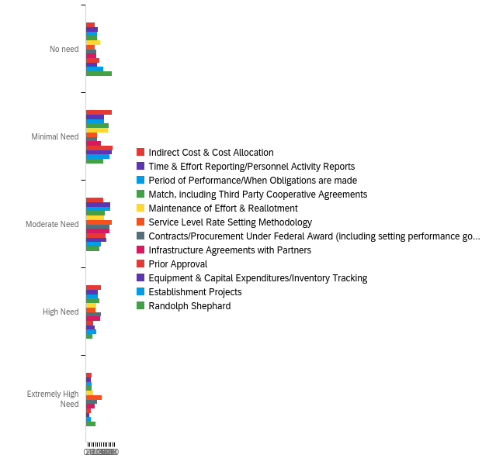

# | Field | Minimum | Maximum | Mean | Std Deviation | Variance | Count
1 | Indirect Cost &amp; Cost Allocation | 1.00 | 5.00 | 2.78 | 1.14 | 1.31 | 76
2 | Time &amp; Effort Reporting/Personnel Activity Reports | 1.00 | 5.00 | 2.71 | 1.13 | 1.28 | 76
3 | Period of Performance/When Obligations are made | 1.00 | 5.00 | 2.76 | 1.15 | 1.31 | 76
4 | Match, including Third Party Cooperative Agreements | 1.00 | 5.00 | 2.71 | 1.17 | 1.36 | 76
5 | Maintenance of Effort &amp; Reallotment | 1.00 | 5.00 | 2.66 | 1.24 | 1.54 | 76
6 | Service Level Rate Setting Methodology | 1.00 | 5.00 | 3.19 | 1.28 | 1.65 | 75
7 | Contracts/Procurement Under Federal Award (including setting performance goals for contracts and monitoring contractors) | 1.00 | 5.00 | 3.08 | 1.25 | 1.57 | 76
8 | Infrastructure Agreements with Partners | 1.00 | 5.00 | 2.93 | 1.21 | 1.46 | 76
9 | Prior Approval | 1.00 | 5.00 | 2.50 | 1.11 | 1.22 | 76
10 | Equipment &amp; Capital Expenditures/Inventory Tracking | 1.00 | 5.00 | 2.54 | 1.07 | 1.14 | 74
11 | Establishment Projects | 1.00 | 5.00 | 2.47 | 1.19 | 1.42 | 75
12 | Randolph Shephard | 1.00 | 5.00 | 2.41 | 1.39 | 1.93 | 76

# | Question | No need |  | Minimal Need |  | Moderate Need |  | High Need |  | Extremely High Need |  | Total
1 | Indirect Cost & Cost Allocation | 11.84% | 9 | 35.53% | 27 | 23.68% | 18 | 21.05% | 16 | 7.89% | 6 | 76
2 | Time & Effort Reporting/Personnel Activity Reports | 17.11% | 13 | 25.00% | 19 | 34.21% | 26 | 17.11% | 13 | 6.58% | 5 | 76
3 | Period of Performance/When Obligations are made | 15.79% | 12 | 25.00% | 19 | 34.21% | 26 | 17.11% | 13 | 7.89% | 6 | 76
4 | Match, including Third Party Cooperative Agreements | 15.79% | 12 | 31.58% | 24 | 26.32% | 20 | 18.42% | 14 | 7.89% | 6 | 76
5 | Maintenance of Effort & Reallotment | 19.74% | 15 | 30.26% | 23 | 25.00% | 19 | 14.47% | 11 | 10.53% | 8 | 76
6 | Service Level Rate Setting Methodology | 12.00% | 9 | 16.00% | 12 | 36.00% | 27 | 13.33% | 10 | 22.67% | 17 | 75
7 | Contracts/Procurement Under Federal Award (including setting performance goals for contracts and monitoring contractors) | 14.47% | 11 | 15.79% | 12 | 32.89% | 25 | 21.05% | 16 | 15.79% | 12 | 76
8 | Infrastructure Agreements with Partners | 14.47% | 11 | 21.05% | 16 | 32.89% | 25 | 19.74% | 15 | 11.84% | 9 | 76
9 | Prior Approval | 18.42% | 14 | 36.84% | 28 | 27.63% | 21 | 10.53% | 8 | 6.58% | 5 | 76
10 | Equipment & Capital Expenditures/Inventory Tracking | 16.22% | 12 | 36.49% | 27 | 29.73% | 22 | 12.16% | 9 | 5.41% | 4 | 74
11 | Establishment Projects | 24.00% | 18 | 33.33% | 25 | 21.33% | 16 | 14.67% | 11 | 6.67% | 5 | 75
12 | Randolph Shephard | 35.53% | 27 | 23.68% | 18 | 18.42% | 14 | 9.21% | 7 | 13.16% | 10 | 76

Q10 - Please rate your level of need for technical assistance and/or training in the following areas related to quality general management using the scale provided.
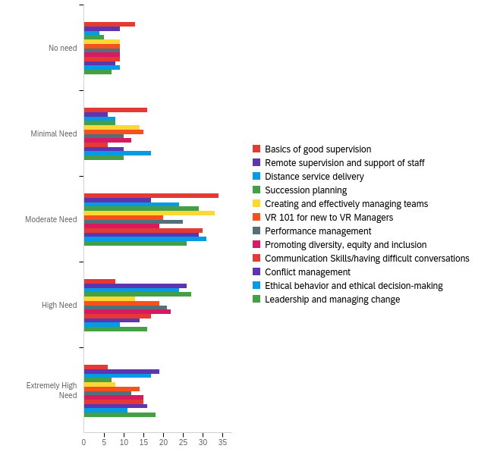

# | Field | Minimum | Maximum | Mean | Std Deviation | Variance | Count
1 | Basics of good supervision | 1.00 | 5.00 | 2.71 | 1.10 | 1.22 | 77
2 | Remote supervision and support of staff | 1.00 | 5.00 | 3.52 | 1.27 | 1.60 | 77
3 | Distance service delivery | 1.00 | 5.00 | 3.55 | 1.10 | 1.21 | 77
4 | Succession planning | 1.00 | 5.00 | 3.30 | 1.00 | 1.00 | 76
5 | Creating and effectively managing teams | 1.00 | 5.00 | 2.96 | 1.11 | 1.23 | 77
6 | VR 101 for new to VR Managers | 1.00 | 5.00 | 3.18 | 1.27 | 1.60 | 77
7 | Performance management | 1.00 | 5.00 | 3.22 | 1.20 | 1.44 | 77
8 | Promoting diversity, equity and inclusion | 1.00 | 5.00 | 3.29 | 1.27 | 1.61 | 77
9 | Communication Skills/having difficult conversations | 1.00 | 5.00 | 3.30 | 1.21 | 1.46 | 77
10 | Conflict management | 1.00 | 5.00 | 3.26 | 1.22 | 1.49 | 77
11 | Ethical behavior and ethical decision-making | 1.00 | 5.00 | 2.95 | 1.17 | 1.37 | 77
12 | Leadership and managing change | 1.00 | 5.00 | 3.36 | 1.23 | 1.50 | 77

# | Question | No need |  | Minimal Need |  | Moderate Need |  | High Need |  | Extremely High Need |  | Total
1 | Basics of good supervision | 16.88% | 13 | 20.78% | 16 | 44.16% | 34 | 10.39% | 8 | 7.79% | 6 | 77
2 | Remote supervision and support of staff | 11.69% | 9 | 7.79% | 6 | 22.08% | 17 | 33.77% | 26 | 24.68% | 19 | 77
3 | Distance service delivery | 5.19% | 4 | 10.39% | 8 | 31.17% | 24 | 31.17% | 24 | 22.08% | 17 | 77
4 | Succession planning | 6.58% | 5 | 10.53% | 8 | 38.16% | 29 | 35.53% | 27 | 9.21% | 7 | 76
5 | Creating and effectively managing teams | 11.69% | 9 | 18.18% | 14 | 42.86% | 33 | 16.88% | 13 | 10.39% | 8 | 77
6 | VR 101 for new to VR Managers | 11.69% | 9 | 19.48% | 15 | 25.97% | 20 | 24.68% | 19 | 18.18% | 14 | 77
7 | Performance management | 11.69% | 9 | 12.99% | 10 | 32.47% | 25 | 27.27% | 21 | 15.58% | 12 | 77
8 | Promoting diversity, equity and inclusion | 11.69% | 9 | 15.58% | 12 | 24.68% | 19 | 28.57% | 22 | 19.48% | 15 | 77
9 | Communication Skills/having difficult conversations | 11.69% | 9 | 7.79% | 6 | 38.96% | 30 | 22.08% | 17 | 19.48% | 15 | 77
10 | Conflict management | 10.39% | 8 | 12.99% | 10 | 37.66% | 29 | 18.18% | 14 | 20.78% | 16 | 77
11 | Ethical behavior and ethical decision-making | 11.69% | 9 | 22.08% | 17 | 40.26% | 31 | 11.69% | 9 | 14.29% | 11 | 77
12 | Leadership and managing change | 9.09% | 7 | 12.99% | 10 | 33.77% | 26 | 20.78% | 16 | 23.38% | 18 | 77

Q11 - If there are other areas of need for training and TA that you have related to quality management of the VR program that have not been covered above, please include them in the space below.

If there are other areas of need for training and TA that you have related to quality management of the VR program that have not been covered above, please include them in the space below.
Working collaboratively corrections agencies.
Developing implementing and monitoring Key Performance Indicators, Risk Management and Change Management, Monitoring budgets in the field offices
N0
None at this time.
Increasing client engagement to decrease the number of drop outs prior to the plan completi0on.
N/A
Conflict of interest with CRPs.
Motivating employees, especially when working remotely.

Q12 - The next set of questions applies to the VRTAC-QE. Do you wish to respond to these questions?
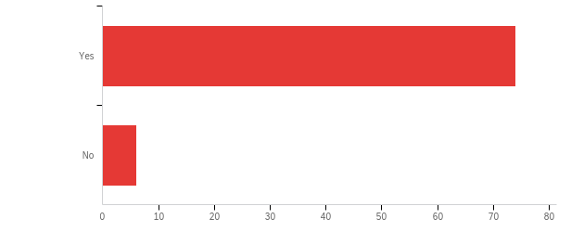

# | Field | Minimum | Maximum | Mean | Std Deviation | Variance | Count
1 | The next set of questions applies to the VRTAC-QE. Do you wish to respond to these questions? | 1.00 | 2.00 | 1.07 | 0.26 | 0.07 | 80

# | Answer | % | Count
1 | Yes | 92.50% | 74
2 | No | 7.50% | 6
 | Total | 100% | 80

Q13#1 - Outreach to diverse populations and potential collaborators - Importance
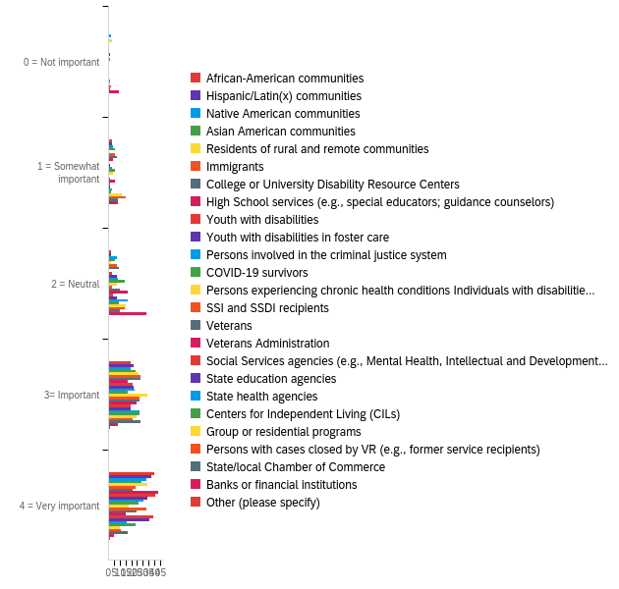

# | Field | Minimum | Maximum | Mean | Std Deviation | Variance | Count
1 | African-American communities | 2.00 | 5.00 | 4.50 | 0.77 | 0.59 | 64
2 | Hispanic/Latin(x) communities | 2.00 | 5.00 | 4.46 | 0.77 | 0.59 | 65
3 | Native American communities | 1.00 | 5.00 | 4.18 | 1.05 | 1.10 | 65
4 | Asian American communities | 2.00 | 5.00 | 4.17 | 0.94 | 0.88 | 65
5 | Residents of rural and remote communities | 1.00 | 5.00 | 4.35 | 0.92 | 0.84 | 65
6 | Immigrants | 2.00 | 5.00 | 4.08 | 0.92 | 0.84 | 65
7 | College or University Disability Resource Centers | 2.00 | 5.00 | 3.97 | 0.94 | 0.89 | 65
8 | High School services (e.g., special educators; guidance counselors) | 2.00 | 5.00 | 4.55 | 0.79 | 0.62 | 65
9 | Youth with disabilities | 3.00 | 5.00 | 4.58 | 0.58 | 0.34 | 65
10 | Youth with disabilities in foster care | 1.00 | 5.00 | 4.34 | 0.85 | 0.72 | 65
11 | Persons involved in the criminal justice system | 2.00 | 5.00 | 4.26 | 0.85 | 0.72 | 65
12 | COVID-19 survivors | 1.00 | 5.00 | 3.95 | 1.07 | 1.14 | 64
13 | Persons experiencing chronic health conditions Individuals with disabilities receiving TANF or SNAP | 2.00 | 5.00 | 4.05 | 0.81 | 0.65 | 63
14 | SSI and SSDI recipients | 3.00 | 5.00 | 4.48 | 0.59 | 0.34 | 63
15 | Veterans | 2.00 | 5.00 | 4.21 | 0.76 | 0.58 | 63
16 | Veterans Administration | 2.00 | 5.00 | 3.78 | 0.92 | 0.84 | 63
17 | Social Services agencies (e.g., Mental Health, Intellectual and Developmental Disabilities) | 2.00 | 5.00 | 4.52 | 0.69 | 0.47 | 63
18 | State education agencies | 2.00 | 5.00 | 4.43 | 0.75 | 0.56 | 63
19 | State health agencies | 2.00 | 5.00 | 3.89 | 0.84 | 0.70 | 63
20 | Centers for Independent Living (CILs) | 1.00 | 5.00 | 4.13 | 0.88 | 0.78 | 63
21 | Group or residential programs | 1.00 | 5.00 | 3.49 | 1.02 | 1.04 | 63
22 | Persons with cases closed by VR (e.g., former service recipients) | 1.00 | 5.00 | 3.38 | 1.12 | 1.25 | 63
23 | State/local Chamber of Commerce | 1.00 | 5.00 | 3.81 | 1.01 | 1.03 | 64
24 | Banks or financial institutions | 1.00 | 5.00 | 2.87 | 1.06 | 1.13 | 63
25 | Other (please specify) | 4.00 | 5.00 | 4.50 | 0.50 | 0.25 | 2

# | Question | 0 = Not important |  | 1 = Somewhat important |  | 2 = Neutral |  | 3= Important |  | 4 = Very important |  | Total
1 | African-American communities | 0.00% | 0 | 4.69% | 3 | 3.13% | 2 | 29.69% | 19 | 62.50% | 40 | 64
2 | Hispanic/Latin(x) communities | 0.00% | 0 | 4.62% | 3 | 3.08% | 2 | 33.85% | 22 | 58.46% | 38 | 65
3 | Native American communities | 3.08% | 2 | 6.15% | 4 | 10.77% | 7 | 29.23% | 19 | 50.77% | 33 | 65
4 | Asian American communities | 0.00% | 0 | 9.23% | 6 | 9.23% | 6 | 36.92% | 24 | 44.62% | 29 | 65
5 | Residents of rural and remote communities | 4.62% | 3 | 0.00% | 0 | 3.08% | 2 | 40.00% | 26 | 52.31% | 34 | 65
6 | Immigrants | 0.00% | 0 | 9.23% | 6 | 10.77% | 7 | 43.08% | 28 | 36.92% | 24 | 65
7 | College or University Disability Resource Centers | 0.00% | 0 | 10.77% | 7 | 13.85% | 9 | 43.08% | 28 | 32.31% | 21 | 65
8 | High School services (e.g., special educators; guidance counselors) | 0.00% | 0 | 6.15% | 4 | 0.00% | 0 | 26.15% | 17 | 67.69% | 44 | 65
9 | Youth with disabilities | 0.00% | 0 | 0.00% | 0 | 4.62% | 3 | 32.31% | 21 | 63.08% | 41 | 65
10 | Youth with disabilities in foster care | 1.54% | 1 | 1.54% | 1 | 10.77% | 7 | 33.85% | 22 | 52.31% | 34 | 65
11 | Persons involved in the criminal justice system | 0.00% | 0 | 4.62% | 3 | 12.31% | 8 | 35.38% | 23 | 47.69% | 31 | 65
12 | COVID-19 survivors | 1.56% | 1 | 9.38% | 6 | 21.88% | 14 | 26.56% | 17 | 40.63% | 26 | 64
13 | Persons experiencing chronic health conditions Individuals with disabilities receiving TANF or SNAP | 0.00% | 0 | 6.35% | 4 | 11.11% | 7 | 53.97% | 34 | 28.57% | 18 | 63
14 | SSI and SSDI recipients | 0.00% | 0 | 0.00% | 0 | 4.76% | 3 | 42.86% | 27 | 52.38% | 33 | 63
15 | Veterans | 0.00% | 0 | 1.59% | 1 | 15.87% | 10 | 42.86% | 27 | 39.68% | 25 | 63
16 | Veterans Administration | 0.00% | 0 | 9.52% | 6 | 26.98% | 17 | 39.68% | 25 | 23.81% | 15 | 63
17 | Social Services agencies (e.g., Mental Health, Intellectual and Developmental Disabilities) | 0.00% | 0 | 1.59% | 1 | 6.35% | 4 | 30.16% | 19 | 61.90% | 39 | 63
18 | State education agencies | 0.00% | 0 | 1.59% | 1 | 11.11% | 7 | 30.16% | 19 | 57.14% | 36 | 63
19 | State health agencies | 0.00% | 0 | 4.76% | 3 | 26.98% | 17 | 42.86% | 27 | 25.40% | 16 | 63
20 | Centers for Independent Living (CILs) | 1.59% | 1 | 3.17% | 2 | 14.29% | 9 | 42.86% | 27 | 38.10% | 24 | 63
21 | Group or residential programs | 1.59% | 1 | 19.05% | 12 | 23.81% | 15 | 39.68% | 25 | 15.87% | 10 | 63
22 | Persons with cases closed by VR (e.g., former service recipients) | 3.17% | 2 | 23.81% | 15 | 22.22% | 14 | 33.33% | 21 | 17.46% | 11 | 63
23 | State/local Chamber of Commerce | 1.56% | 1 | 12.50% | 8 | 15.63% | 10 | 43.75% | 28 | 26.56% | 17 | 64
24 | Banks or financial institutions | 14.29% | 9 | 12.70% | 8 | 52.38% | 33 | 12.70% | 8 | 7.94% | 5 | 63
25 | Other (please specify) | 0.00% | 0 | 0.00% | 0 | 0.00% | 0 | 50.00% | 1 | 50.00% | 1 | 2

Q13#2 - Outreach to diverse populations and potential collaborators - Level of TA need
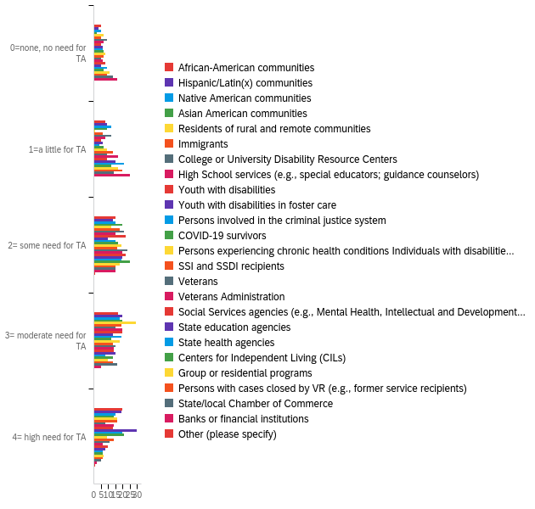

# | Field | Minimum | Maximum | Mean | Std Deviation | Variance | Count
1 | African-American communities | 1.00 | 5.00 | 3.60 | 1.25 | 1.56 | 65
2 | Hispanic/Latin(x) communities | 1.00 | 5.00 | 3.67 | 1.17 | 1.38 | 64
3 | Native American communities | 1.00 | 5.00 | 3.40 | 1.24 | 1.53 | 65
4 | Asian American communities | 1.00 | 5.00 | 3.54 | 1.07 | 1.14 | 65
5 | Residents of rural and remote communities | 1.00 | 5.00 | 3.71 | 1.17 | 1.38 | 65
6 | Immigrants | 1.00 | 5.00 | 3.55 | 1.18 | 1.40 | 64
7 | College or University Disability Resource Centers | 1.00 | 5.00 | 3.02 | 1.21 | 1.46 | 65
8 | High School services (e.g., special educators; guidance counselors) | 1.00 | 5.00 | 3.41 | 1.26 | 1.58 | 64
9 | Youth with disabilities | 1.00 | 5.00 | 3.48 | 1.12 | 1.26 | 65
10 | Youth with disabilities in foster care | 1.00 | 5.00 | 3.85 | 1.34 | 1.79 | 65
11 | Persons involved in the criminal justice system | 1.00 | 5.00 | 3.67 | 1.24 | 1.53 | 64
12 | COVID-19 survivors | 1.00 | 5.00 | 3.52 | 1.33 | 1.78 | 64
13 | Persons experiencing chronic health conditions Individuals with disabilities receiving TANF or SNAP | 1.00 | 5.00 | 3.17 | 1.22 | 1.48 | 63
14 | SSI and SSDI recipients | 1.00 | 5.00 | 3.22 | 1.30 | 1.70 | 63
15 | Veterans | 1.00 | 5.00 | 3.29 | 1.15 | 1.32 | 63
16 | Veterans Administration | 1.00 | 5.00 | 2.95 | 1.12 | 1.25 | 63
17 | Social Services agencies (e.g., Mental Health, Intellectual and Developmental Disabilities) | 1.00 | 5.00 | 3.14 | 1.22 | 1.49 | 63
18 | State education agencies | 1.00 | 5.00 | 3.10 | 1.14 | 1.29 | 63
19 | State health agencies | 1.00 | 5.00 | 2.70 | 1.15 | 1.32 | 63
20 | Centers for Independent Living (CILs) | 1.00 | 5.00 | 2.98 | 1.11 | 1.22 | 63
21 | Group or residential programs | 1.00 | 5.00 | 2.76 | 1.23 | 1.51 | 63
22 | Persons with cases closed by VR (e.g., former service recipients) | 1.00 | 5.00 | 2.79 | 1.20 | 1.43 | 63
23 | State/local Chamber of Commerce | 1.00 | 5.00 | 2.78 | 1.25 | 1.57 | 63
24 | Banks or financial institutions | 1.00 | 5.00 | 2.24 | 1.02 | 1.04 | 63
25 | Other (please specify) | 3.00 | 5.00 | 4.00 | 1.00 | 1.00 | 2

# | Question | 0=none, no need for TA |  | 1=a little for TA |  | 2= some need for TA |  | 3= moderate need for TA |  | 4= high need for TA |  | Total
1 | African-American communities | 7.69% | 5 | 12.31% | 8 | 23.08% | 15 | 26.15% | 17 | 30.77% | 20 | 65
2 | Hispanic/Latin(x) communities | 4.69% | 3 | 14.06% | 9 | 20.31% | 13 | 31.25% | 20 | 29.69% | 19 | 64
3 | Native American communities | 7.69% | 5 | 18.46% | 12 | 23.08% | 15 | 27.69% | 18 | 23.08% | 15 | 65
4 | Asian American communities | 3.08% | 2 | 13.85% | 9 | 30.77% | 20 | 30.77% | 20 | 21.54% | 14 | 65
5 | Residents of rural and remote communities | 10.77% | 7 | 1.54% | 1 | 18.46% | 12 | 44.62% | 29 | 24.62% | 16 | 65
6 | Immigrants | 7.81% | 5 | 9.38% | 6 | 28.13% | 18 | 29.69% | 19 | 25.00% | 16 | 64
7 | College or University Disability Resource Centers | 13.85% | 9 | 18.46% | 12 | 32.31% | 21 | 23.08% | 15 | 12.31% | 8 | 65
8 | High School services (e.g., special educators; guidance counselors) | 10.94% | 7 | 12.50% | 8 | 23.44% | 15 | 31.25% | 20 | 21.88% | 14 | 64
9 | Youth with disabilities | 7.69% | 5 | 7.69% | 5 | 33.85% | 22 | 30.77% | 20 | 20.00% | 13 | 65
10 | Youth with disabilities in foster care | 9.23% | 6 | 9.23% | 6 | 15.38% | 10 | 20.00% | 13 | 46.15% | 30 | 65
11 | Persons involved in the criminal justice system | 9.38% | 6 | 6.25% | 4 | 23.44% | 15 | 29.69% | 19 | 31.25% | 20 | 64
12 | COVID-19 survivors | 10.94% | 7 | 10.94% | 7 | 26.56% | 17 | 18.75% | 12 | 32.81% | 21 | 64
13 | Persons experiencing chronic health conditions Individuals with disabilities receiving TANF or SNAP | 12.70% | 8 | 14.29% | 9 | 30.16% | 19 | 28.57% | 18 | 14.29% | 9 | 63
14 | SSI and SSDI recipients | 11.11% | 7 | 20.63% | 13 | 25.40% | 16 | 20.63% | 13 | 22.22% | 14 | 63
15 | Veterans | 7.94% | 5 | 14.29% | 9 | 36.51% | 23 | 23.81% | 15 | 17.46% | 11 | 63
16 | Veterans Administration | 9.52% | 6 | 26.98% | 17 | 31.75% | 20 | 22.22% | 14 | 9.52% | 6 | 63
17 | Social Services agencies (e.g., Mental Health, Intellectual and Developmental Disabilities) | 12.70% | 8 | 14.29% | 9 | 34.92% | 22 | 22.22% | 14 | 15.87% | 10 | 63
18 | State education agencies | 7.94% | 5 | 23.81% | 15 | 31.75% | 20 | 23.81% | 15 | 12.70% | 8 | 63
19 | State health agencies | 14.29% | 9 | 33.33% | 21 | 30.16% | 19 | 12.70% | 8 | 9.52% | 6 | 63
20 | Centers for Independent Living (CILs) | 11.11% | 7 | 19.05% | 12 | 39.68% | 25 | 20.63% | 13 | 9.52% | 6 | 63
21 | Group or residential programs | 17.46% | 11 | 26.98% | 17 | 28.57% | 18 | 15.87% | 10 | 11.11% | 7 | 63
22 | Persons with cases closed by VR (e.g., former service recipients) | 14.29% | 9 | 31.75% | 20 | 23.81% | 15 | 20.63% | 13 | 9.52% | 6 | 63
23 | State/local Chamber of Commerce | 20.63% | 13 | 22.22% | 14 | 23.81% | 15 | 25.40% | 16 | 7.94% | 5 | 63
24 | Banks or financial institutions | 25.40% | 16 | 39.68% | 25 | 23.81% | 15 | 7.94% | 5 | 3.17% | 2 | 63
25 | Other (please specify) | 0.00% | 0 | 0.00% | 0 | 50.00% | 1 | 0.00% | 0 | 50.00% | 1 | 2

Q14#1 - Service Provision for Youth with Disabilities Please rate the level of importance and level o... - Importance
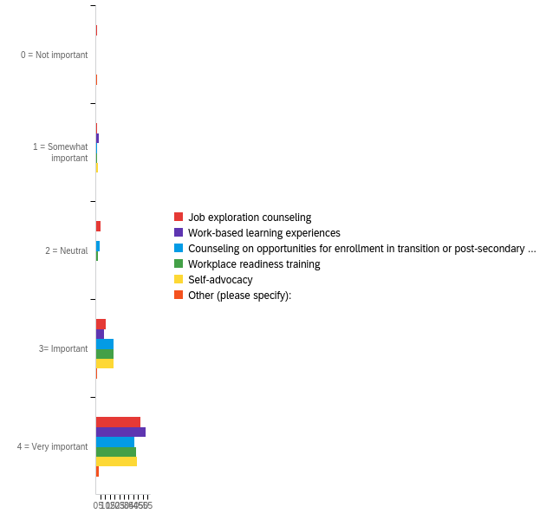

# | Field | Minimum | Maximum | Mean | Std Deviation | Variance | Count
1 | Job exploration counseling | 1.00 | 5.00 | 4.57 | 0.82 | 0.68 | 65
2 | Work-based learning experiences | 2.00 | 5.00 | 4.72 | 0.69 | 0.48 | 65
3 | Counseling on opportunities for enrollment in transition or post-secondary programs | 2.00 | 5.00 | 4.54 | 0.68 | 0.46 | 65
4 | Workplace readiness training | 2.00 | 5.00 | 4.60 | 0.63 | 0.39 | 65
5 | Self-advocacy | 2.00 | 5.00 | 4.62 | 0.65 | 0.42 | 65
6 | Other (please specify): | 1.00 | 5.00 | 4.00 | 1.55 | 2.40 | 5

# | Question | 0 = Not important |  | 1 = Somewhat important |  | 2 = Neutral |  | 3= Important |  | 4 = Very important |  | Total
1 | Job exploration counseling | 1.54% | 1 | 1.54% | 1 | 7.69% | 5 | 16.92% | 11 | 72.31% | 47 | 65
2 | Work-based learning experiences | 0.00% | 0 | 4.62% | 3 | 0.00% | 0 | 13.85% | 9 | 81.54% | 53 | 65
3 | Counseling on opportunities for enrollment in transition or post-secondary programs | 0.00% | 0 | 1.54% | 1 | 6.15% | 4 | 29.23% | 19 | 63.08% | 41 | 65
4 | Workplace readiness training | 0.00% | 0 | 1.54% | 1 | 3.08% | 2 | 29.23% | 19 | 66.15% | 43 | 65
5 | Self-advocacy | 0.00% | 0 | 3.08% | 2 | 0.00% | 0 | 29.23% | 19 | 67.69% | 44 | 65
6 | Other (please specify): | 20.00% | 1 | 0.00% | 0 | 0.00% | 0 | 20.00% | 1 | 60.00% | 3 | 5

Q14#2 - Service Provision for Youth with Disabilities Please rate the level of importance and level o... - Level of TA need
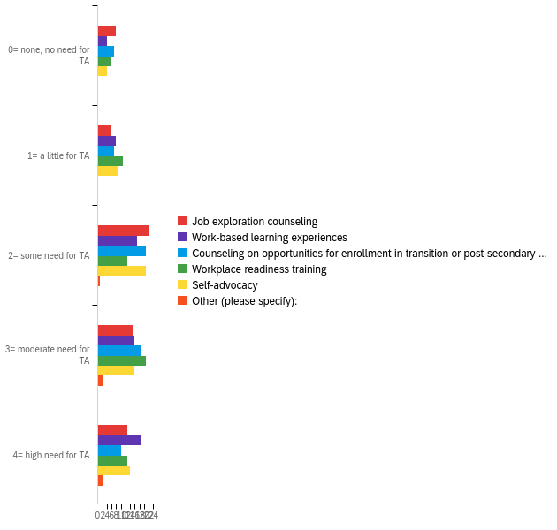

# | Field | Minimum | Maximum | Mean | Std Deviation | Variance | Count
1 | Job exploration counseling | 1.00 | 5.00 | 3.30 | 1.25 | 1.55 | 64
2 | Work-based learning experiences | 1.00 | 5.00 | 3.59 | 1.21 | 1.46 | 64
3 | Counseling on opportunities for enrollment in transition or post-secondary programs | 1.00 | 5.00 | 3.28 | 1.18 | 1.39 | 64
4 | Workplace readiness training | 1.00 | 5.00 | 3.38 | 1.24 | 1.55 | 64
5 | Self-advocacy | 1.00 | 5.00 | 3.42 | 1.16 | 1.34 | 64
6 | Other (please specify): | 3.00 | 5.00 | 4.20 | 0.75 | 0.56 | 5

# | Question | 0= none, no need for TA |  | 1= a little for TA |  | 2= some need for TA |  | 3= moderate need for TA |  | 4= high need for TA |  | Total
1 | Job exploration counseling | 12.50% | 8 | 9.38% | 6 | 34.38% | 22 | 23.44% | 15 | 20.31% | 13 | 64
2 | Work-based learning experiences | 6.25% | 4 | 12.50% | 8 | 26.56% | 17 | 25.00% | 16 | 29.69% | 19 | 64
3 | Counseling on opportunities for enrollment in transition or post-secondary programs | 10.94% | 7 | 10.94% | 7 | 32.81% | 21 | 29.69% | 19 | 15.63% | 10 | 64
4 | Workplace readiness training | 9.38% | 6 | 17.19% | 11 | 20.31% | 13 | 32.81% | 21 | 20.31% | 13 | 64
5 | Self-advocacy | 6.25% | 4 | 14.06% | 9 | 32.81% | 21 | 25.00% | 16 | 21.88% | 14 | 64
6 | Other (please specify): | 0.00% | 0 | 0.00% | 0 | 20.00% | 1 | 40.00% | 2 | 40.00% | 2 | 5

Q15#1 - Service Provision Please rate the importance and level of need for TA and/or training wi... - Importance
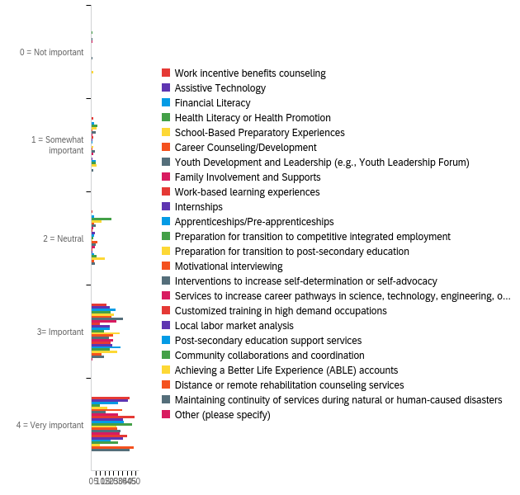

# | Field | Minimum | Maximum | Mean | Std Deviation | Variance | Count
1 | Work incentive benefits counseling | 2.00 | 5.00 | 4.60 | 0.68 | 0.46 | 63
2 | Assistive Technology | 4.00 | 5.00 | 4.66 | 0.47 | 0.22 | 62
3 | Financial Literacy | 2.00 | 5.00 | 4.33 | 0.78 | 0.60 | 63
4 | Health Literacy or Health Promotion | 1.00 | 5.00 | 3.52 | 0.94 | 0.88 | 63
5 | School-Based Preparatory Experiences | 2.00 | 5.00 | 3.90 | 0.93 | 0.86 | 62
6 | Career Counseling/Development | 2.00 | 5.00 | 4.48 | 0.67 | 0.44 | 62
7 | Youth Development and Leadership (e.g., Youth Leadership Forum) | 1.00 | 5.00 | 3.97 | 0.89 | 0.79 | 63
8 | Family Involvement and Supports | 1.00 | 5.00 | 4.37 | 0.77 | 0.59 | 62
9 | Work-based learning experiences | 2.00 | 5.00 | 4.71 | 0.66 | 0.43 | 62
10 | Internships | 2.00 | 5.00 | 4.48 | 0.69 | 0.48 | 62
11 | Apprenticeships/Pre-apprenticeships | 2.00 | 5.00 | 4.52 | 0.67 | 0.44 | 62
12 | Preparation for transition to competitive integrated employment | 3.00 | 5.00 | 4.71 | 0.52 | 0.27 | 62
13 | Preparation for transition to post-secondary education | 2.00 | 5.00 | 4.37 | 0.67 | 0.45 | 63
14 | Motivational interviewing | 2.00 | 5.00 | 4.32 | 0.74 | 0.54 | 62
15 | Interventions to increase self-determination or self-advocacy | 1.00 | 5.00 | 4.27 | 0.96 | 0.93 | 63
16 | Services to increase career pathways in science, technology, engineering, or math (STEM) fields | 2.00 | 5.00 | 4.38 | 0.74 | 0.55 | 63
17 | Customized training in high demand occupations | 3.00 | 5.00 | 4.62 | 0.52 | 0.27 | 63
18 | Local labor market analysis | 2.00 | 5.00 | 4.53 | 0.61 | 0.38 | 62
19 | Post-secondary education support services | 2.00 | 5.00 | 4.14 | 0.83 | 0.69 | 63
20 | Community collaborations and coordination | 2.00 | 5.00 | 4.23 | 0.92 | 0.85 | 62
21 | Achieving a Better Life Experience (ABLE) accounts | 1.00 | 5.00 | 3.63 | 0.97 | 0.94 | 62
22 | Distance or remote rehabilitation counseling services | 3.00 | 5.00 | 4.71 | 0.55 | 0.30 | 63
23 | Maintaining continuity of services during natural or human-caused disasters | 2.00 | 5.00 | 4.56 | 0.75 | 0.56 | 63
24 | Other (please specify) | 4.00 | 4.00 | 4.00 | 0.00 | 0.00 | 1

# | Question | 0 = Not important |  | 1 = Somewhat important |  | 2 = Neutral |  | 3= Important |  | 4 = Very important |  | Total
1 | Work incentive benefits counseling | 0.00% | 0 | 3.17% | 2 | 1.59% | 1 | 26.98% | 17 | 68.25% | 43 | 63
2 | Assistive Technology | 0.00% | 0 | 0.00% | 0 | 0.00% | 0 | 33.87% | 21 | 66.13% | 41 | 62
3 | Financial Literacy | 0.00% | 0 | 4.76% | 3 | 4.76% | 3 | 42.86% | 27 | 47.62% | 30 | 63
4 | Health Literacy or Health Promotion | 1.59% | 1 | 11.11% | 7 | 36.51% | 23 | 34.92% | 22 | 15.87% | 10 | 63
5 | School-Based Preparatory Experiences | 0.00% | 0 | 9.68% | 6 | 19.35% | 12 | 41.94% | 26 | 29.03% | 18 | 62
6 | Career Counseling/Development | 0.00% | 0 | 1.61% | 1 | 4.84% | 3 | 37.10% | 23 | 56.45% | 35 | 62
7 | Youth Development and Leadership (e.g., Youth Leadership Forum) | 1.59% | 1 | 7.94% | 5 | 7.94% | 5 | 57.14% | 36 | 25.40% | 16 | 63
8 | Family Involvement and Supports | 1.61% | 1 | 1.61% | 1 | 3.23% | 2 | 45.16% | 28 | 48.39% | 30 | 62
9 | Work-based learning experiences | 0.00% | 0 | 3.23% | 2 | 1.61% | 1 | 16.13% | 10 | 79.03% | 49 | 62
10 | Internships | 0.00% | 0 | 1.61% | 1 | 6.45% | 4 | 33.87% | 21 | 58.06% | 36 | 62
11 | Apprenticeships/Pre-apprenticeships | 0.00% | 0 | 1.61% | 1 | 4.84% | 3 | 33.87% | 21 | 59.68% | 37 | 62
12 | Preparation for transition to competitive integrated employment | 0.00% | 0 | 0.00% | 0 | 3.23% | 2 | 22.58% | 14 | 74.19% | 46 | 62
13 | Preparation for transition to post-secondary education | 0.00% | 0 | 3.17% | 2 | 1.59% | 1 | 50.79% | 32 | 44.44% | 28 | 63
14 | Motivational interviewing | 0.00% | 0 | 1.61% | 1 | 11.29% | 7 | 40.32% | 25 | 46.77% | 29 | 62
15 | Interventions to increase self-determination or self-advocacy | 1.59% | 1 | 6.35% | 4 | 7.94% | 5 | 31.75% | 20 | 52.38% | 33 | 63
16 | Services to increase career pathways in science, technology, engineering, or math (STEM) fields | 0.00% | 0 | 3.17% | 2 | 6.35% | 4 | 39.68% | 25 | 50.79% | 32 | 63
17 | Customized training in high demand occupations | 0.00% | 0 | 0.00% | 0 | 1.59% | 1 | 34.92% | 22 | 63.49% | 40 | 63
18 | Local labor market analysis | 0.00% | 0 | 1.61% | 1 | 1.61% | 1 | 38.71% | 24 | 58.06% | 36 | 62
19 | Post-secondary education support services | 0.00% | 0 | 7.94% | 5 | 4.76% | 3 | 52.38% | 33 | 34.92% | 22 | 63
20 | Community collaborations and coordination | 0.00% | 0 | 8.06% | 5 | 9.68% | 6 | 33.87% | 21 | 48.39% | 30 | 62
21 | Achieving a Better Life Experience (ABLE) accounts | 3.23% | 2 | 9.68% | 6 | 24.19% | 15 | 46.77% | 29 | 16.13% | 10 | 62
22 | Distance or remote rehabilitation counseling services | 0.00% | 0 | 0.00% | 0 | 4.76% | 3 | 19.05% | 12 | 76.19% | 48 | 63
23 | Maintaining continuity of services during natural or human-caused disasters | 0.00% | 0 | 3.17% | 2 | 6.35% | 4 | 22.22% | 14 | 68.25% | 43 | 63
24 | Other (please specify) | 0.00% | 0 | 0.00% | 0 | 0.00% | 0 | 100.00% | 1 | 0.00% | 0 | 1

Q15#2 - Service Provision Please rate the importance and level of of need for TA and/or training wi... - Level of TA need
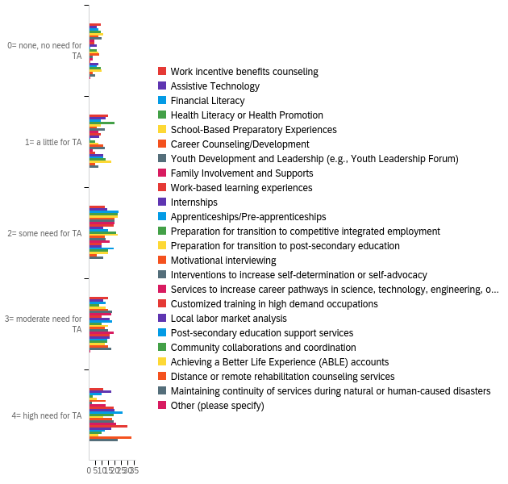

# | Field | Minimum | Maximum | Mean | Std Deviation | Variance | Count
1 | Work incentive benefits counseling | 1.00 | 5.00 | 3.06 | 1.33 | 1.77 | 62
2 | Assistive Technology | 1.00 | 5.00 | 3.33 | 1.34 | 1.79 | 61
3 | Financial Literacy | 1.00 | 5.00 | 3.16 | 1.19 | 1.43 | 62
4 | Health Literacy or Health Promotion | 1.00 | 5.00 | 2.61 | 1.04 | 1.08 | 62
5 | School-Based Preparatory Experiences | 1.00 | 5.00 | 2.90 | 1.21 | 1.47 | 61
6 | Career Counseling/Development | 1.00 | 5.00 | 3.34 | 1.24 | 1.54 | 61
7 | Youth Development and Leadership (e.g., Youth Leadership Forum) | 1.00 | 5.00 | 2.84 | 1.11 | 1.23 | 62
8 | Family Involvement and Supports | 1.00 | 5.00 | 3.46 | 1.14 | 1.30 | 61
9 | Work-based learning experiences | 1.00 | 5.00 | 3.51 | 1.25 | 1.56 | 61
10 | Internships | 1.00 | 5.00 | 3.59 | 1.32 | 1.75 | 61
11 | Apprenticeships/Pre-apprenticeships | 1.00 | 5.00 | 4.10 | 0.94 | 0.88 | 61
12 | Preparation for transition to competitive integrated employment | 1.00 | 5.00 | 3.51 | 1.28 | 1.63 | 61
13 | Preparation for transition to post-secondary education | 1.00 | 5.00 | 3.26 | 1.20 | 1.45 | 62
14 | Motivational interviewing | 1.00 | 5.00 | 3.34 | 1.40 | 1.96 | 61
15 | Interventions to increase self-determination or self-advocacy | 1.00 | 5.00 | 3.56 | 1.24 | 1.54 | 62
16 | Services to increase career pathways in science, technology, engineering, or math (STEM) fields | 1.00 | 5.00 | 3.84 | 1.10 | 1.20 | 62
17 | Customized training in high demand occupations | 1.00 | 5.00 | 4.11 | 1.05 | 1.10 | 62
18 | Local labor market analysis | 1.00 | 5.00 | 3.41 | 1.36 | 1.85 | 61
19 | Post-secondary education support services | 1.00 | 5.00 | 3.24 | 1.23 | 1.51 | 62
20 | Community collaborations and coordination | 1.00 | 5.00 | 3.05 | 1.30 | 1.69 | 61
21 | Achieving a Better Life Experience (ABLE) accounts | 1.00 | 5.00 | 2.82 | 1.25 | 1.56 | 61
22 | Distance or remote rehabilitation counseling services | 1.00 | 5.00 | 4.13 | 1.17 | 1.37 | 62
23 | Maintaining continuity of services during natural or human-caused disasters | 1.00 | 5.00 | 3.71 | 1.27 | 1.63 | 62
24 | Other (please specify) | 1.00 | 4.00 | 2.50 | 1.50 | 2.25 | 2

# | Question | 0= none, no need for TA |  | 1= a little for TA |  | 2= some need for TA |  | 3= moderate need for TA |  | 4= high need for TA |  | Total
1 | Work incentive benefits counseling | 14.52% | 9 | 24.19% | 15 | 19.35% | 12 | 24.19% | 15 | 17.74% | 11 | 62
2 | Assistive Technology | 9.84% | 6 | 21.31% | 13 | 22.95% | 14 | 18.03% | 11 | 27.87% | 17 | 61
3 | Financial Literacy | 11.29% | 7 | 14.52% | 9 | 37.10% | 23 | 20.97% | 13 | 16.13% | 10 | 62
4 | Health Literacy or Health Promotion | 14.52% | 9 | 32.26% | 20 | 35.48% | 22 | 12.90% | 8 | 4.84% | 3 | 62
5 | School-Based Preparatory Experiences | 18.03% | 11 | 14.75% | 9 | 36.07% | 22 | 21.31% | 13 | 9.84% | 6 | 61
6 | Career Counseling/Development | 11.48% | 7 | 9.84% | 6 | 32.79% | 20 | 24.59% | 15 | 21.31% | 13 | 61
7 | Youth Development and Leadership (e.g., Youth Leadership Forum) | 16.13% | 10 | 19.35% | 12 | 32.26% | 20 | 29.03% | 18 | 3.23% | 2 | 62
8 | Family Involvement and Supports | 6.56% | 4 | 11.48% | 7 | 32.79% | 20 | 27.87% | 17 | 21.31% | 13 | 61
9 | Work-based learning experiences | 6.56% | 4 | 14.75% | 9 | 31.15% | 19 | 16.39% | 10 | 31.15% | 19 | 61
10 | Internships | 9.84% | 6 | 13.11% | 8 | 18.03% | 11 | 26.23% | 16 | 32.79% | 20 | 61
11 | Apprenticeships/Pre-apprenticeships | 1.64% | 1 | 1.64% | 1 | 24.59% | 15 | 29.51% | 18 | 42.62% | 26 | 61
12 | Preparation for transition to competitive integrated employment | 9.84% | 6 | 8.20% | 5 | 34.43% | 21 | 16.39% | 10 | 31.15% | 19 | 61
13 | Preparation for transition to post-secondary education | 11.29% | 7 | 11.29% | 7 | 35.48% | 22 | 24.19% | 15 | 17.74% | 11 | 62
14 | Motivational interviewing | 13.11% | 8 | 18.03% | 11 | 19.67% | 12 | 19.67% | 12 | 29.51% | 18 | 61
15 | Interventions to increase self-determination or self-advocacy | 4.84% | 3 | 19.35% | 12 | 20.97% | 13 | 24.19% | 15 | 30.65% | 19 | 62
16 | Services to increase career pathways in science, technology, engineering, or math (STEM) fields | 4.84% | 3 | 4.84% | 3 | 25.81% | 16 | 30.65% | 19 | 33.87% | 21 | 62
17 | Customized training in high demand occupations | 1.61% | 1 | 8.06% | 5 | 16.13% | 10 | 25.81% | 16 | 48.39% | 30 | 62
18 | Local labor market analysis | 11.48% | 7 | 18.03% | 11 | 16.39% | 10 | 26.23% | 16 | 27.87% | 17 | 61
19 | Post-secondary education support services | 9.68% | 6 | 17.74% | 11 | 30.65% | 19 | 22.58% | 14 | 19.35% | 12 | 62
20 | Community collaborations and coordination | 14.75% | 9 | 21.31% | 13 | 24.59% | 15 | 22.95% | 14 | 16.39% | 10 | 61
21 | Achieving a Better Life Experience (ABLE) accounts | 16.39% | 10 | 27.87% | 17 | 24.59% | 15 | 19.67% | 12 | 11.48% | 7 | 61
22 | Distance or remote rehabilitation counseling services | 4.84% | 3 | 8.06% | 5 | 9.68% | 6 | 24.19% | 15 | 53.23% | 33 | 62
23 | Maintaining continuity of services during natural or human-caused disasters | 8.06% | 5 | 11.29% | 7 | 17.74% | 11 | 27.42% | 17 | 35.48% | 22 | 62
24 | Other (please specify) | 50.00% | 1 | 0.00% | 0 | 0.00% | 0 | 50.00% | 1 | 0.00% | 0 | 2

Q16#1 - Employment Please rate the importance and level of of need for TA and/or training with the... - Importance
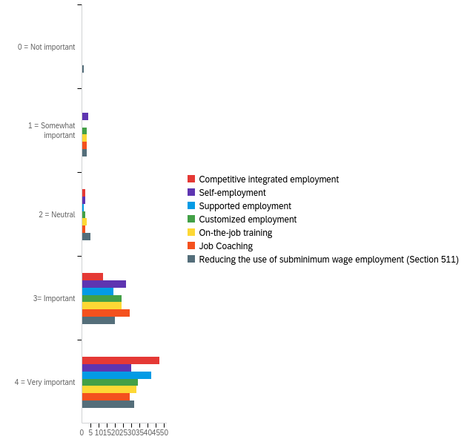

# | Field | Minimum | Maximum | Mean | Std Deviation | Variance | Count
1 | Competitive integrated employment | 3.00 | 5.00 | 4.73 | 0.51 | 0.26 | 62
2 | Self-employment | 2.00 | 5.00 | 4.32 | 0.81 | 0.66 | 63
3 | Supported employment | 3.00 | 5.00 | 4.66 | 0.51 | 0.26 | 62
4 | Customized employment | 2.00 | 5.00 | 4.41 | 0.77 | 0.59 | 63
5 | On-the-job training | 2.00 | 5.00 | 4.38 | 0.79 | 0.62 | 63
6 | Job Coaching | 2.00 | 5.00 | 4.33 | 0.76 | 0.57 | 63
7 | Reducing the use of subminimum wage employment (Section 511) | 1.00 | 5.00 | 4.30 | 0.93 | 0.86 | 61

# | Question | 0 = Not important |  | 1 = Somewhat important |  | 2 = Neutral |  | 3= Important |  | 4 = Very important |  | Total
1 | Competitive integrated employment | 0.00% | 0 | 0.00% | 0 | 3.23% | 2 | 20.97% | 13 | 75.81% | 47 | 62
2 | Self-employment | 0.00% | 0 | 6.35% | 4 | 3.17% | 2 | 42.86% | 27 | 47.62% | 30 | 63
3 | Supported employment | 0.00% | 0 | 0.00% | 0 | 1.61% | 1 | 30.65% | 19 | 67.74% | 42 | 62
4 | Customized employment | 0.00% | 0 | 4.76% | 3 | 3.17% | 2 | 38.10% | 24 | 53.97% | 34 | 63
5 | On-the-job training | 0.00% | 0 | 4.76% | 3 | 4.76% | 3 | 38.10% | 24 | 52.38% | 33 | 63
6 | Job Coaching | 0.00% | 0 | 4.76% | 3 | 3.17% | 2 | 46.03% | 29 | 46.03% | 29 | 63
7 | Reducing the use of subminimum wage employment (Section 511) | 1.64% | 1 | 4.92% | 3 | 8.20% | 5 | 32.79% | 20 | 52.46% | 32 | 61

Q16#2 - Employment Please rate the importance and level of of need for TA and/or training with the... - Level of TA need
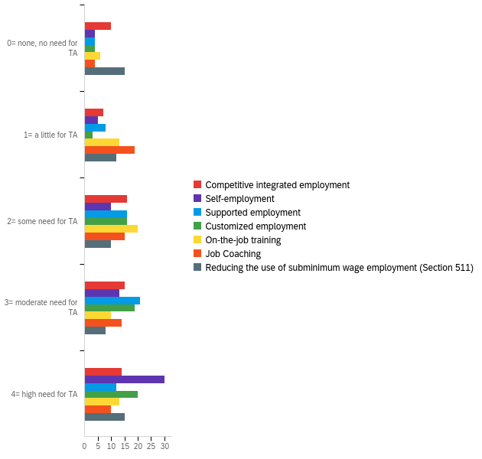

# | Field | Minimum | Maximum | Mean | Std Deviation | Variance | Count
1 | Competitive integrated employment | 1.00 | 5.00 | 3.26 | 1.36 | 1.84 | 62
2 | Self-employment | 1.00 | 5.00 | 3.97 | 1.24 | 1.55 | 62
3 | Supported employment | 1.00 | 5.00 | 3.48 | 1.14 | 1.30 | 61
4 | Customized employment | 1.00 | 5.00 | 3.77 | 1.14 | 1.30 | 62
5 | On-the-job training | 1.00 | 5.00 | 3.18 | 1.25 | 1.57 | 62
6 | Job Coaching | 1.00 | 5.00 | 3.11 | 1.19 | 1.42 | 62
7 | Reducing the use of subminimum wage employment (Section 511) | 1.00 | 5.00 | 2.93 | 1.53 | 2.33 | 60

# | Question | 0= none, no need for TA |  | 1= a little for TA |  | 2= some need for TA |  | 3= moderate need for TA |  | 4= high need for TA |  | Total
1 | Competitive integrated employment | 16.13% | 10 | 11.29% | 7 | 25.81% | 16 | 24.19% | 15 | 22.58% | 14 | 62
2 | Self-employment | 6.45% | 4 | 8.06% | 5 | 16.13% | 10 | 20.97% | 13 | 48.39% | 30 | 62
3 | Supported employment | 6.56% | 4 | 13.11% | 8 | 26.23% | 16 | 34.43% | 21 | 19.67% | 12 | 61
4 | Customized employment | 6.45% | 4 | 4.84% | 3 | 25.81% | 16 | 30.65% | 19 | 32.26% | 20 | 62
5 | On-the-job training | 9.68% | 6 | 20.97% | 13 | 32.26% | 20 | 16.13% | 10 | 20.97% | 13 | 62
6 | Job Coaching | 6.45% | 4 | 30.65% | 19 | 24.19% | 15 | 22.58% | 14 | 16.13% | 10 | 62
7 | Reducing the use of subminimum wage employment (Section 511) | 25.00% | 15 | 20.00% | 12 | 16.67% | 10 | 13.33% | 8 | 25.00% | 15 | 60

Q17#1 - Employment Please rate the importance and level of need for TA and/or training with the fo... - Importance
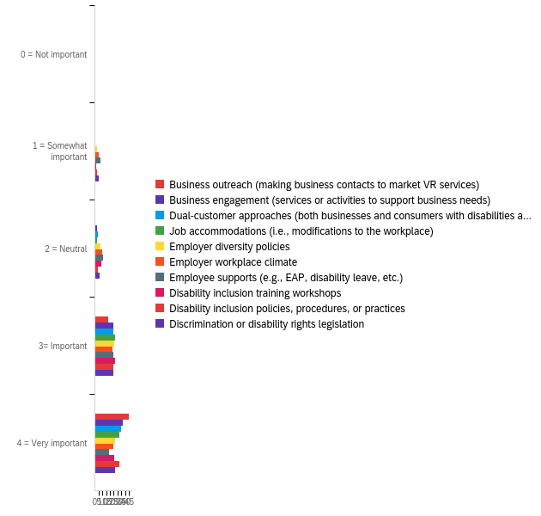

# | Field | Minimum | Maximum | Mean | Std Deviation | Variance | Count
1 | Business outreach (making business contacts to market VR services) | 3.00 | 5.00 | 4.69 | 0.50 | 0.25 | 64
2 | Business engagement (services or activities to support business needs) | 3.00 | 5.00 | 4.53 | 0.59 | 0.34 | 64
3 | Dual-customer approaches (both businesses and consumers with disabilities are customers) | 2.00 | 5.00 | 4.45 | 0.68 | 0.47 | 64
4 | Job accommodations (i.e., modifications to the workplace) | 2.00 | 5.00 | 4.43 | 0.66 | 0.44 | 63
5 | Employer diversity policies | 2.00 | 5.00 | 4.22 | 0.83 | 0.68 | 63
6 | Employer workplace climate | 2.00 | 5.00 | 4.08 | 0.93 | 0.87 | 63
7 | Employee supports (e.g., EAP, disability leave, etc.) | 1.00 | 5.00 | 3.86 | 1.02 | 1.04 | 63
8 | Disability inclusion training workshops | 2.00 | 5.00 | 4.20 | 0.79 | 0.63 | 64
9 | Disability inclusion policies, procedures, or practices | 2.00 | 5.00 | 4.34 | 0.79 | 0.63 | 64
10 | Discrimination or disability rights legislation | 2.00 | 5.00 | 4.17 | 0.90 | 0.81 | 63

# | Question | 0 = Not important |  | 1 = Somewhat important |  | 2 = Neutral |  | 3= Important |  | 4 = Very important |  | Total
1 | Business outreach (making business contacts to market VR services) | 0.00% | 0 | 0.00% | 0 | 1.56% | 1 | 28.13% | 18 | 70.31% | 45 | 64
2 | Business engagement (services or activities to support business needs) | 0.00% | 0 | 0.00% | 0 | 4.69% | 3 | 37.50% | 24 | 57.81% | 37 | 64
3 | Dual-customer approaches (both businesses and consumers with disabilities are customers) | 0.00% | 0 | 1.56% | 1 | 6.25% | 4 | 37.50% | 24 | 54.69% | 35 | 64
4 | Job accommodations (i.e., modifications to the workplace) | 0.00% | 0 | 1.59% | 1 | 4.76% | 3 | 42.86% | 27 | 50.79% | 32 | 63
5 | Employer diversity policies | 0.00% | 0 | 4.76% | 3 | 11.11% | 7 | 41.27% | 26 | 42.86% | 27 | 63
6 | Employer workplace climate | 0.00% | 0 | 7.94% | 5 | 15.87% | 10 | 36.51% | 23 | 39.68% | 25 | 63
7 | Employee supports (e.g., EAP, disability leave, etc.) | 1.59% | 1 | 11.11% | 7 | 17.46% | 11 | 39.68% | 25 | 30.16% | 19 | 63
8 | Disability inclusion training workshops | 0.00% | 0 | 3.13% | 2 | 14.06% | 9 | 42.19% | 27 | 40.63% | 26 | 64
9 | Disability inclusion policies, procedures, or practices | 0.00% | 0 | 4.69% | 3 | 6.25% | 4 | 39.06% | 25 | 50.00% | 32 | 64
10 | Discrimination or disability rights legislation | 0.00% | 0 | 7.94% | 5 | 9.52% | 6 | 39.68% | 25 | 42.86% | 27 | 63

Q17#2 - Employment Please rate the importance and level of need for TA and/or training with the fo... - Level of TA need
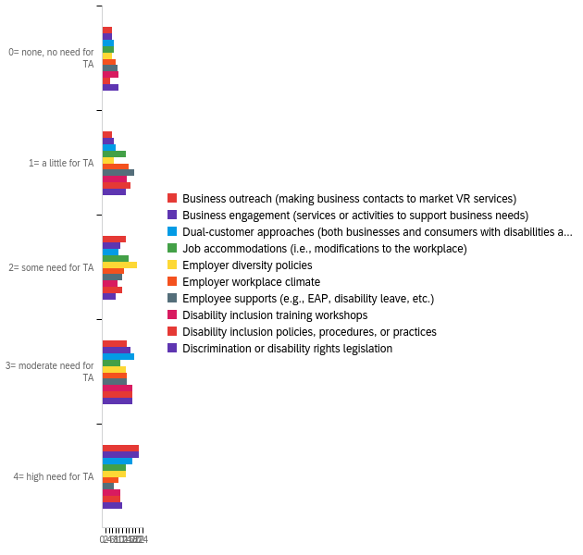

# | Field | Minimum | Maximum | Mean | Std Deviation | Variance | Count
1 | Business outreach (making business contacts to market VR services) | 1.00 | 5.00 | 3.65 | 1.30 | 1.69 | 63
2 | Business engagement (services or activities to support business needs) | 1.00 | 5.00 | 3.67 | 1.31 | 1.71 | 63
3 | Dual-customer approaches (both businesses and consumers with disabilities are customers) | 1.00 | 5.00 | 3.53 | 1.33 | 1.77 | 62
4 | Job accommodations (i.e., modifications to the workplace) | 1.00 | 5.00 | 3.18 | 1.31 | 1.73 | 62
5 | Employer diversity policies | 1.00 | 5.00 | 3.37 | 1.22 | 1.49 | 62
6 | Employer workplace climate | 1.00 | 5.00 | 3.05 | 1.29 | 1.66 | 62
7 | Employee supports (e.g., EAP, disability leave, etc.) | 1.00 | 5.00 | 2.87 | 1.25 | 1.56 | 62
8 | Disability inclusion training workshops | 1.00 | 5.00 | 3.08 | 1.36 | 1.85 | 63
9 | Disability inclusion policies, procedures, or practices | 1.00 | 5.00 | 3.21 | 1.24 | 1.53 | 63
10 | Discrimination or disability rights legislation | 1.00 | 5.00 | 3.13 | 1.39 | 1.92 | 62

# | Question | 0= none, no need for TA |  | 1= a little for TA |  | 2= some need for TA |  | 3= moderate need for TA |  | 4= high need for TA |  | Total
1 | Business outreach (making business contacts to market VR services) | 9.52% | 6 | 9.52% | 6 | 22.22% | 14 | 23.81% | 15 | 34.92% | 22 | 63
2 | Business engagement (services or activities to support business needs) | 9.52% | 6 | 11.11% | 7 | 17.46% | 11 | 26.98% | 17 | 34.92% | 22 | 63
3 | Dual-customer approaches (both businesses and consumers with disabilities are customers) | 11.29% | 7 | 12.90% | 8 | 16.13% | 10 | 30.65% | 19 | 29.03% | 18 | 62
4 | Job accommodations (i.e., modifications to the workplace) | 11.29% | 7 | 22.58% | 14 | 25.81% | 16 | 17.74% | 11 | 22.58% | 14 | 62
5 | Employer diversity policies | 9.68% | 6 | 11.29% | 7 | 33.87% | 21 | 22.58% | 14 | 22.58% | 14 | 62
6 | Employer workplace climate | 12.90% | 8 | 25.81% | 16 | 20.97% | 13 | 24.19% | 15 | 16.13% | 10 | 62
7 | Employee supports (e.g., EAP, disability leave, etc.) | 14.52% | 9 | 30.65% | 19 | 19.35% | 12 | 24.19% | 15 | 11.29% | 7 | 62
8 | Disability inclusion training workshops | 15.87% | 10 | 23.81% | 15 | 14.29% | 9 | 28.57% | 18 | 17.46% | 11 | 63
9 | Disability inclusion policies, procedures, or practices | 7.94% | 5 | 26.98% | 17 | 19.05% | 12 | 28.57% | 18 | 17.46% | 11 | 63
10 | Discrimination or disability rights legislation | 16.13% | 10 | 22.58% | 14 | 12.90% | 8 | 29.03% | 18 | 19.35% | 12 | 62

Q21 - Please rate your level of agreement that the following technical assistance or training methods are useful to your agency?
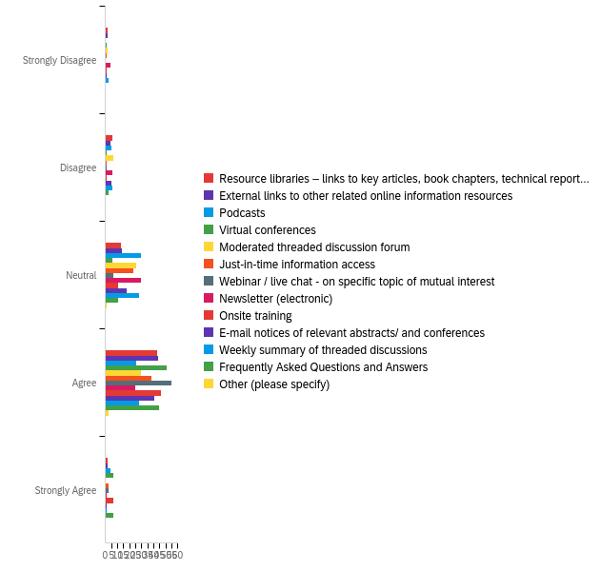

# | Field | Minimum | Maximum | Mean | Std Deviation | Variance | Count
1 | Resource libraries – links to key articles, book chapters, technical reports, books, book reviews, training videos, and manuals | 11.00 | 15.00 | 13.56 | 0.82 | 0.67 | 66
2 | External links to other related online information resources | 11.00 | 15.00 | 13.61 | 0.78 | 0.60 | 66
3 | Podcasts | 12.00 | 15.00 | 13.45 | 0.72 | 0.52 | 65
4 | Virtual conferences | 11.00 | 15.00 | 13.94 | 0.62 | 0.39 | 66
5 | Moderated threaded discussion forum | 11.00 | 14.00 | 13.29 | 0.78 | 0.61 | 65
6 | Just-in-time information access | 11.00 | 15.00 | 13.62 | 0.67 | 0.45 | 66
7 | Webinar / live chat - on specific topic of mutual interest | 12.00 | 15.00 | 13.91 | 0.45 | 0.20 | 66
8 | Newsletter (electronic) | 11.00 | 15.00 | 13.20 | 0.86 | 0.73 | 66
9 | Onsite training | 11.00 | 15.00 | 13.86 | 0.67 | 0.45 | 66
10 | E-mail notices of relevant abstracts/ and conferences | 11.00 | 15.00 | 13.55 | 0.72 | 0.52 | 66
11 | Weekly summary of threaded discussions | 11.00 | 15.00 | 13.27 | 0.83 | 0.68 | 66
12 | Frequently Asked Questions and Answers | 12.00 | 15.00 | 13.85 | 0.66 | 0.43 | 66
13 | Other (please specify) | 13.00 | 14.00 | 13.75 | 0.43 | 0.19 | 4

# | Question | Strongly Disagree |  | Disagree |  | Neutral |  | Agree |  | Strongly Agree |  | Total
1 | Resource libraries – links to key articles, book chapters, technical reports, books, book reviews, training videos, and manuals | 3.03% | 2 | 9.09% | 6 | 19.70% | 13 | 65.15% | 43 | 3.03% | 2 | 66
2 | External links to other related online information resources | 3.03% | 2 | 6.06% | 4 | 21.21% | 14 | 66.67% | 44 | 3.03% | 2 | 66
3 | Podcasts | 0.00% | 0 | 7.69% | 5 | 46.15% | 30 | 40.00% | 26 | 6.15% | 4 | 65
4 | Virtual conferences | 1.52% | 1 | 1.52% | 1 | 9.09% | 6 | 77.27% | 51 | 10.61% | 7 | 66
5 | Moderated threaded discussion forum | 3.08% | 2 | 10.77% | 7 | 40.00% | 26 | 46.15% | 30 | 0.00% | 0 | 65
6 | Just-in-time information access | 1.52% | 1 | 1.52% | 1 | 34.85% | 23 | 57.58% | 38 | 4.55% | 3 | 66
7 | Webinar / live chat - on specific topic of mutual interest | 0.00% | 0 | 1.52% | 1 | 10.61% | 7 | 83.33% | 55 | 4.55% | 3 | 66
8 | Newsletter (electronic) | 6.06% | 4 | 9.09% | 6 | 45.45% | 30 | 37.88% | 25 | 1.52% | 1 | 66
9 | Onsite training | 1.52% | 1 | 1.52% | 1 | 16.67% | 11 | 69.70% | 46 | 10.61% | 7 | 66
10 | E-mail notices of relevant abstracts/ and conferences | 1.52% | 1 | 7.58% | 5 | 27.27% | 18 | 62.12% | 41 | 1.52% | 1 | 66
11 | Weekly summary of threaded discussions | 4.55% | 3 | 9.09% | 6 | 42.42% | 28 | 42.42% | 28 | 1.52% | 1 | 66
12 | Frequently Asked Questions and Answers | 0.00% | 0 | 4.55% | 3 | 16.67% | 11 | 68.18% | 45 | 10.61% | 7 | 66
13 | Other (please specify) | 0.00% | 0 | 0.00% | 0 | 25.00% | 1 | 75.00% | 3 | 0.00% | 0 | 4

Q22 - Please rate your level of agreement that the following barriers may impact participation in technical assistance activities?
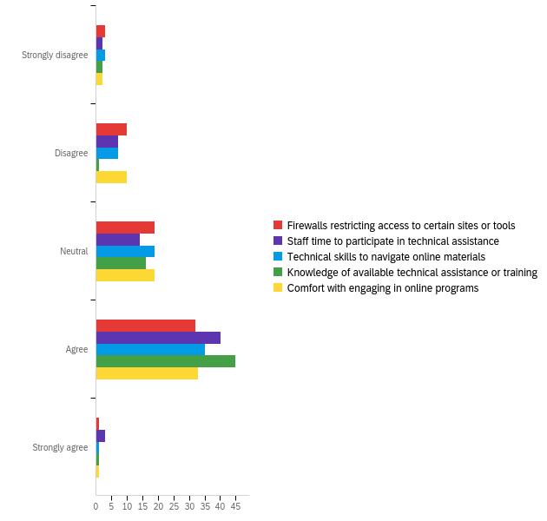

# | Field | Minimum | Maximum | Mean | Std Deviation | Variance | Count
1 | Firewalls restricting access to certain sites or tools | 1.00 | 5.00 | 3.28 | 0.90 | 0.82 | 65
2 | Staff time to participate in technical assistance | 1.00 | 5.00 | 3.53 | 0.86 | 0.73 | 66
3 | Technical skills to navigate online materials | 1.00 | 5.00 | 3.37 | 0.87 | 0.76 | 65
4 | Knowledge of available technical assistance or training | 1.00 | 5.00 | 3.65 | 0.69 | 0.47 | 65
5 | Comfort with engaging in online programs | 1.00 | 5.00 | 3.32 | 0.86 | 0.74 | 65

# | Question | Strongly disagree |  | Disagree |  | Neutral |  | Agree |  | Strongly agree |  | Total
1 | Firewalls restricting access to certain sites or tools | 4.62% | 3 | 15.38% | 10 | 29.23% | 19 | 49.23% | 32 | 1.54% | 1 | 65
2 | Staff time to participate in technical assistance | 3.03% | 2 | 10.61% | 7 | 21.21% | 14 | 60.61% | 40 | 4.55% | 3 | 66
3 | Technical skills to navigate online materials | 4.62% | 3 | 10.77% | 7 | 29.23% | 19 | 53.85% | 35 | 1.54% | 1 | 65
4 | Knowledge of available technical assistance or training | 3.08% | 2 | 1.54% | 1 | 24.62% | 16 | 69.23% | 45 | 1.54% | 1 | 65
5 | Comfort with engaging in online programs | 3.08% | 2 | 15.38% | 10 | 29.23% | 19 | 50.77% | 33 | 1.54% | 1 | 65

Q23 - Do you have any other information regarding the technical assistance needs of state VR agencies that you would like to share? If so, please provide your input in the comment box.

Do you have any other information regarding the technical assistance needs of state VR agencies that you would like to share? If so, please provide your input in the comment box.
There is a real divide between staff who are comfortable with technology and those who are still clinging to other methods. Major problem with online resources that are not accessible to screen reader users. Tools may be accessible to end user, but not to a staff person using them. Saw this repeatedly when attending sessions during CSAVR. Assumption that staff don't have disabilities, only consumers.
Not at this time.
WebEx is the least user-friendly platform for TA.
N/A
Some staff members have barriers in all of these areas. Accessibiliy is critical

Q24 - The next set of questions relates to the NTACT:C. Do you wish to answer these questions?
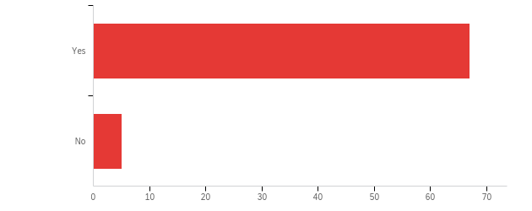

# | Field | Minimum | Maximum | Mean | Std Deviation | Variance | Count
1 | The next set of questions relates to the NTACT:C. Do you wish to answer these questions? | 1.00 | 4.00 | 1.21 | 0.76 | 0.58 | 72

# | Answer | % | Count
1 | Yes | 93.06% | 67
4 | No | 6.94% | 5
 | Total | 100% | 72

Q26 - Please rate your level of need for training and/or technical assistance in the following areas using the scale provided:
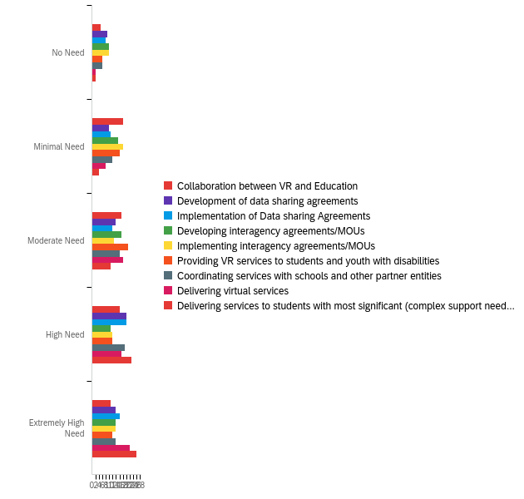

# | Field | Minimum | Maximum | Mean | Std Deviation | Variance | Count
1 | Collaboration between VR and Education | 1.00 | 5.00 | 3.15 | 1.20 | 1.44 | 67
2 | Development of data sharing agreements | 1.00 | 5.00 | 3.30 | 1.32 | 1.73 | 67
3 | Implementation of Data sharing Agreements | 1.00 | 5.00 | 3.37 | 1.33 | 1.76 | 67
4 | Developing interagency agreements/MOUs | 1.00 | 5.00 | 3.06 | 1.35 | 1.82 | 67
5 | Implementing interagency agreements/MOUs | 1.00 | 5.00 | 3.03 | 1.37 | 1.88 | 67
6 | Providing VR services to students and youth with disabilities | 1.00 | 5.00 | 3.12 | 1.22 | 1.48 | 67
7 | Coordinating services with schools and other partner entities | 1.00 | 5.00 | 3.34 | 1.24 | 1.54 | 67
8 | Delivering virtual services | 1.00 | 5.00 | 3.73 | 1.13 | 1.27 | 67
9 | Delivering services to students with most significant (complex support needs) disabilities | 1.00 | 5.00 | 4.02 | 1.04 | 1.08 | 66

# | Question | No Need |  | Minimal Need |  | Moderate Need |  | High Need |  | Extremely High Need |  | Total
1 | Collaboration between VR and Education | 7.46% | 5 | 26.87% | 18 | 25.37% | 17 | 23.88% | 16 | 16.42% | 11 | 67
2 | Development of data sharing agreements | 13.43% | 9 | 14.93% | 10 | 20.90% | 14 | 29.85% | 20 | 20.90% | 14 | 67
3 | Implementation of Data sharing Agreements | 11.94% | 8 | 16.42% | 11 | 17.91% | 12 | 29.85% | 20 | 23.88% | 16 | 67
4 | Developing interagency agreements/MOUs | 14.93% | 10 | 22.39% | 15 | 25.37% | 17 | 16.42% | 11 | 20.90% | 14 | 67
5 | Implementing interagency agreements/MOUs | 14.93% | 10 | 26.87% | 18 | 19.40% | 13 | 17.91% | 12 | 20.90% | 14 | 67
6 | Providing VR services to students and youth with disabilities | 8.96% | 6 | 23.88% | 16 | 31.34% | 21 | 17.91% | 12 | 17.91% | 12 | 67
7 | Coordinating services with schools and other partner entities | 8.96% | 6 | 17.91% | 12 | 23.88% | 16 | 28.36% | 19 | 20.90% | 14 | 67
8 | Delivering virtual services | 2.99% | 2 | 11.94% | 8 | 26.87% | 18 | 25.37% | 17 | 32.84% | 22 | 67
9 | Delivering services to students with most significant (complex support needs) disabilities | 3.03% | 2 | 6.06% | 4 | 16.67% | 11 | 34.85% | 23 | 39.39% | 26 | 66

Q27 - Please rate your level of need for training and/or TA related to the statewide availability and provision of the following pre-employment transition services using the scale provided:
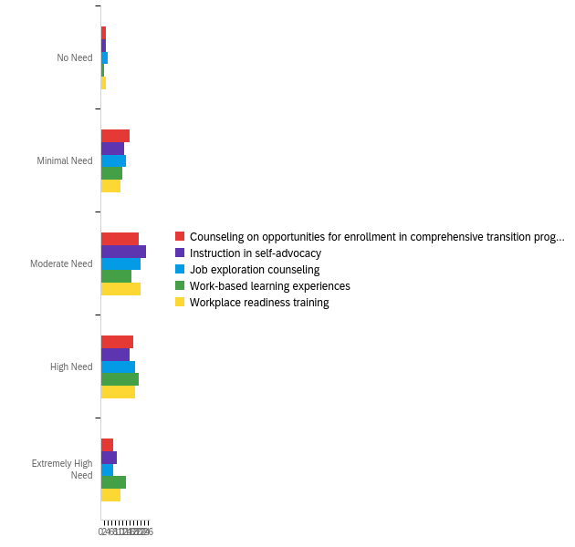

# | Field | Minimum | Maximum | Mean | Std Deviation | Variance | Count
1 | Counseling on opportunities for enrollment in comprehensive transition programs and postsecondary education | 1.00 | 5.00 | 3.15 | 1.06 | 1.11 | 65
2 | Instruction in self-advocacy | 1.00 | 5.00 | 3.23 | 1.06 | 1.12 | 66
3 | Job exploration counseling | 1.00 | 5.00 | 3.17 | 1.07 | 1.14 | 66
4 | Work-based learning experiences | 1.00 | 5.00 | 3.50 | 1.10 | 1.22 | 66
5 | Workplace readiness training | 1.00 | 5.00 | 3.36 | 1.08 | 1.17 | 66

# | Question | No Need |  | Minimal Need |  | Moderate Need |  | High Need |  | Extremely High Need |  | Total
1 | Counseling on opportunities for enrollment in comprehensive transition programs and postsecondary education | 4.62% | 3 | 24.62% | 16 | 32.31% | 21 | 27.69% | 18 | 10.77% | 7 | 65
2 | Instruction in self-advocacy | 4.55% | 3 | 19.70% | 13 | 37.88% | 25 | 24.24% | 16 | 13.64% | 9 | 66
3 | Job exploration counseling | 6.06% | 4 | 21.21% | 14 | 33.33% | 22 | 28.79% | 19 | 10.61% | 7 | 66
4 | Work-based learning experiences | 3.03% | 2 | 18.18% | 12 | 25.76% | 17 | 31.82% | 21 | 21.21% | 14 | 66
5 | Workplace readiness training | 4.55% | 3 | 16.67% | 11 | 33.33% | 22 | 28.79% | 19 | 16.67% | 11 | 66

Q28 - Targeted Populations: Please check all that apply regarding your needs for training and/or TA for youth and students with disabilities in the following targeted populations:
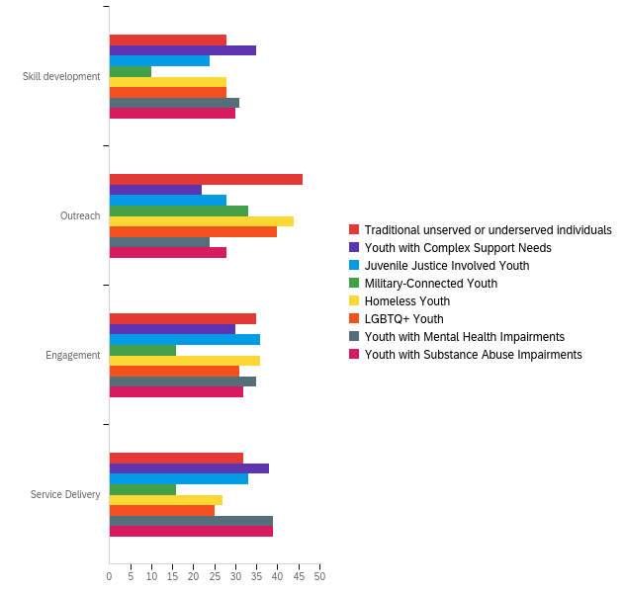

# | Question | Skill development |  | Outreach |  | Engagement |  | Service Delivery |  | Total
1 | Traditional unserved or underserved individuals | 19.86% | 28 | 32.62% | 46 | 24.82% | 35 | 22.70% | 32 | 141
2 | Youth with Complex Support Needs | 28.00% | 35 | 17.60% | 22 | 24.00% | 30 | 30.40% | 38 | 125
3 | Juvenile Justice Involved Youth | 19.83% | 24 | 23.14% | 28 | 29.75% | 36 | 27.27% | 33 | 121
4 | Military-Connected Youth | 13.33% | 10 | 44.00% | 33 | 21.33% | 16 | 21.33% | 16 | 75
5 | Homeless Youth | 20.74% | 28 | 32.59% | 44 | 26.67% | 36 | 20.00% | 27 | 135
6 | LGBTQ+ Youth | 22.58% | 28 | 32.26% | 40 | 25.00% | 31 | 20.16% | 25 | 124
7 | Youth with Mental Health Impairments | 24.03% | 31 | 18.60% | 24 | 27.13% | 35 | 30.23% | 39 | 129
8 | Youth with Substance Abuse Impairments | 23.26% | 30 | 21.71% | 28 | 24.81% | 32 | 30.23% | 39 | 129

# | Question | Skill development |  | Outreach |  | Engagement |  | Service Delivery |  | Total
1 | Traditional unserved or underserved individuals | 19.86% | 28 | 32.62% | 46 | 24.82% | 35 | 22.70% | 32 | 141
2 | Youth with Complex Support Needs | 28.00% | 35 | 17.60% | 22 | 24.00% | 30 | 30.40% | 38 | 125
3 | Juvenile Justice Involved Youth | 19.83% | 24 | 23.14% | 28 | 29.75% | 36 | 27.27% | 33 | 121
4 | Military-Connected Youth | 13.33% | 10 | 44.00% | 33 | 21.33% | 16 | 21.33% | 16 | 75
5 | Homeless Youth | 20.74% | 28 | 32.59% | 44 | 26.67% | 36 | 20.00% | 27 | 135
6 | LGBTQ+ Youth | 22.58% | 28 | 32.26% | 40 | 25.00% | 31 | 20.16% | 25 | 124
7 | Youth with Mental Health Impairments | 24.03% | 31 | 18.60% | 24 | 27.13% | 35 | 30.23% | 39 | 129
8 | Youth with Substance Abuse Impairments | 23.26% | 30 | 21.71% | 28 | 24.81% | 32 | 30.23% | 39 | 129

