# **CSAVR PROVIDER CAPACITY EVALUATION SURVEY RESULTS**

**FACT SHEET**

## DEMOGRAPHICS

* Highest response frequency: Texas, Colorado, and Indiana
* Highest populations served: All populations **(20.29%)**, primarily served individuals with intellectual or developmental disabilities (**18.04%)**, services to students with a disability pre-employment transition service **(12.54%)**
* Role in Agency: Majority were “Executive Level” **(53.26%)**

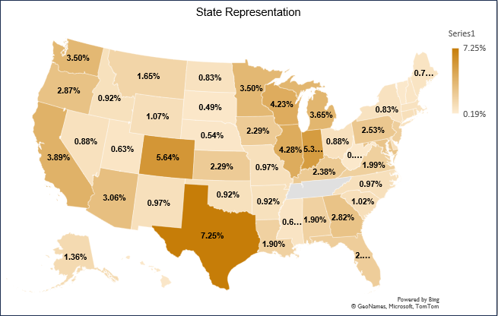

## ORGANIZATIONAL STAFFING & SERVICE CAPACITY

More than 61% of service providers were not fully staffed, and 37% had no capacity to serve more VR customers.

## ORGANIZATIONAL CAPACITY BUILDING

* Effective, ongoing communication between provider, VR, and customer **(79.16%)**
* Team approach/positive relationship with VR for service provision **(74.69%)**
* Increased rates for VR services **(59.80%)**
* Availability of qualified candidates for job openings **(57.9%)**
* Hourly fee-for-service payment structure **(52.06%)**
* Use of technology to support communication/service documentation **(49.49%)**
* Standardized or uniform documents/forms **(48.01%)**
* Milestone/outcome payment structure **(46.69%)**

## BARRIERS IMPACTING TIMELY AND QUALITY SERVICES

* Billing/Reimbursement: Some activities are not billable e.g., documentation time, travel, etc. **(30.56%)**
* Wage inflation is making it difficult to compete with other employers **(29.66%)**
* Low provider rates paid by VR **(28.52%)**
* Lack of referrals from VR **(25.05%)**
* Inconsistent requirements and/or procedures from one VR office to the next **(23.89%)**
* Administrative Burden: The level of administrative burden in working with VR is too high or processes are too complex **(21.09%)**
* Challenges or inability to recruit qualified provider staff **(20.11%)**

## TOP CURRENT TYPES OF STAFF TRAINING

* Confidentiality requirements for working with VR customers **(11.83%)**
* Ethics and boundaries for working with VR customers **(11.10%)**
* Administrative processes (e.g., timekeeping, data entry to support billings processes, completed required VR documentation) **(11.10%)**
* Basic HR onboarding **(10.95%)**
* Americans with Disabilities Act, reasonable accommodations, and related content **(10.52%)**
* Diversity, equity, inclusion, and accessibility (DEI&A) related training **(10.38%)**
* Customer engagement strategies **(9.38%)**

## CURRENT STAFF TRAINING AND NEEDS

## LESSONS LEARNED

* Effective and ongoing communication between SVRAs, service providers, and customers is a critical component of quality and timely service delivery to individuals with disabilities served by the VR program.
* Training and professional development for service providers that is supported by SVRAs is needed and should be explored further.
* There is a need to reduce the administrative burden associated with providing and billing for VR services. Streamlining and simplifying reporting and billing procedures, as well as allowing for case documentation time and travel to be reimbursed, will contribute to provider capacity to deliver quality and timely services.
* Service providers are willing to invest in training for their staff and support career pathways models, though they are frequently impacted by resource limitations related to professional development. They do support the development of a national training hub for service providers, especially one that provides training for new staff.
* Staff turnover is a significant challenge for service providers. A regular review of fee schedules and rate revisions are important elements that contribute to recruitment and retention for service providers.

[**VRTAC-QM**](https://www.vrtac-qm.org/) **|** [**CSAVR**](https://www.csavr.org/)