Caren Sax, Chaz Compton and Chip Kenney

End-of-Year Annual Report, Year Four

SAN DIEGO STATE UNIVERSITY Research foundation

INTERWORK INSTITUTE

VRTAC-QM

End of year Annual Performance and FIscal Report - year 4

# Executive Summary

At the end of Year Four, the VRTAC-QM completed 24 intensive TA agreements (ITAAs). Our target for the end of Year Four was 24, so we met our target. The VR agencies we have ITAAs with include:

1. Arizona Combined
2. Arkansas Blind
3. Colorado Combined
4. Delaware Blind
5. Florida Blind
6. Florida General
7. Georgia Combined
8. Hawaii Combined
9. Idaho General
10. Kansas Combined
11. Kentucky Combined
12. Maryland Combined
13. Montana Combined
14. New Jersey General
15. New Mexico General
16. Oklahoma Combined
17. Oregon General
18. Pennsylvania Combined
19. South Carolina Blind
20. South Carolina General
21. Virginia General
22. Washington Blind
23. Washington General
24. Wyoming Combined

Targeted TA has been extremely active for the VRTAC-QM since its inception. To date we have provided at least targeted TA to all 78 VR agencies (100%) in 1,622 targeted TA events serving 13,302 VR staff. These totals far exceed our target rates in every area. Our communities of practice were very active this year with the addition of the rapid engagement, state plan and innovating and transforming services CoPs.

The National Rehabilitation Leadership Institute (NRLI) had its best year ever in Year 4 of the VRTAC-QM, with a cohort of 47 people in one cohort. NRLI remains the primary way that we provide leadership development training for SVRA staff at the executive level.

Universal TA is delivered primarily through our website, which has added content regularly. We added an AI chatbot to eh QM website this year to enhance the user experience and search function. We have completed multiple webinars, many in partnership with other TA Centers. Our staff have been very active at the CSAVR conferences, the Summit conference, the VRTAC-QE Symposium and the NTACT:C’s Capacity Building Institute.

The VR Grants Management Certificate training through Management Concepts is fully developed and has been very active with 395 courses taken this year and 73 individuals completing the entire certificate.

The demand for quality program and performance, and fiscal and resource management is very high. We will be concluding as many ITAA activities as possible this last year and finishing helpful tools and resources that will be made available to the field.

Contents

Executive Summary 1

Section A: Substantial progress toward completion of goals, objectives, and outputs 4

Part 1: Program activities, outputs, and products 4

Intensive TA agreement development and progress on activities, outputs, and outcomes: 4

Intensive TA Agency Narratives 6

Arizona Combined 6

Arkansas Blind 7

Colorado Combined 12

Delaware Blind 15

Florida Blind 17

Florida General 19

Georgia Combined 24

Hawaii Combined 29

Idaho General 33

Kansas Combined 35

Kentucky Combined 37

Maryland Combined 43

Montana Combined 45

New Jersey General 49

New Mexico General 54

Oklahoma Combined 58

Oregon General 60

Pennsylvania Combined 64

South Carolina General 70

South Carolina Blind 73

Virginia General 75

Washington Blind 76

Washington General 79

Wyoming Combined 82

SWOT assessment tools development and assessments conducted 86

Program Evaluation: 86

Targeted TA 86

Number of events by type, topic, agency and number served: 87

Targeted TA of Note in Year 4, Quarter 4: 91

VR Grants Management Training Certificate 92

Communities of Practice: 92

ITS CoP: 92

Rapid Engagement Community of Practice: 93

Fiscal Management CoP: 95

2024 Monitoring CoP: 96

Case File Review CoP – Part 2: 97

Customized Employment CoP 98

Executive Leadership Seminar Series - NRLI 100

Program Evaluation: 101

Universal TA 101

Website Analytics for Year 4 101

Universal TA of Note in the 4th Quarter: 104

Website Resources: 108

Collaboration with other TA Centers 109

Special Projects 109

Community Reinvestment Act Project: 109

SARA Project: 113

Significant program activities, outputs, products and outcomes anticipated by September 30, 2024 117

Challenges, Opportunities and Emerging Issues 117

Section B: Work Plan 118

Project Measures Update 119

Section C: Budget 123

**Vocational Rehabilitation Technical Assistance Center for**

**Quality Management**

**End-of-Year Annual Reporting Form**

Name of individual filling out form: Chaz Compton

Organization: SDSURF – Interwork Institute

Annual report period: (Oct. 1, 2023 – September 30, 2024)

Date submitted: December 31, 2024

# Section A: Substantial progress toward completion of goals, objectives, and outputs

## Part 1: Program activities, outputs, and products

## Intensive TA agreement development and progress on activities, outputs, and outcomes:

At the end of Year Four, the VRTAC-QM completed 24 intensive TA agreements (ITAAs) meeting our target for the project. Table 1 includes a list of all ITAAs by agency, date and project year. The project years have been color-coded as a visual aide.

Table 1

*Intensive TA Agreements by Agency, Date Signed and Project Year*

| **VRTAC-QM ITAAs by Agency, Date Signed and Project Year** | | | | | **Monitoring or CAP generated?** |
| --- | --- | --- | --- | --- | --- |
| **Agency** | **Date Signed** | **Revision Date** | **Project Year** | **Joint TAC** |
| Delaware Blind | 5/11/2022 |  | One |  | Yes |
| Kansas Combined | 3/26/2021 | 7/13/2021 | One | NTACT:C | Yes |
| Montana Combined | 6/4/2021 |  | One |  | Yes |
| Pennsylvania Combined | 6/28/2021 |  | One | NTACT:C | Yes |
| Arkansas Blind | 1/5/2022 |  | Two |  | Yes |
| Florida General | 4/19/2022 |  | Two |  | No |
| Hawaii Combined | 4/6/2022 | 7/6/2022 | Two | NTACT:C | Yes |
| Maryland Combined | 10/15/2021 |  | Two |  | No |
| New Mexico General | 8/15/2022 |  | Two |  | Yes |
| South Carolina General | 5/10/2022 |  | Two |  | Yes |
| Washington Blind | 1/12/2022 |  | Two |  | No |
| Wyoming Combined | 2/15/2022 |  | Two |  | No |
| Arizona Combined | 3/20/2023 |  | Three |  | No |
| Colorado Combined | 2/23/2023 |  | Three |  | No |
| Florida Blind | 7/14/2023 |  | Three | NTACT:C | Yes |
| Georgia Combined | 7/26/2023 |  | Three | NTACT:C | Yes |
| Kentucky Combined | 10/11/2022 |  | Three |  | Yes |
| New Jersey General | 11/7/2022 |  | Three | NTACT:C | Yes |
| Oregon General | 1/2/2024 |  | Four | NTACT:C | Yes |
| South Carolina Blind | 11/17/2023 |  | Four | NTACT:C | Yes |
| Virginia General | 2/23/2024 |  | Four |  | No |
| Oklahoma Combined | 5/22/2024 |  | Four | NTACT:C | No |
| Idaho General | 6/11/2024 |  | Four |  | No |
| Washington General | 8/30/2024 |  | Four |  | Yes |

When we complete an ITAA, we establish monthly calls with the VR agency, at least at the beginning of the process), to monitor our progress in completing the activities and achieving the outputs and outcomes. These meetings are driven by a work plan that includes all of the elements of the ITAA and tracks the progress in each area. The overall progress for the center is captured in the formal End-of-Year Program Evaluation report that is submitted 30 days after this report since it is dependent on the information in this report. The work plans for each ITAA moved to a completely on-line application since Year 3. Work plans are updated in our regular meetings with the agency and the progress in achieving the activities, outputs and outcomes are presented in the State Agency narratives below as well as the end-of-year program evaluation report.

This annual report includes an updated narrative of the work in each VR agency for which we have an ITAA. The progress on all of the activities, outputs and outcomes are included on the work plan and in the formal program evaluation report.

## Intensive TA Agency Narratives

### Arizona Combined

*Reason for TA Request*

Arizona-C initially reached out to receive targeted activities focused on training the VR Leadership team on key Federal financial grant management principles. Three sessions were held with that group. The VR Administrator then reached out and asked about intensive assistance. There were significant changes at the DSA level, with financial support services being restructured into a shared services model at the DSA, and administration levels within the overall division. The program wants to improve the VR program's financial management, resulting in reliable/accurate financial reporting and spending strategies. This will include fiscal forecasting, written policies & procedures, and internal controls.

*Interaction with the Agency*

During this period, there have been 18 interactions with the Arizona team.

These interactions included:

A diagram of a diagram

Agency interaction diagram

During this period, a primary focus was preparing for the monitoring visit, reviewing budget reports being prepared for the VR program, and continuing to address the direct split they are applying to every expenditure. During the monitoring, RSA also clarified the pitfalls of using this direct split practice, and the Designated State Agency fiscal personnel seemed more amenable to revamping their current practice. Major issues were identified during the monitoring regarding their current contracts with schools, which will require a complete deconstruction and then reconstruction. Other issues identified included the VR director's lack of access to necessary information to assist her in running the program, data integrity issues, and a lack of written fiscal policies & procedures. Once the monitoring report is received, further action will be taken to address the reflection of items in the report. RSA asked QM to pause TA until the monitoring activities are completed.

*Summary of the Areas in Need of Improvement*

During the initial review, the QM team identified a significant misunderstanding regarding the spending cadence. This led to a critical adjustment that prevented $30 million from lapsing at the end of the final grant reporting period for FY21 funds.

Additionally, there was a problem with tracking, recording, and reporting Pre-ETS expenditures toward the 15% reserve requirement. A fiscal error by the DSA involved improper direct splits, causing non-federal funds to cover Pre-ETS expenditures. As a result, over $800,000 could not be counted toward the reserve, since only federal funds qualify, and it was too late to make journal entries to correct the mistake. This situation highlights the ongoing instability within the DSA fiscal department, where key staff were on leave, and others were unaware of the need for correction.

Although initial progress was made between the DSA and DSU, the effort has now stalled. DSA fiscal staff continue to transition into different roles, and the VR Director has no authority over the fiscal management of the program.

*Strengths & Challenges*

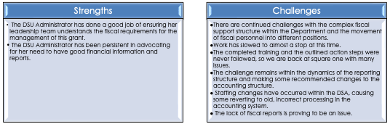

*Previous Collaborations*

Work was primarily performed by QM. Some items identified will involve future collaboration with the NTACT: C to address.

*Future Plans*

A reboot of TA activities will occur in late October 2024.

### Arkansas Blind

*Reason for TA Request*

Fiscal—DSB initially contacted the VRTAC-QM due to their need for technical assistance (TA) and training resulting from their RSA monitoring report, which resulted in a corrective action plan (CAP). The ITAA is focused on Fiscal & Resource Quality Management and General Quality Management.

*Interaction with the Agency*

**Fiscal Summary**

During this period, there were 38 total interactions with the agency, 25 of which involved the fiscal team, while 13 were focused on management coaching. All work plan items have been completed except for the implementation of the self-assessment. Notably, the QM Wellness Check has been launched, and the Arkansas Blind program will complete its baseline report this fall. **Furthermore, recent communications from the Rehabilitation Services Administration (RSA) indicate progress is complete on the 107 Monitoring Corrective Action Plan (CAP), which has now been fully resolved with no further action required**.

Over the past year, a substantial number of key initiatives were undertaken, including creating a revamped contract management & administration policy, a detailed checklist, a revised RSA-17 reporting policy, and a new period of performance (POP) policy. The challenge of implementing a grants management system to address the period of performance was mitigated through the development of an Excel workbook. This tool manages remaining administrative items that could not be handled by the current statewide accounting system, helping to close this outstanding issue.

Additionally, our team has provided ongoing support to Arkansas Blind in navigating the implementation of the indirect cost rate with the Designated State Agency (DSA). There was a major misunderstanding surrounding this with the DSA and its importance. The current rate expired in June 2024, and the DSA is now actively working on a new indirect cost proposal.

Recent changes, including the further centralization of fiscal functions at the DSA level, have also prompted discussions regarding the non-delegable responsibilities of the Designated State Unit (DSU) and how the Arkansas Blind program is structured. Technical assistance has been provided to address these organizational requirements.

Arkansas Blind has consistently managed and forecasted their funds in a prudent, as well as thoughtful manner putting them in a position to request additional reallotment funding. **They received $1.2 million in additional funding in August.** These funds help them to continue to provide high quality services and support to customers.

Products Completed:

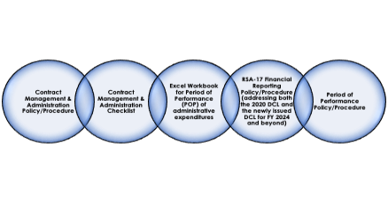

ITAA Activities Checklist:

|  |  |
| --- | --- |
| **Activity** | **Completion Status** |
| Rate-setting methodology policy/procedure |  |
| SF 425 reporting policy/procedure |  |
| Contract addendum language |  |
| Invoice processing policy/procedure |  |
| 8 chapters of the consumer services policy/procedure manual were rewritten |  |
| RSA 911 report procedures and QA tool procedures and review were all resolved |  |
| QM team provided input into the contract monitoring policy/procedure, the RSA-17 reporting policy, and the period of performance policy. |  |
| DSB completed a revision of the SF-425 reports for the period covered by the review |  |
| Contract management and administration policy/procedure/internal control |  |
| Completed and approved Period of Performance policy |  |
| Implementation of the self-assessment | In progress |

**Culture and Management Work Summary**

VRTAC-QM team members Ron Vessell and John Walsh have been providing training and technical assistance to the agency’s leadership team, including senior and middle management, with a primary focus on developing strategies in the agency for leading and managing organizational change linked to the Intensive Technical Assistance Agreement. Based on those interventions, the leadership team at AR-DSB decided to convene organizational change teams focused on three priorities to improve in their organization:

* Recruitment and retention
* Organizational culture
* Process improvement

Senior leadership has selected team leaders (co-leaders), team members, and alternates to serve on these change teams. VRTAC-QM team members will provide training to the members of the three change teams via an in-person training in early October 2024 on how to effectively lead teams and manage the work of the change teams. AR-B has made progress in its change efforts, including filling counselor vacancies, developing & implementing specialized caseloads for the OIB-IL program, successfully utilizing its internship program to recruit new counselors, and then moving them into vacant positions. The leadership team has also set the groundwork for involving staff in all their change efforts and improved overall communication within the organization. Based on the interventions from the VRTAC-QM team, AR-DBS implemented the following changes in their organization:

* Developed and implemented their first Employee Engagement survey, which they will perform bi-annually. They are utilizing the results from the first survey to inform their change efforts.
* They revamped the agency’s Mission and Vision Statements.
* Developed specialized caseloads to serve individuals under the OIB-IL program (VR Counselors previously served these individuals).
* Agency leadership was able to waive the statewide hiring freeze for Counseling and Administrative positions, allowing the agency to fill many of its vacancies. They cannot fill ten support staff positions, but they are continuing to work with their HR department to fill these positions as well.
* Hired two Training Coordinators to develop new onboarding protocols and enhance overall staff training opportunities.
* The administration secured salary increases for staff, including a 3% COLA for staff

*Summary of the Areas in Need of Improvement*

Fiscal—With all CAP activities completed, the remaining item is focused on continuing executive coaching of Arkansas Blind management through the end of this grant. Now that the QM Wellness checker is in place, DBS will assess its internal progress and take appropriate steps based on that review.

Results:

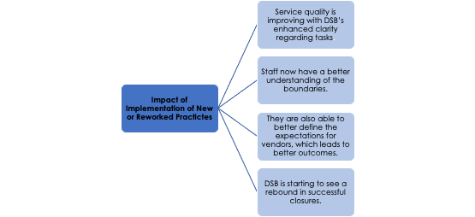

*Strengths & Challenges*

While providing TA, the following have been noted as promising practices and challenges:

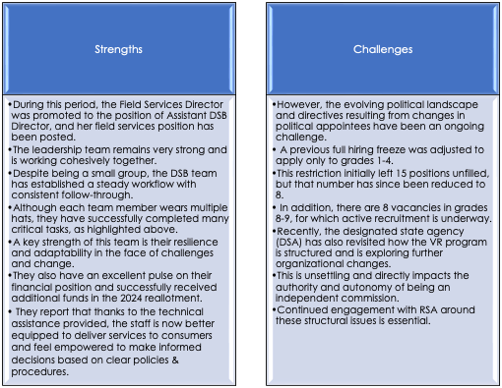

*Previous Collaborations*

The NTACT: C and the QE have all done work with the agency.

*Future Plans*

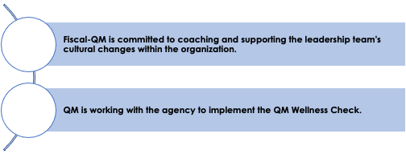

### Colorado Combined

Reason for TA Request

The agency initially reached out and discussed issues with significant turnover in the fiscal, contract, and budget teams within VR. They were still determining if they had the best practices to manage MOE, carry forward the RSA-17 reporting, and effective funds management. They were interested in pursuing a new CMS. Additionally, the SWAS was set up to do an automatic direct split of all payments with the 78.7/21.3% match applied to every purchase. They were interested in a new strategy that would let them better handle MOE and Match.

Interaction with the Agency

Until recently, the fiscal team met weekly with the Colorado state team to address fiscal activities, primarily focusing on the AWARE case management system. When the fiscal team began working with the state, the system was not correctly configured to manage the period of performance. To address this, all system settings and internal controls were thoroughly evaluated. Also, necessary system corrections were made to enable accurate tracking, recording, and reporting of the period of performance.

In addition, related staff processes and internal controls were reviewed to ensure the system is adequately supported throughout the federal fiscal year, preserving the integrity of the newly implemented controls. The agency also requested assistance with fiscal forecasting and identifying the key data elements required for informed financial decision-making. Initially, there was uncertainty regarding the state's non-federal share, but the fiscal team worked closely with the agency to clarify and establish balances. This information was essential in developing a spending plan for the year, leaving the agency better equipped to manage its finances.

The QM Fiscal Team was also onsite during the RSA 107 monitoring in January to provide support and consultation. Additionally, the relationship between the Designated State Agency (DSA) and Designated State Unit (DSU) has significantly improved. This is partly due to the efforts of a new DSA fiscal staff member who is eager to learn VR regulations and the Non-Delegable training provided by the VRTAC-QM Fiscal team.

During the discussion, the team shared their experiences using the wellness check tool. Kristin mentioned it was long and overwhelming, reflecting the program's complexity and responsibility. Augusta noted that while not all questions were included, it was beneficial to raise awareness about what needs to be done. She created a poll to gauge participant responses quietly, with minimal discussion.

Summary of the Areas in Need of Improvement

To ensure the agency maintains a strong financial foundation, efforts continue in implementing fiscal forecasting, establishing a spending strategy, and documenting fiscal policies & procedures that will withstand staff turnover. The ultimate goal is to achieve zero lapsing dollars by the final report of the grant year.

The agency began developing a new case management system (CMS) in FFY24, awarding the contract to MTX Group, Inc. The implementation is on an ambitious one-year timeline and will replace the existing Aware CMS. The VRTAC-QM fiscal team continues to stress the importance of ensuring that federal and state fiscal requirements are fully understood, as well as communicated to the vendor. This will further ensure proper management of the period of performance, which is an area where the current Aware system has been insufficient.

MTX’s grants management system, based in its Salesforce environment, is designed for discretionary grants. Both the agency and the vendor recognize that it is not equipped to handle the complexities of the VR grant. A rewrite will be necessary to achieve adequate financial management within the CMS. This awareness is crucial as the new CMS is developed to meet the agency’s specific needs.

Colorado fully expended its FFY23 award without returning or lapsing any grant funds. Additionally, the agency did not return any funds through reallotment in FFY24. Due to flat funding and the absence of an expected cost-of-living increase, the agency requested reallotment funds. A significant contributing factor to this request was associated with building a new case management system.

Policies and procedures are being drafted in real time to capture essential activities as they evolve. Fiscal forecasting is underway and continues to be refined. The fiscal team will provide ongoing support to the agency through helping them develop insights and utilize analysis/ data. This will encourage the agency to make informed and data-driven decisions.

Throughout the year, there have been a total of 43 technical assistance activities in the following areas:

* Allowability of Costs
* Assignment of Obligations
* CAP Responses
* CMS Fiscal
* Contracts
* DSA-DSU Relationship
* Fiscal Forecasting
* Federal Fiscal Reporting
* Indirect Cost
* Match/Maintenance of Effort
* Monitoring
* Policies, Procedures, and Internal Controls
* Period of Performance
* Pre-Employment Transition Services
* Prior Approval
* Purchasing
* Reallotment
* Sources of Match
* Training - Grants Management

The agency also actively participates in the monthly Fiscal Community of Practice meetings. Leadership regularly engages in discussions, frequently shares lessons learned, and demonstrates best practices to assist other agencies during the calls.

As a result of the TA, the agency has implemented or reworked practices in the following areas:

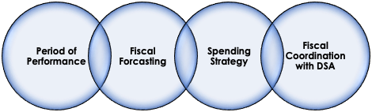

Results:

The impact of the newly implemented or revised policies on customers has not yet fully materialized. However, in the long term, with improved management of VR funds, Colorado will have the opportunity to enhance participant outcomes.

Strengths & Challenges

The leadership team is committed to doing this work. Despite having a small core team to do all the work, they are making many things happen.

While providing TA the following have been noted as promising practices:

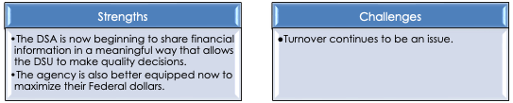

Previous Collaborations

QM completed the primary work.

Future Plans

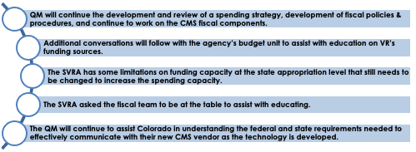

### Delaware Blind

Reason for TA Request

The agency received a Specific Conditions Letter from RSA and RSA requested to assist the state agency.

Interaction with the Agency

**Fiscal Summary**

DVI was required to correct federal financial reports for a designated period to establish financial position. Training was provided around requirements for Period of Performance to allow forensic accounting activities to be conducted and subsequent adjustments to be made to their financials. This included an evaluation of the state accounting system and case management system to identify efficiencies. Training was also provided on financial reporting elements, along with follow-up reviews of financial data prior to submission to RSA. The QM provided training on internal controls and the development of policies & procedures. QM is currently in more of a maintenance phase, ensuring the continued fiscal reporting is being done in a timely and accurate manner. We are also advising the agency with questions as they arise and have been supporting the team as they work through the centralization of fiscal staff. Upon completion of the VRTAC-QM Wellness Checker, DVI was excited to test the new tool, which will be used to evaluate the progress of the agency and identify further improvements.

During this period, a total of nine intensive technical assistance activities have been completed as the agency progresses toward the completion of the designated intensive tasks. The fiscal team has supported DVI with fiscal forecasting and monitoring efforts. The most significant interaction remains focused on their federal reporting process. We continue to provide support for their ongoing progress and the strengthening of internal controls to ensure accuracy, as well as timely submissions.

Summary of the Areas in Need of Improvement

The primary goal was to assist the agency in completing all necessary activities to achieve release from specific conditions and resolve their CAP findings. All necessary activities have been successfully accomplished. Significant progress has been made in ensuring the accurate and timely completion of federal financial reports. Additionally, the leadership team has demonstrated a notable improvement in their understanding of federal fiscal requirements and their application to the program's ongoing administration. This improvement is evident in the discussions during our monthly check-ins.

As a result of the TA, the agency has implemented or reworked practices in the following areas:



Strengths & Challenges

This team has been very responsive and coordinated since the beginning. The director's inclusion of core staff in all training and improvement activities has assisted in building expertise and a knowledge base that will survive any changeover in leadership.

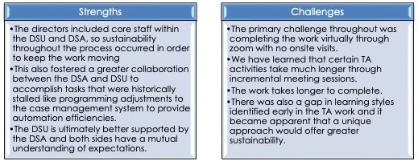

Previous Collaborations

Primary work completed by the QM.

Future Plans

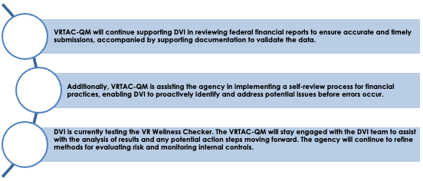

### Florida Blind

Reason for TA Request

Director Doyle reached out for assistance as Florida-B has been selected for monitoring by RSA three times in the past seven years, with monitoring that occurred in July 2023. He was looking for assistance in three main areas: monitoring preparation, completion of the previous CAP activities, and budgeting fiscal forecasting. Assistance required for completion of the CAP involved a review of procedures regarding payroll tracking that included tracking of time spent on pre-ets and a review of a rate-setting policy/procedure that was developed. The agency has also struggled with fiscal forecasting and understanding its fiscal position. The leadership team had essentially no access to concrete budget reports. They relinquished significant funds during reallotment and let funds lapse at the end of the grant for several years. The DSU primary fiscal staff was on extended leave and the agency needed help reviewing the limited financial reports to build the financial position. Additionally, Florida-B wants to improve the program's financial management, which results in reliable and accurate financial reporting, spending strategies, fiscal forecasting, written policies & procedures, and internal controls. They also needed assistance with improving the implementation of transition services and pre-ets, including the review/revision of policies/procedures, vendor contracts, fiscal & programmatic management, effective implementation of the state interagency agreement, and staff training.

Interaction with the Agency

Since October 2023, 27 interactions with Florida-Blind have occurred, including an intensive 3-day onsite visit in March 2024. This year's primary focus has been coordinating a plan to address the findings of the RSA monitoring report. During the onsite visit, a plan was developed to address each finding, and staff were assigned to complete each activity's required work. Significant progress was made on the Period of Performance procedure and the RSA 17 procedure was updated to include the new instructions for reports starting with the FFY24 grant. A new cash management procedure was developed due to monitoring the Florida- General program, and comments were sent back to the DSA for their response. The Business and Operations Manager also developed, as well as disseminated a monthly budget tracking report unveiled onsite in March. **The projection is that FL-B will completely spend down the FFY23 award,** and **no funds will be lapsed to the U.S. Treasury**. Staff updated the current spending plan, made assignments, and identified the next steps for carrying out each of the items identified in the document.

Florida Blind has been faced with an unusual situation where the legislature has given them less appropriation authority than what drawing down the full Federal award would take. In simpler terms, it's like having money in your bank account, but your state has not given you permission to withdraw or spend all of it. You need both the federal funds and state budget approval to fully use the grant. This results in them having match available, but they have to revert funds in reallotment. A total of $6 million was sent back during the 2024 reallotment period. Although extensive work was done to get additional appropriation authority, the request was eliminated from the final bill that passed during the legislative session. Brainstorming was done to consider a new strategy for next year’s ask, which includes looking at leveraging the Older Blind Program and the services provided by the transfer of program income to that program. This remains a high priority and focus.

The team developed a projected spending strategies spreadsheet that they would like to implement for both this FFY and in the future. The spending strategies were updated with details and next steps. Regular reporting occurs in the monthly check-ins to assess progress.

Over the summer, a collaboration between NTACT: C and the QM fiscal team resulted in a complete revamp of the pre-ets/transition contracts. The Florida-B team presented the proposed changes to both RSA and the CRP community. Final changes are being made and this will culminate in the completion of a major task listed within the CAP.

Summary of the Areas in Need of Improvement

Areas in the Corrective Action Plan include a complete revamp of the pre-ets/transition contracts, implementation of period of performance fixes within the CMS, development of fiscal policies & procedures, continued strategizing match possibilities, and seeking appropriation approval from the Legislature again.

As a result of the TA, the agency has implemented or reworked practices in the following areas:

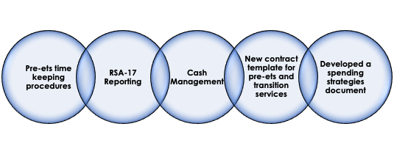

Results:

Although extensive work was done to get additional appropriation authority, the request was eliminated from the final bill that passed during the legislative session. Brainstorming was done to consider a new strategy for next year’s ask, which includes looking at leveraging the Older Blind Program and the services provided by the transfer of program income to that program. The spending strategies were updated with details and next steps. Regular reporting will occur in the monthly check ins to assess progress.

Strengths & Challenges

The Florida-B staff have been eager and very engaged. Significant progress has been made in all the areas of focus.

While providing TA the following have been noted as promising practices and challenges:

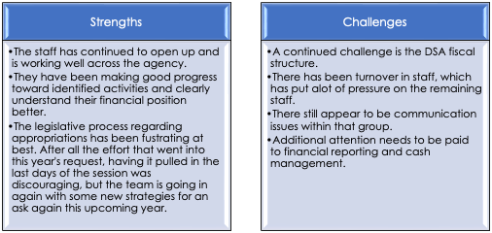

Previous Collaborations

VRTAC-QM is working hand in glove with the NTACT: C to tackle the pre-ets issues, which is going extremely well.

Future Plans

The QM and NTACT: C team will continue to work with the agency through identified work plan items, including completion of policy & procedure development for grants management, implementing a comprehensive fiscal plan & spending strategies, and completion of improvements to the AWARE CMS to comply with the period of performance.

### Florida General

Reason for TA Request

The agency is interested in analyzing its data to identify the factors that contribute to high-quality VR outcomes. The intent is to develop/ implement strategies and practices that enhance these outcomes. Additionally, the agency aims to increase field staff involvement in decision-making processes and ensure that staff performance evaluations are aligned with the performance indicators set forth by the Workforce Innovation and Opportunity Act (WIOA).

Interaction with the Agency

Engagement with the agency has occurred through regularly scheduled Zoom meetings, along with various ad hoc interactions via Zoom, email, and phone calls. Given the nature of the ITAA activities, on-site interactions have not been necessary to date.

The agency’s ITAA has identified five technical assistance (TA) activities aimed at enhancing program and performance areas. The following list outlines these TA activities along with their current progress (% complete):

Technical Assistance Activities:

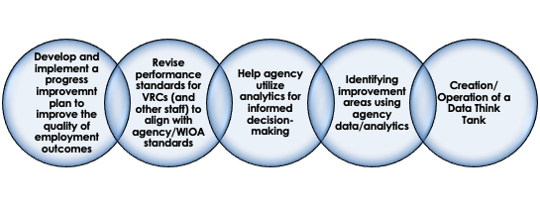

Completion Performance Progress (%) of Activities:

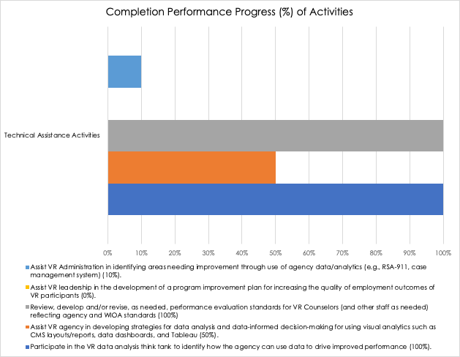

During the reporting period, the ITAA activities were re-prioritized based on the agency's interests and capacity. As a result of the sporadic nature of the ITAA activity, “identifying areas needing improvement through the use of agency data and analytics,” will be provided on a targeted basis moving forward. This will be based on mutual agreement and level of need.

Summary of the Areas in Need of Improvement

The TA is intended to impact and improve the quality of employment outcomes for VR participants. This will be accomplished by utilizing data reports and analytics to drive/improve decisions impacting outcomes. This will be measured by comparing year-to-year quality outcome indicators (wage, hours, benefits) and other key data points defined by the agency.

As a result of the TA, the agency has implemented or reworked practices in the following areas:

|  |  |
| --- | --- |
| Area of Improvement | Objectives |
| Implemented a cross-functional “Data Think Tank” team to inform and advance the use of data/analytics as an agency priority | * + Engage with field staff to assess and identify their level of data use, its purpose, and gaps in driving decisions/managing performance.   + Develop and implement strategies/practices, which promote data literacy/use as an essential skill agency-wide to improve performance.   + Review, analyze, and recommend key data elements, as well as management reports/tools to assist in monitoring progress toward unit/area/agency goals and identify targeted support needs.   + Review, analyze, identify services, practices, and other factors positively impacting performance outcomes. |
| The agency is developing strategies for data analysis and data-informed decision-making for using visual analytics such as CMS layouts/reports, data dashboards, and Tableau. | * + Review, analyze, identify services, practices, and other factors positively impacting performance outcomes using the quarterly RSA Data Dashboard.   + Review, analyze, and act on insights gained using the Timeliness & Rapid Engagement Tool.   + Review, analyze, and act on insights gained using the Performance Forecasting Tool.   + Identify, create, and disseminate high value reports using Tableau and/or Aware. |
| The agency has updated the VRC performance evaluation standards to increase alignment with WIOA performance indicators. TA and guidance have aided this endeavor | * Provide VRC performance content standards aligned with WIOA for agency consideration. * Review and provide comments on all proposed versions of the revised VRS performance evaluation standards. |

To date the team has engaged in the following activities:

|  |  |
| --- | --- |
| **Activity** | **Completion Status** |
| Comprehensive review and improvement recommendations for all internal performance management data reports. |  |
| Initial strategy development on methodology to assess data literacy agency wide. |  |
| Initial strategy development on accessing provider effectiveness on customer outcomes agency wide. The agency has contracted for the creation of a web-based dashboard. TA will be provided as requested. |  |
| Provided input on the development and implementation of the new VRC performance evaluation standards. The agency is piloting the new standards. |  |
| Provided input on the initial work plan for the agency’s “MyJourney” (web-based career & training planning tool) project. This project planned to kick off fully in ’24. TA will be provided as requested. |  |
| Incomplete: Develop and implement a program improvement plan to improve the quality of employment outcomes for VR participants TA activity. |  |

Results:

Progress is ongoing but has not yet reached a stage where its impact on the customers served can be assessed.

Strengths & Challenges

While providing TA the following have been noted as promising practices and challenges:

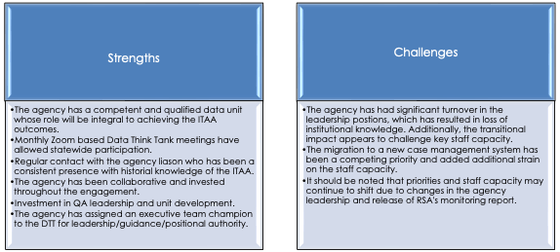

Previous Collaborations

N/A.

Future Plans

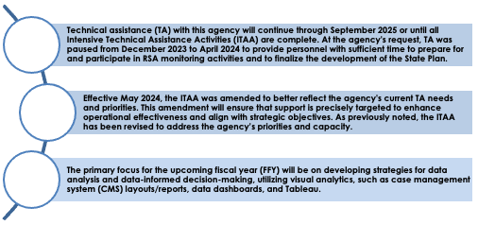

### Georgia Combined

Reason for TA Request

Georgia Vocational Rehabilitation Agency (GVRA) sought VRTAC-QM assistance and presence during their RSA monitoring in March 2023. The monitoring process revealed various needs, including the identification of staff training needs, revision/development of policies to reduce restrictions on VR participants in accessing services/funding, enhancement of performance accountability understanding, development of internal controls for the WIOA performance accountability system, alignment of the agency's case management system data collection process with WIOA performance indicators to improve reporting accuracy, integration of performance accountability into staff evaluations, identification of areas for improvement in local transition activities statewide, development of forecasting for the 15% Pre-ETS reserve, provision of staff training on allowable costs, tracking, and reporting.

Interaction with the Agency

VRTAC-QM has provided a blend of onsite meetings, in addition to numerous virtual meetings, and emails to provide support for various activities. Specifically, VRTAC-QM aided GVRA in conducting a statewide training needs assessment survey/generating a report, presenting insights into specific training needs and feedback from staff. The team also reviewed numerous policies & procedures, offering feedback and technical consultation. VRTAC-QM conducted training sessions on understanding the correlation between the Case Management System and data reporting, along with methods to streamline processes for enhanced data accuracy. Collaboratively with NTACT:C, VRTAC-QM provided technical assistance in developing a fiscal forecast, drawing on examples from other states. The teams also assisted the GVRA team with consultation on understanding allowable costs and authorized activities for Pre-ETS spending. GVRA has formulated a fiscal forecasting plan and is currently in the process of finalizing Standard Operating Procedures to align with the assistance provided. In addition, GVRA has implemented changes in staff time recording, as well as training to allocate the allowable costs for Pre-ETS activities.

In February, VRTAC-QM partnered with GVRA to provide a two-day, onsite training for supervisors and district managers to address various topics identified in the needs assessment or as an agency expressed need. In addition, VRTAC-QM has been working with the team to develop a Performance Accountability policy & procedures, which will include WIOA performance, RSA-911, and validation policy & procedures. As part of this development, VRTAC-QM has been working alongside their program analytics team to assist in analyzing their ability to accurately report performance data. The team identified some revisions that can increase accuracy, streamline processes, and provide potential long-term savings with data exchange agreements (by filtering current data set requested for wages, to only the data set needed for post exit measures). In addition, the team began additional validation activities, which has increased their understanding of how the data is reported on the RSA-911. VRTAC-QM and NTACT:C have also been partnering with GVRA to assist in identifying spending strategies to increase spending, including Pre-ETS spending and authorized activities. In addition, VRTAC-QM provided technical consultation to assist the agency in revising internal data reports, which increased visibility to timeliness needs. GVRA developed a strategic plan which helped them achieve timeliness for both IPE and eligibility and has recently implemented an intake unit to assist.

The agency’s ITAA identified 16 technical assistance (TA) activities targeting program and performance areas. The TA activities and progress (% complete) are listed below:

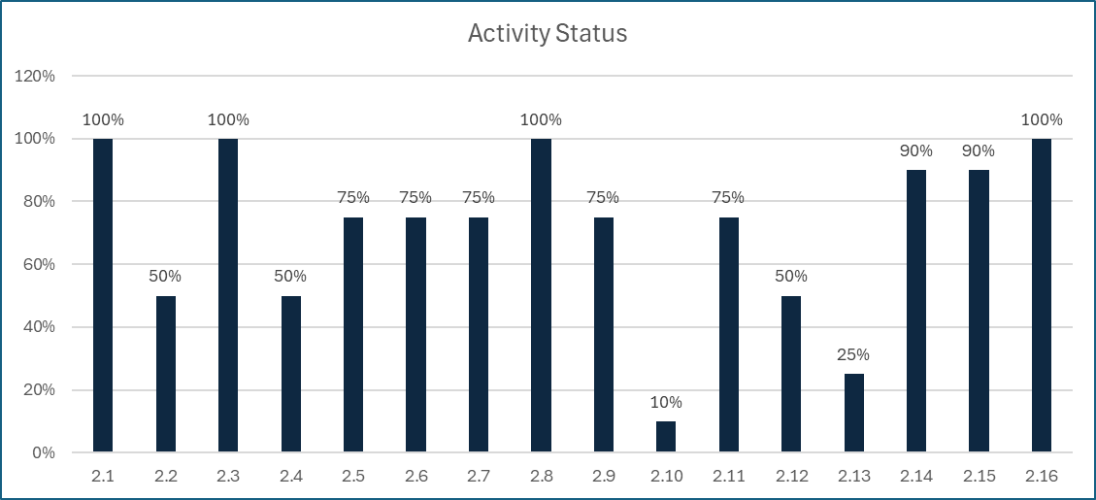

Activity breakdown:

* Training
  + 2.1-Conduct a staff training needs assessment, including a report with staff training needs identified for different job classifications.
  + 2.2-Analyze GVRA ability to effectively train and evaluate staff (i.e., current processes, identify gaps, develop plan); includes a completed assessment with implementation strategies and timelines necessary to improve training/ evaluation of staff.
  + 2.3-Review, revise, and/or develop policies & procedures related to GVRA training plan/implementation. This includes completed reviews and draft/revisions with recommendations for GVRA training/implementation.
* Performance
  + 2.4-Review, develop and/or revise, as needed, policies & procedures for the WIOA Performance Accountability System.
  + 2.5-Review, develop, and/or revise, as needed, written internal controls necessary for the WIOA Performance Accountability System.
  + 2.6-Assist VR Agency’s data/case management system and program staff to develop/revise data collection processes for the WIOA Performance Indicators.
  + 2.7-Provide staff training on performance indicators, education/training programs for Credential Attainment/Measurable Skill Gains, tracking/reporting, documentation requirements, data, sanctions, and negotiations of the WIOA Performance Accountability System.
* VR Regulations and Process
  + 2.8-Review, develop, and/or revise, as needed, policies & procedures.
  + 2.9-Review, develop and/or revise, as needed, written internal controls.
  + 2.10-Review, develop and/or revise, as needed, performance evaluation standards for VR Counselors & Supervisors.
  + 2.11-Analyze VR agency’s ability to accurately track and report VR requirements in the RSA-911 for post exit data.
* Pre-Employment Transition Services
* 2.12-Assist GVRA in identifying areas needing improvement and/or impact of state/local transition practices and activities through use of agency data/analytics, including a completed plan and implementation needs.
* 2.13-Provide TA regarding funding (activities/positions) between State Education Agency and State VR Agency to support the (1) implementation of the Interagency Agreement (MOU) and services to students with disabilities, (2) using the 15% reserve; forecasting includes recommended contract/agreement.
* 2.14-Review, and/or revise, as appropriate, Pre-ETS fiscal forecasting and written processes, in order to move from required and coordination activities to authorized activities.
* 2.15-Review Agency's process for provision of Pre-ETS services/allocation of costs to the reserve for RSA-17 reporting and provide TA/recommendations to assist the agency in meeting the minimum 15% reservation/expenditure of funds for Pre-ETS.
* 2.16-Provide staff training on allocation of allowable costs (including tracking and reporting).

Summary of the Areas in Need of Improvement

The impact of the work will be evident through various lenses, encompassing the perspectives of VR staff, VR participants, and observable changes in performance data/spending. Here are key indicators of the impact:

|  |  |
| --- | --- |
| **Indicators of Impact** | **Indicator Details** |
| Less Restrictive Policies | * Specifically, removing ‘needs assessments’ to increase service funds to participants. * This will be measured by staff feedback, an increase in service spending for participants, specifically for training services, and anticipation of positive participant feedback. |
| Training | * Analysis of staff training needs, providing staff training, and monitoring of agency performance data. |
| Increased Understanding of Performance Reporting within the Case Management System | * Understanding data, how to measure, and monitor performance. * This will be measured by the development of performance reports, internal monitoring, and increased streamlining of processes to improve services. |
| Improved Policies, Procedures, & Training | * This will provide staff with guidance in serving participants * The result will be a better understanding of policies & procedures, anticipation of positive staff feedback, and improved staff retention. * This will be measured by internal controls, validation, and retention. |
| Increased Spending | * Increase in Pre-ETS spending * Increase in ability to monitor spending * Increase in ability to project, forecast, and plan for future spending. * This will be monitored throughout the federal fiscal year to meet forecast spending needs. |

These activities address many challenges nationally which include: accuracy, reliability, and validity of data, the need to increase performance, staff retention, increased spending for VR participant services, increase in training services to lead to better paying high quality employment, and increase in Pre-ETS spending/services for pre-employment transition students. Through these initiatives, we contribute to positive transformations on multiple fronts within the VR landscape.

Strengths & Challenges

While providing TA, the following have been noted as promising practices and challenges: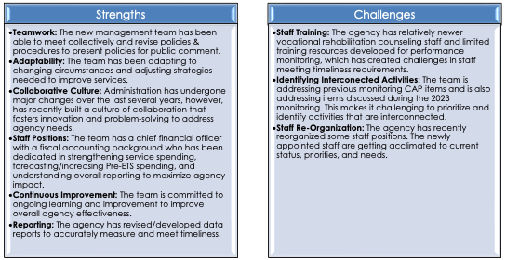

Previous Collaborations

VRTAC-QM and NTACT:C developed a joint ITAA plan to assist GVRA in performance and Pre-ETS related needs. Although the VRTAC-QM is leading the ITAA plan and coordinating activities, the two teams are working closely collaborating with GVRA, meeting at a minimum of monthly, if not more frequently to support GVRA. NTACT:C and VRTAC-QM have provided braided consultation regarding Pre-ETS services and spending with utilizing fund sources within the case management system to streamline processes to indicate these services.

Future Plans

VRTAC-QM will continue to collaborate with NTACT:C to support GVRA through the items identified in the workplan and on the ITAA. Specific activities in the near future include:

**Support GVRA in finalizing Performance Accountability policy and procedures.**

**Support GVRA in finalizing Data Validation policy and procedures.**

**Support GVRA in drafting internal controls**

**VRTAC-QM and NTACT:C will work collaboratively in helping GVRA finalize their Pre-ETS fiscal forecasting and Standard Operating Procedures.**

### Hawaii Combined

Reason for TA Request

Hawaii-VR initially contacted the VRTAC-QM due to their need for technical assistance (TA) and training. This stemmed from their 2019 RSA monitoring report and resulting corrective action plan (CAP). The ITAA is focused on Fiscal & Resource Quality Management, as well as Program & Performance Management.

Interaction with the Agency

Our team has been collaborating with DVR staff through a mix of onsite and virtual meetings. In February 2024, VRTAC-QM and NTACT:C jointly provided onsite technical assistance and training. The technical assistance was aimed at optimizing the Pre-ETS process in the case management system and establishing clear documentation practices for field staff to ensure precise reporting. In addition, technical assistance also focused on aligning processes with federal regulations regarding providing Pre-ETS services to students with disabilities with a VR plan, engagement, which included ongoing and rapid engagement by examining DVR’s existing data landscape, and refining processes, particularly in referrals, applications, eligibility, and prioritization of disabilities to enhance timeliness/quality of services.

Additionally, comprehensive staff training on the Pre-ETS processes within the case management system, MSG/Credentials, and documentation methods, as well as on rapid engagement strategies, including analyzing current rapid engagement data, was conducted in collaboration by VRTAC-QM, NTACT:C, and DVR.

Notably, previous training was provided onsite for all DVR staff on timely eligibility determinations and IPE development, which also included early discussions on rapid engagement. In addition, TA on the SEA agreement, assistance with policies & procedures revision, and internal controls development has been provided.

For the fiscal focused activities, the VRTAC-QM provided 18 onsite and virtual technical assistance sessions during this reporting period. These sessions covered fiscal forecasting, reallotment, maintenance of effort, fiscal reporting, match, and tracking of expenditures. Written policies, procedures, and internal controls specific to the fiscal activities have been an integral part of each discussion, as well as the work being done. Hawaii continues to make progress in capturing their processes and internal controls in a written format.

Hawaii has made progress in resolving their correction action plan (CAP) from their 2019 RSA monitoring. During this reporting period, Hawaii has resolved five of the nine findings and 22 of the 27 corrective actions. Specific to their fiscal corrective actions, Hawaii resolved 4.1.4, which required correction of financial reporting. The outstanding findings and corrective actions related to fiscal are directly correlated to their written policies, procedures, and internal controls. Hawaii continues to develop a comprehensive Grants Management Manual that will address the remaining monitoring issues.

There have been numerous Technical Assistance activities provided through virtual meetings and emails on specific fiscal topics:

* Prior approval
* Unliquidated obligation
* Purchasing allowances
* Grant Tracking
* Randolph Sheppard purchasing threshold
* MOE
* Fiscal Forecasting
* Reallocation
* Financial Reporting

Summary of the Areas in Need of Improvement

Performance- VRTAC-QM continues to assist DVR in identifying and addressing areas for program improvement. Although great progress has been made the team continues to work on re-defining their roles and responsibilities. The recent appointments of a permanent director and associate director have facilitated alignment within the administration team, directing their efforts towards shared agency objectives.

Fiscal - VRTAC-QM wants to ensure the Hawaii fiscal policies and procedures, as well as internal controls are documented in a manner so turnover in staff does not impact the program’s ability to carry out the required grants management duties according to Federal regulatory requirements. The agency temporarily assigned an internal employee to the fiscal position that is located on the DSU side, who serves as a bridge between the DSU and DSA. This individual has been moved into permanent status, which will provide consistency for the agency long term.

The level of fiscal understanding has increased with greater collaboration between the DSA and the DSU. The newly permanent fiscal administrator has a solid understanding of the financial position of the Agency and is working towards completion of the Corrective Action Plan findings. Several solutions have been submitted and are pending a response from RSA. During the most recent onsite visit, the creation of the Grant Management Manual, which is a large requirement to close the fiscal portion of the Corrective Action Plan, is now in draft form. This manual requires the consolidation of other policies & procedures into one new document.

During the most recent reallocation period, Hawaii strategically returned a large portion of their FFY24 grant to RSA in order to ‘right-size’ their grant and get spending more inline with the period of performance requirements. This adjustment ensures that the FFY23 grant is fully expended without lapsing funds, the FFY24 grant will be spent more inline with the Year of Appropriation, and the FFY25 grant award will be managed more effectively.

The team checks in bi- monthly with Hawaii and assesses completion of the ITAA workplan activities. All Federal reports were corrected (4.1.4 & 4.2.4), submitted to RSA, and accepted by RSA. By having the foundational fiscal knowledge and understanding, the DVR leadership is better able to evaluate service delivery opportunities/efficiencies. Additionally, by providing foundational training to the DSA, the VR Administrator is better able to understand and maintain control of the allocation/expenditure of VR funds.

As a result of the TA, the agency has implemented or reworked practices in the following areas:

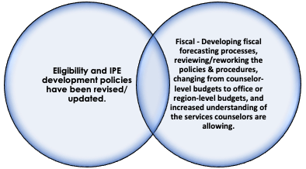

Results:

**Impact of Implementation of New Reworked Practices on Customers**

Eligibility timeframes have been reduced so that the agency has resolved their CAP finding in this area. They have had six months of more than 90% of all applicants being found eligible within the 60 day timeframe.

Fiscal - Fewer limits on the amounts and types of services being provided, since funds are not limited.

Strengths & Challenges

The training seems to have worked well in conjunction with other monitoring efforts for eligibility determinations and IPE developments by the agency. Hawaii staff vacancies have been an overall challenge for effective Technical Assistance. The culture of the organization continues to be a challenge with staff turnover, and a history of temporary personnel assignments, but staff vacancies continue to decline. In addition, the organization culture is shifting to a more productive and supportive environment. The Administrator (VR Director) has successfully placed a permanent fiscal administrator within the DSU, which will assist tremendously with the communication that must occur between the DSA and DSU specific to fiscal activities.

While providing TA the following have been noted as promising practices and challenges:

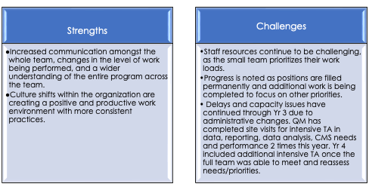

Previous Collaborations

The QM Team collaborated with the NTACT-C to focus on Pre-ETS improvements, including the SEA agreement. Additionally, providing significant TA related to tracking and reporting of SWD and Pre-ETS.

Future Plans

**The QM team will continue to work on the activities within the ITAA and workplan and assist the agency with program improvement.**

**The Fiscal Management activities will continue to focus on completion of the Grants Management Manual and incorporating internal controls within their processes.**

### Idaho General

Reason for TA Request

Idaho General entered into an intensive technical assistance agreement (ITAA) with VRTAC-QM in June 2024 due to a Specific Conditions Letter from RSA. Within the letter, RSA requested VRTAC-QM assistance on Fiscal and Resource management. The agency has gone through several fiscal officers in the last few years and is in need of intensive training related to VR fiscal requirements.

Interaction with the Agency

Idaho-G has had weekly meetings with the VRTAC-QM fiscal and resource management team since implementing the ITAA. Meetings occurred virtually 24 times during the last 4 months of the review period. In addition, the fiscal and resource management team participated in the bi-weekly meetings between Idaho and RSA. The recurring meetings focus on the corrective action plan in response to the specific conditions letter and management of their grant award. Prior to the Specific Conditions Letter, one on one training was provided for the new Fiscal Officer to help acclimate her to the Vocational Rehabilitation requirements for grant tracking. Following the Specific Conditions letter, this training was expanded to include requirements for Period of Performance and the Fiscal Basics for both central office administrators and direct field service staff. In addition, we are providing the team with support and advising the agency with questions as they come up, while they implement an order of selection closing all categories.

Summary of the Areas in Need of Improvement

The priority of the agency is to address the specific conditions through the corrective action plan and resolve the fiscal issue. Idaho has completed forensic accounting to establish the fiscal status of the agency. All priority categories were closed through an order of selection and efforts continue to address grant management deficits in tracking of obligations, adhering to the period of performance and correct financial reporting. Idaho is also reviewing and addressing shortfalls in the statewide accounting system. In addition, the case management system is prohibiting the proper tracking/reporting of both obligations and expenditures. RSA provided a $10 million supplement with a required non-federal match of 21.3% to support the services on approved Individualized Plans for Employment (IPE) and competitive integrated employment goals for individuals with disabilities.

The VRTAC-QM Fiscal team is helping the agency:

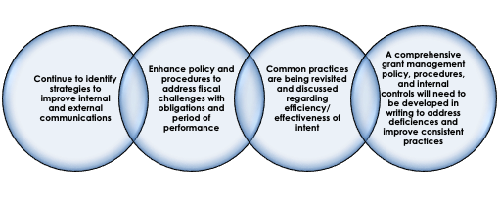

Strengths & Challenges

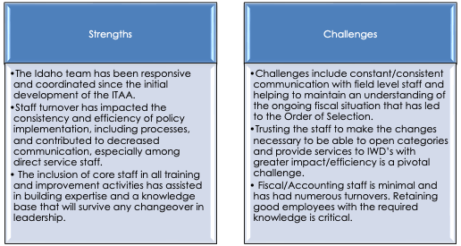

Previous Collaborations

Primary work completed by the VRTAC-QM.

Future Plans

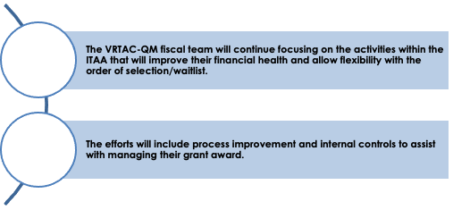

### Kansas Combined

Reason for TA Request

The agency requested intensive technical assistance (ITAA) because of difficulty in managing their data, case management system, and policies around the WIOA performance accountability system. Specifically, they were performing with a 0% MSG rate and knew their participants were actively achieving these gains.

Interaction with the Agency

KRS has been a very active participant in their ITAA. All of the activities have been completed and the agency has made steady progress in all areas. The ITAA is completed and all activity is at the targeted level at this point.

We continue to monitor their short-term and long-term outcomes.

Summary of the Areas in Need of Improvement

As a result of the TA, the agency has implemented or reworked practices in the following areas:

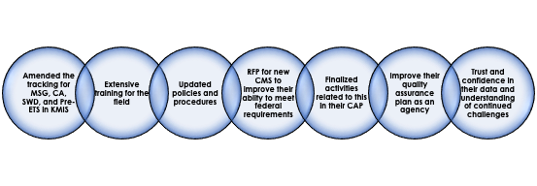

Results:

**Impact of Implementation of New Reworked Practices on Customers**

An understanding of the functionality (pros and cons) of their current CMS (KMIS), the RSA-911 and WIOA Annual report requirements, as well as making data-informed decisions.

Policy and training have improved in this area, as well as data validation and internal controls at the administrative level.

Agency is starting to move to program improvement.

Strengths & Challenges

While providing TA the following have been noted as promising practices and challenges:

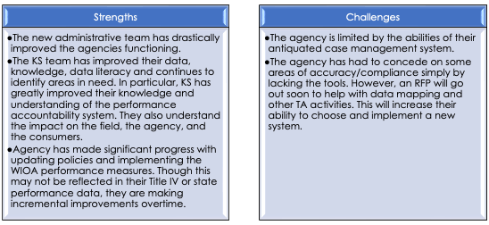

Previous Collaborations

TA was provided to this agency in collaboration with NTACT:C. This joint effort has improved the accuracy of their SWD and Pre-ETS tracking/ reporting, data analysis, and implementation of the NOI flexibilities.

Future Plans

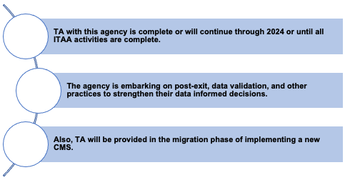

### Kentucky Combined

Reason for TA Request

Kentucky-C reached out to VRTAC-QM in January 2022 following their RSA monitoring in 2021. The agency requested intensive technical assistance with fiscal & resource management, as well as program & performance.

The fiscal and resource management technical assistance (TA) was specific to centralized fiscal management at the designated state agency level. Target areas requested by the agency include:

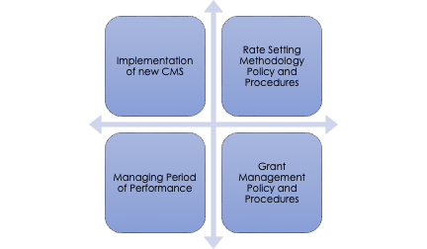

For program and performance technical assistance, the agency requested support in four areas: 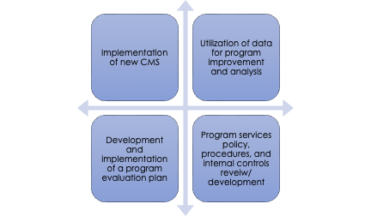

Interaction with the Agency

For fiscal - During this reporting period, the VRTAC-QM supported KY-C with 30 Intensive and Targeted activities combined through virtual meetings. The topics included period of performance and when an obligation is made, as well as CMS recommendations for new conversion. Assistance was also provided on managing the period of performance in their current legacy system and providing input on work-around options, due to significant delays in implementing their new CMS. The Rate Setting Methodology policy, procedures, and internal controls were approved by RSA, which resulted in this specific CAP finding being resolved. KY-C also received approval from RSA on their prior approval policy, procedures, and internal controls. In addition, monthly ITAA check-ins occurred with leadership for ongoing progress updates.

KY-C ITAA included 3 activities targeting fiscal and resource management areas and includes:

|  |  |
| --- | --- |
| **ITAA Activities** | **Progress (% complete)** |
| Provide TA and training to develop the VR agency’s capacity to correctly manage the period of performance. | 50% |
| Review, develop and/or revise, as needed, written internal controls for managing the grant. | 100% |
| Assist agency to establish a method and policy for rate setting, as well as evaluating the performance of service providers. | 100% |

The remaining ITAA activity is specific to implementation of a new Case Management System and correctly managing the period of performance. Delays from the CMS vendor in development of the fiscal components resulted in the VRTAC-QM assisting with development of a work around in their legacy system.

For program and performance – Engagement with the agency has been through recurring scheduled (Zoom) meetings and various ad hoc engagements via Zoom, emails, and phone calls. Additionally, a site visit was held at the Perkins and McDowell Centers to complete the following:

* + Performance Accountability training for leadership/staff.
  + Assist in analyzing data for WIOA performance indicators, focusing on credential attainment and measurable skill gains.
  + Aiding leadership in program improvement and data-driven decision-making strategies.

As a result, the agency received a report containing an analysis and recommendations to identify/address inaccuracies in center-based performance reporting. Additionally, a data mapping activity was completed to ensure CMS data fields are accurately aligned with the corresponding RSA-911 data elements. Further recommendations were provided to refine the current CMS and reduce field-level data entry errors. With the transition to a new CMS in mind, implementation of these recommendations remains at the agency’s discretion. Additionally, technical assistance has been focused on providing the agency with various resources to finalize its policies and procedures on performance accountability. Resources and information were also shared to help the agency assess the value of data matching for measurable skill gains and credential attainment using education clearinghouses. Support for strengthening internal controls led to the implementation of a new case file review process, which is now being refined to resolve an RSA corrective action.

The agency’s ITAA identified nine technical assistance (TA) activities targeting program and performance areas.

The TA activities and progress (% complete) are outlined below:

|  |
| --- |
| 1. Assist with Case Management System (CMS) conversion. |
| 1. Analyze ability to accurately track and report the RSA-911 in the current and future case management systems. |
| 1. Review, develop, and/or revise, as needed, policies & procedures to align with WIOA Performance Accountability System. |
| 1. Review, develop, and/or revise, as needed, performance evaluation standards for VR Counselors. |
| 1. WIOA performance accountability training. |
| 1. Analyze capacity to track and report data for WIOA Performance Indicators specific to the Perkins Center and McDowell Center, with a focus on Credential Attainment/Measurable Skills Gains. |
| 1. Assist in developing a program improvement plan for training leading to CA/MSG at Perkins & McDowell centers. |
| 1. Assist in developing strategies for data analysis/decision making for the Perkins & McDowell Centers. |
| 1. Assist KY-OVR with development and review of program services internal controls. |

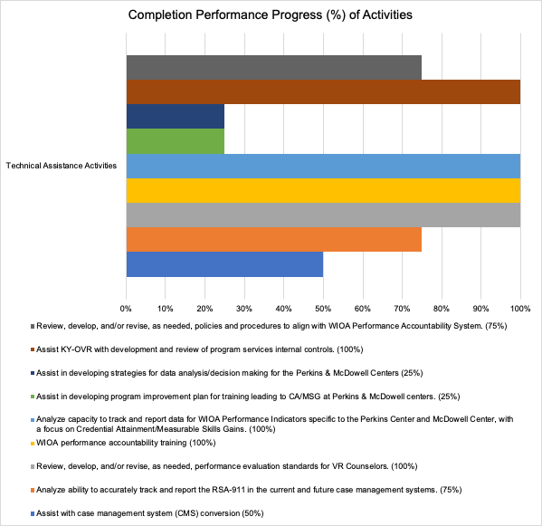

Summary of the Areas in Need of Improvement

For fiscal - KY-C continues to develop written fiscal policies/procedures/internal controls that will ensure continuity of completion of critical grants management functions as staff come and go. This is done by having thorough written documentation that can be used by any new person coming in the door. This ensures that the agency is operating with up-to-date policies and procedures that are reflective of Federal regulatory requirements and written in a spirit that is focused on achieving CIE for customers. By having the foundational fiscal knowledge and understanding, the DVR leadership is better able to evaluate service delivery opportunities and efficiencies. Additionally, by providing foundational training to the DSA, the VR Director is better able to maintain control of the allocation and expenditure of VR funds.

The current most critical work ahead for KY-C is implementation of a new CMS. The CMS Vendor has not met the deliverables outlined in the contract. The agency continues to provide regulatory requirements for the fiscal components and processes needed within the new CMS. TA will continue on a targeted basis with the agency, as they continue to work through the fiscal components needed in CMS to satisfy the federal requirements specific to period of performance, obligations and liquidations, as well as reporting.

For program and performance:

| **Indicators of Impact** | **Indicator Details** |
| --- | --- |
| * The TA is intended to impact the agency’s ability to successfully report accurate/valid data related to RSA-911 quarterly reports and WIOA Annual Report. | * + To be measured by comparing the result of reports against the previous year’s actual numbers and/or rates. |
| * The TA is intended to impact improvements in the area of program evaluation. | * + To be measured by comparing the case file reviews and other program evaluation activities.   + These activities will be compared against the previous year’s actual numbers and/or rates. |

As a result of the TA, the agency has implemented or reworked practices in the following areas:

|  |
| --- |
| * **The agency’s case file review process, including policy & procedures, has been revised to ensure compliance with performance accountability and regulatory requirements.** |
| * **The VRC performance evaluation has been updated to better align with WIOA standards.** |
| * **Comprehensive performance accountability training has been provided for all staff.** |
| * **Policies & procedures have been developed or revised to ensure the timely, valid, and accurate submission of the RSA-911/ETA 9169 reports.** |
| * **Policies & procedures related to WIOA Performance Accountability are in the final phase of development.** |
| * **The agency has been provided with the Performance Forecasting Tool and the Timeliness & Rapid Engagement Tool to support data-driven decision-making.** |
| * **Additional policy & procedure resources have been shared upon request.** |
| * **Recommendations and data mapping provided to evaluate options for improving the current CMS fields, coding, as well as naming conventions impacting accuracy of center-based reporting of CA/MSG.** |
| * **The remaining areas needing improvement include completing all activities related to the center-based programs' use of data and performance reporting for CA and MSG. Additionally, due to delays in the CMS conversion and the resulting impact on technical assistance, activities focused on the new CMS will be provided on a targeted or as-requested basis in PY’ 24.** |

Results:

During this reporting period, KY-C has resolved all corrective action plans with the exception of two partially resolved.

|  |  |  |
| --- | --- | --- |
| **Finding #** | **Past Quarter Status** | **Current Quarter Status** |
| 2.1.1 | Partially Resolved | Partially Resolved |
| 2.1.2 | Partially Resolved | Resolved |
| 2.1.3 | Partially Resolved | Partially Resolved |
| 2.1.4 | Resolved | Resolved |
| 2.2.1 | Resolved | Resolved |
| 2.2.2 | Resolved | Resolved |
| 3.1.1 | Resolved | Resolved |
| 3.1.2 | Resolved | Resolved |
| 3.2.1 | Resolved | Resolved |
| 3.2.2 | Partially Resolved | Resolved |

Corrective action 2.1.1 involves internal controls specific to case service record reviews and 2.1.3, which speaks to internal control policies, as well as procedures to ensure compliance/ accurate reporting of data elements submitted through the RSA-911 report.

Strengths & Challenges

For fiscal - The KY-C leadership team is committed to doing the work. Staff are pleasant to work with and ask diligent questions to assure they understand the requirements. The pace of staff completing various activities within the ITAA workplan often delays the target dates, but the QM staff continue to be available when they are ready to move forward with a specific activity. The fiscal activities have moved to a targeted approach since one activity remains incomplete.

For program and performance - While providing TA the following have been noted as promising practices and challenges:

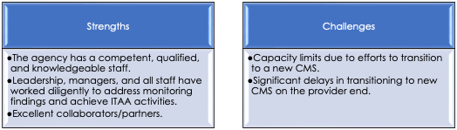

Previous Collaborations

The primary work was completed by QM.

Future Plans

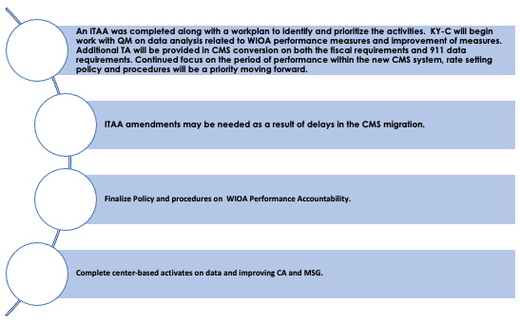

### Maryland Combined

Reason for TA Request

The agency contacted us as they were interested in building a data analysis tool like the one we used for Florida Blind. Maryland was specifically interested in examining outcomes by CRPs by Region.

Interaction with the Agency

Currently, the data analysis piece of the work has been put on hold, as the agency has experienced significant leadership changes. In October of 2024, the agency hired a new VR Director. After the VR Director gets settled in, the plan is to reach out to their leadership to see when they intend to resume the analysis portion of the TA or if they would like to suspend this activity.

However, the primary activity through the end of Year 2 was the development of the database and the scrubbing of existing data. This was a monumental task that required significant hours by Maryland staff and Chris Smith of the VRTAC-QM. This was accomplished and data analysis began at the end of Year 2. The final tool is currently in BETA release, but due to the current leadership changes this is currently on hold.

Summary of the Areas in Need of Improvement

|  |  |
| --- | --- |
| **Indicators of Impact** | **Indicator Details** |
| The intended impact of the work is to help DORS use its data to make informed decisions about the purchase of services for consumers and to identify effective services that lead to high quality outcomes. | * One of the early outcomes is that the agency identified multiple areas where their data was not valid or accurate. * The “cleaning” process has helped get the agency to a place where it can trust its data and begin the process of analyzing it with confidence that what they are seeing is a good reflection of the truth. * The agency was able to use the tool to determine that the expenditures they were making on formal vocational evaluation was not positively impacting outcomes for customers. * Consequently, they reassigned their VE staff to become an intake and eligibility unit. * This has helped alleviate some work from counselors and allowed them to spend more time counseling with clients * In addition, it has sped up the average eligibility determination time frames according to DORS. |

Results:

The results of the impact of the above refocusing efforts have yet to be measured.

Strengths & Challenges

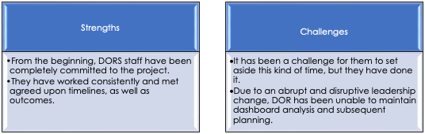

Previous Collaborations

N/A.

Future Plans

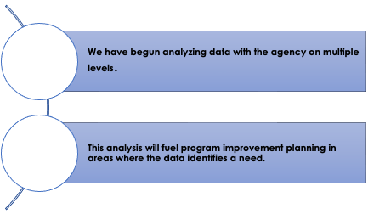

### Montana Combined

Reason for TA Request

The agency requested intensive technical assistance (ITAA) for several main reasons. It experienced difficulty managing its data, a challenging transition to a new case management system, and internal controls around the WIOA performance accountability system.

On the fiscal side, Montana initially contacted the VRTAC-QM due to their need for technical assistance (TA) and training. This stemmed from their RSA monitoring report and resulting corrective action plan (CAP).

Interaction with the Agency

The agency’s ITAA identified seven technical assistance (TA) activities targeting program and performance areas and three targeting fiscal operations. The TA activities and progress (% complete) are listed below:

Activity Breakdown:

* CE and Training
  + 2.1 Assist VRBS and community partners to establish and sustain CE as an Employment First system option for individuals with the most significant disabilities in Montana.
  + 2.2 Conduct staff training on eligibility determinations and IPE development for VRBS staff
* Performance
  + 2.5 Analyze VR agency readiness and capacity to track and report data for (i.e., RSA-911 and supporting documentation) the WIOA Performance Indicators
  + 2.6 Review, develop and/or revise, as needed, written internal controls necessary for the WIOA Performance Accountability System
  + 2.7 Assist VR agency in developing strategies for data analysis and data-informed decision-making (visual analytics – Tableau, tracking reports, etc.) for meeting or exceeding WIOA performance established targets.
* VR Regulations and Process
  + 2.3 Review, revise and/or develop policies and procedures related to case processing and service delivery.
  + 2.4 Review and revise/develop internal controls related to case processing and service delivery as needed.
  + 2.11 Analyze VR agency readiness and capacity to track and report data for the RSA-911 and supporting documentation.
* Fiscal
  + 2.8 Review, develop and/or revise, as needed, written internal controls necessary for all fiscal operations.
  + 2.9 Conduct training regarding the fiscal requirements for managing the VR grant, period of performance, and D-RAAN
  + 2.10 Assist VR to develop and implement an internal fiscal monitoring process.

Fiscal: The work with Montana has been light at the VR agency’s discretion. There were a total of 11 intensive and targeted activities. They requested assistance with fiscal aspects of order of selection, recognizing they may need to reconsider whether to stay in or formally exit OOS. We discussed fiscal forecasting and the need for a spending strategy to properly inform the agency regarding any future impact on their decision. Montana asked for help with developing a more formal spending strategy when they are ready. The agency also reviewed a list of targeted needs regarding services to groups, Randolph Sheppard questions, use of innovation and expansion, and use of the establishment authority related to provider training.

In addition, Montana participated in the monthly Fiscal Management Community of Practice, which focused on topics such as fiscal forecasting, spending strategies, maintenance of effort and match, reallotment, program income, regulatory requirements, and resources available. The fiscal team has one activity remaining, which includes an internal fiscal monitoring process. Montana is utilizing the VR Wellness Checker to assist with their internal monitoring processes.

Summary of the Areas in Need of Improvement

|  |  |
| --- | --- |
| **Indicators of Impact** | **Indicator Details** |
| * The TA is intended to impact the accuracy of their data, improve their performance indicator outcomes, and have a better understanding of the overall reporting requirements, as well as the ability of their CMS to meet these requirements. | * The outcomes will be measured by tracking their data and performance rates from year to year * Also, analyzing quarterly reports/ dashboards, other internal control, and data validation activities will be used to ensure confidence in the system, as well as provide measurable outcomes. |
| * On the fiscal side - Training was meant to increase knowledge on the fiscal management of the grant and give field staff the tools they need in working with the complexities of the grant requirements. | * Through participation in the fiscal management community of practice, the agency was happy to report they have spent the FY 22 funds and will not be lapsing any funds at the end of the Federal Fiscal year. * They are looking to expand services and opportunities that will benefit customers served. * Additionally, the fiscal lead is fully confident in her Federal fiscal reporting and thorough understanding of the requirements. * The agency also reported their CAP was closed out. * Two of the three ITAA Fiscal activities have been completed. * The third activity is around use of the QM Wellness Check that will be available in 2024. The SVRA can use this to measure their own progress. |

As a result of the TA, the agency has implemented or reworked practices in the following areas:

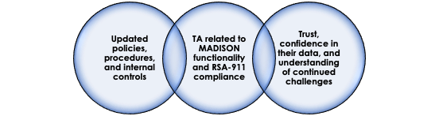

Results:

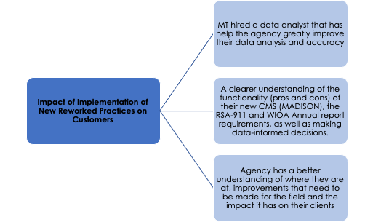

Strengths & Challenges

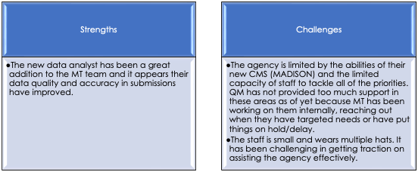

Previous Collaborations

N/A.

Future Plans

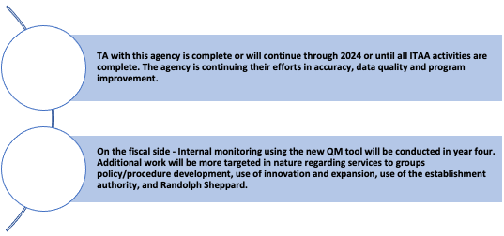

### New Jersey General

Reason for TA Request

The agency requested intensive technical assistance (ITAA) because of findings and/or recommendations resulting from the 2021 RSA 107 Monitoring. There are four specific areas requested by the agency. These areas include: (1) tracking, reporting, and data analysis for the common performance measures, with a particular focus on Measurable Skill Gains (MSGs); (2) guidance on developing a Quality Assurance (QA) unit, including recommendations on case file reviews; (3) training on DSA-DSU relationship and roles; and (4) fiscal training. Additionally, at the request of the agency, the VRTAC-QM fiscal team participated in their 2024 RSA monitoring and, as a result of anticipated findings, has engaged in intensive technical assistance related to fiscal/resource management.

Interaction with the Agency

Program and performance coordination with the agency has been facilitated through regularly scheduled Zoom meetings, as well as numerous ad hoc interactions via Zoom, email, and phone. Biweekly technical assistance (TA) meetings have addressed a range of quality assurance (QA), data reporting, and regulatory clarification issues. In a proactive response to RSA monitoring, significant efforts were made to correct case management system (CMS) and RSA-911 coding related to VR services, staff-provided services, and comparable benefits (80-90% complete). A brief onsite visit was conducted in late spring to meet with interim leadership, introduce new key personnel, and reprioritize technical assistance activities.

The agency’s ITAA identified four technical assistance (TA) activities targeting program and performance areas. The TA activities and progress (% complete) are listed below:

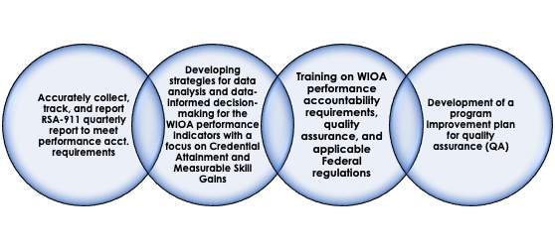A blue line on a black backgroundprogram


**PERFORMANCE**

**PROGRAM**

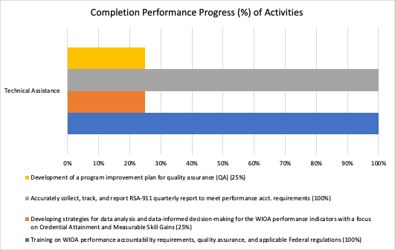

The VRTAC-QM fiscal team has engaged with the NJ-G staff 17 times during the reporting period. This included virtual meetings and email correspondence. In addition, the fiscal team provided training in person in March 2024 that focused on the following topics:

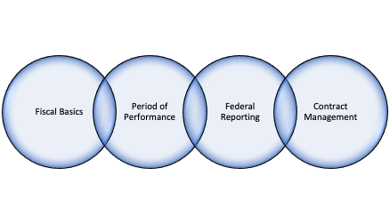

In addition, resources/tools were shared to assist with managing the grant award and fiscal forecasting to assist with reallotment and spending patterns.

Summary of the Areas in Need of Improvement

For the program and performance management:

|  |  |
| --- | --- |
| Indicator of Impact | Indicator Details |
| * Positively impact the agency’s ability to successfully report accurate and valid data related to RSA-911 quarterly reports and WIOA Annual Report. | * To be measured by comparing the result of reports against the previous year’s actual numbers and/or rates. |
| * Training on WIOA performance accountability requirements, quality assurance, and applicable Federal regulations. | * To be measured by comparing against the previous year’s numbers and types of actions taken based on data analysis/data-informed decision-making. |
| * Improvement in quality assurance. | * To be measured by the development and implementation of case review practices, which may partially satisfy the SVRA’s requirement to “monitor its activities under Federal awards. This will ensure compliance with applicable Federal requirements and that performance expectations are being achieved,” as outlined in 2 CFR 200.329(a). |

As a result of the TA, the agency has implemented or reworked practices in the following areas:

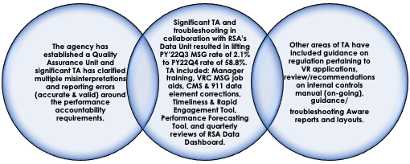

Efforts will continue with written policies, procedures, and internal controls related to the fiscal management of the award including topics such as:

* Period of Performance
* Financial Reporting
* Program Income
* Cash Management
* Internal Fiscal Monitoring

The 2024 RSA monitoring report will likely impact the priorities and activities currently identified on the ITAA. The VRTAC-QM team will be prepared to pivot to meet the needs of the agency and the resources they have available.

Results:

N/A, activities are in process.

Strengths & Challenges

While providing TA the following have been noted as promising practices and challenges:

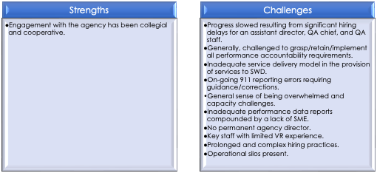

Previous Collaborations

TA was provided to this agency in collaboration with NTACT:C. This joint effort is or was limited and not an ITAA activity. There is a tentative future collaboration/site visit with NTACT:C in ’25.

Future Plans

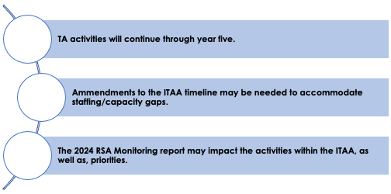

### New Mexico General

Reason for TA Request

The reason for the TA request includes difficulty in managing their data, case management system, and policies around the WIOA performance accountability system. In particular, they are struggling with tracking and reporting data for the MSG/CA indicators. They had to resubmit quarterly reports (directed by RSA) due to inaccuracies and missing performance data. They also struggle with understanding the coding in their CMS and how it aligns with the federal reporting requirements.

Fiscal TA was requested based on fiscal training that demonstrated that the team needed some additional intensive assistance in the fiscal area.

Interaction with the Agency

The agency’s ITAA identified technical assistance (TA) activities targeting both program and performance areas and additional activities targeting fiscal areas. The TA activities and progress (% complete) are listed below:

Activity breakdown:

* Performance
  + 2.2-Analyze VR agency readiness and capacity to track and report data for (i.e., RSA-911 and supporting documentation) the WIOA Performance Indicators.
  + 2.3-Assist VR agency’s data/case management system and program staff to develop/revise data collection processes for the WIOA Performance Indicators (MSG and CA).
  + 2.4-Activity 4: Review, develop and/or revise, as needed, written internal controls necessary for the WIOA Performance Accountability System
* VR Regulations and Process
  + 2.1-Review, develop and/or revise, as needed, performance evaluation standards for VR Counselors (and other staff as needed) reflecting agency and WIOA standards.
  + 2.9-Analyze DVR’s ability to accurately track and report VR requirements for students with disabilities (SWD) and pre-employment transition services (including potentially eligible SWD), includes completed assessment and strategies.
* Program
  + 2.10-Assist VR agency in developing strategies for data analysis and data-informed decision-making for quality assurance and program evaluation.
  + 2.11-Professional Development Training.
  + 2.12-Assist DVR in assessing data/case management system adaptations and updates to ensure program compliance, improve usability, and increase the understanding of impact across the agency.
* Fiscal
  + 2.5 - Review/analyze sources of VR agency’s non-federal share, its adherence to applicable match/MOE requirements, and make recommendations for maximizing the Federal share.
  + 2.6 - Review and analyze the VR agency’s indirect cost/cost allocation plan for correct utilization in collaboration with RSA.
  + 2.7-Conduct training regarding the fiscal requirements for managing the VR grant
  + 2.8-Activity 8: Review, develop, and/or revise, as needed, fiscal policies and procedures.

Progress on the ITAA has been very steady and the program/performance team has made several site visits to NM-G to work closely with them in the identified TA areas during Yr 4. Feedback has been positive and the agency feels that significant progress has been made. Data validation efforts have been underway. These efforts are primarily focused on MSG and credentials, as well as the revision of their MSG and Credential policies. In addition, these efforts include multiple staff trainings to assist and address findings from data validation/case reviews. The team is now moving towards validating post exit measures as their next goal.

The team meets 2-3 times a month to work on activities in addition to other activities in the ITAA.

Fiscal - There have been **58 activities conducted by the Fiscal team** since October 1, 2023. Significant efforts were made to ensure the strategic spending plans put into place in FFY 23 continued into FFY 24. After completing the Final FFY22 RSA 17 report, less than 300k was lapsed out of a potential lapse of 3 million. A team is dedicated to ongoing efforts to ensure short-, medium-, and long-term spending strategies are implemented. Additionally, NM-G has focused efforts on fiscal forecasting during this period.

In July 2024, two onsite visits, referred to as Summits, were held with all leadership staff and fiscal teams in attendance. The New Mexico General Director aimed to ensure that the entire team had a solid understanding of fiscal and programmatic considerations. This was done to improve collaboration, as well as build a deeper foundation of knowledge among staff regarding financial and program operations.

**Day 1** of the first session centered on refining policies & procedures related to purchasing, contract monitoring, financial reporting, and allowable costs. New fiscal team members received training on fiscal basics, including RSA-17 reporting requirements.

**Day 2** was dedicated to fiscal forecasting, highlighting how the fiscal and program areas intersect and work together. An in-depth presentation of the agency’s current fiscal and programmatic landscape sparked considerable discussion, leading to assignments for further exploration of the reasons behind certain operational decisions. Additional topics covered included: Allowability=Documentation, Reasonable, Allocable, and Necessary (A=DRAN), the period of performance, and reallotment.

The second session focused on a strategic finance discussion. It began with a review of why the team was gathered, an overview of the State Plan and Comprehensive Statewide Needs Assessment (CSNA), and an analysis of the proposed performance measures for FY25. The discussion then shifted to a regional breakdown of data, focusing on authorization attrition rates and materialization percentages. Regional managers reported back on the "why behind the what" homework from Session 1, further unpacking key insights. The fiscal team then provided an update on FFY 24 and presented a budget plan for FFY 25**, confirming that no funds from FFY 23 would lapse**. They also reviewed the spending increases in care and support for FFY 23 and 24, as well as outlined steps needed to secure funding for future costs. This realization led to a candid conversation between fiscal and program teams about shared responsibilities/budgeting realities.

The Summit concluded with a discussion on the reporting needed to help both program and fiscal teams better analyze/monitor agency operations. Next steps were outlined, which focused on the continued alignment of strategic finance priorities.

Continued partnered work has also taken place with the NTACT:C around the Pre-ETS contracts. Work has continued on the period of performance and much progress has been made, including addressing unauthorized services. The New Mexico General Director reported that **all the CAP findings were resolved and RSA closed the CAP**.

Summary of the Areas in Need of Improvement

Continued support of the team in their fiscal forecasting and strategic spending priorities.

|  |  |
| --- | --- |
| **Indicators of Impact** | **Indicator Details** |
| * The TA is intended to impact the accuracy of their data, improve their performance indicator outcomes, and for the management team to have a better understanding of the overall reporting requirements/the ability of their CMS to meet these requirements. | * The outcomes will be measured by tracking their data and performance rates from year to year * This will be done by analyzing quarterly reports/dashboards, other internal control, and data validation activities to ensure confidence in the system. * To date the agency reports 50% progress in the outcome of accurately reporting valid data related to credential attainment and MSG. |

As a result of the TA, the agency has implemented or reworked practices in the following areas:

**Updated policies and procedures and internal controls (in progress)**

**RSA-911/Aware data mapping to analyze accuracy in coding and use**

**Assisted with activities in their CAP**

**Train management and the field on all aspects of the performance accountability system to promote better outcomes and tracking of participants**

**Trust and confidence in their data and understanding of continued challenges**

Results:

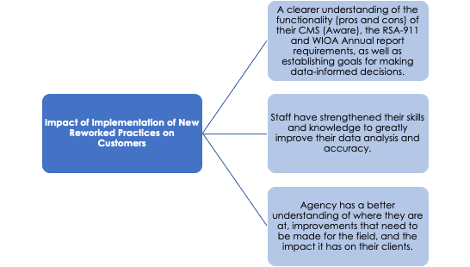

Strengths & Challenges

While providing TA the following have been noted as promising practices and challenges:

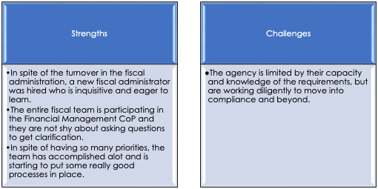

Previous Collaborations

TA was provided to this agency in collaboration with NTACT:C. This joint effort has provided a bridge between education and VR to help with knowledge translation, tracking & reporting efforts, staff training, and compliance related to SWD and Pre-ETS. This collaboration will continue.

Future Plans

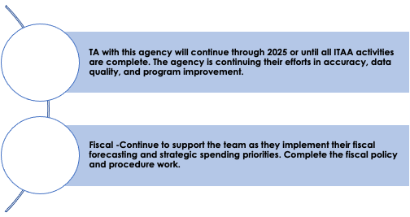

### Oklahoma Combined

*Reason for TA Request*

Oklahoma-C initially reached out for help in enhancing its agency culture. At the same time, they underwent monitoring and received their report in April 2024. Following this report, they sought further assistance to address its findings. This included recommendations for the AWARE system regarding fund priorities, performance periods, Pre-ETS tracking, developing fiscal policies, internal controls, fiscal forecasting, and managing Pre-ETS fiscal & programmatic activities.

Interaction with the Agency

During this engagement, there were 34 interactions with the Oklahoma team, including two onsite visits. The first visit aimed to ground the expanded leadership team in fiscal fundamentals, providing a comprehensive review of EDGAR and 2 CFR 200, including markup of the regulations. Discussions covered contracts, a refresher on performance periods, a walkthrough of technology systems, and strategies for expenditure.

The second visit focused on the case management system’s backend parameters, assessing gaps in accounting for the period of performance, and formulating a plan to address these gaps. Key efforts centered on ensuring that the period of performance was correctly established for the new grant reporting year starting October 1, 2024.

Additionally, we reviewed processes for State and Federal fiscal year-end. We offered recommendations to enhance accuracy and efficiency. Coordination with NTACT: C involved joint meetings to analyze the OU contract, leading to recommendations for improvements. A review of their current financial position and match situation generated significant discussion about potential strategies. This resulted in the organization securing additional non-federal share funding.

Also, cultural work was done, including implementing an employee engagement survey, providing training & resources to conduct 360-degree assessments for leadership, management, and supervisory staff. In addition, workshops on organizational change were also conducted.

*Summary of the Areas in Need of Improvement*

Staff having the time they need to complete the work.

*Strengths & Challenges*

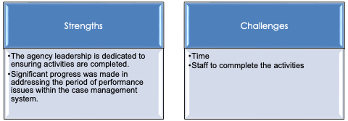

*Previous Collaborations*

Work is coordinated with the NTACT: C.

*Future Plans*

Continuation of ITAA activities in year 5.

### Oregon General

Reason for TA Request

Oregon-G requested TA from VRTAC-QM following their January 2022 monitoring visit and subsequent monitoring report that included 11 findings. As of this reporting period, Oregon-G has resolved 3 of the 11 findings.

Interaction with the Agency

Activity Breakdown:

* Fiscal:
  + Review, develop and or/revise, as needed, policies & procedures for Contract Management, to include Monitoring.
  + Review, develop and/or revise, as needed, policies & procedures for Grants Management.
  + Update the MOU with OCB-expand to add MATCH, MOE, and Pre-ETS
  + Review, develop and/or revise, as needed, written Rate Setting methodology policy & procedures, including rates for Pre-ETS services.
  + Correct and resubmit federal financial reports as indicated in monitoring findings.
  + Develop an overall spending strategy that reduces the balance in the O-Fund.
  + Develop strategy to overhaul the budget process to a statewide level instead of down to the VRC level.
  + Review/analyze sources of VR agency’s non-federal share and its adherence to applicable match/MOE requirements, as well as make recommendations for maximizing the Federal share. -MOE Reduction Strategy
  + "ORCA: Funding Sources, Budgets, Fund Management - Period of Performance Compliance Attrition Rate (impact on Funding) and age off process"
  + Review, develop, and/or revise, as needed, policies & procedures for Period of Performance Policy & Procedures
  + Conduct training regarding Fiscal Basics Training for mid-level managers and field staff.
  + Conduct training regarding Internal Controls
* Pre-ETS:
  + Develop YTP interim/ongoing implementation plan in collaboration with RSA, begin to spend Pre-ETS funds on services consistent with plan outlined with RSA, as well as the use of the 3434 funds.
  + Provide training that will focus on roles/responsibilities, processes, and documentation/reporting of Pre-ETS/VR transition services.
  + Review/analyze contracts for students & youth programs and fiscal internal controls, including Pre-ETS and VR transition services.
  + Develop a process for the agency to review and approve students who meet the definition of SWD and are in need of the services to be provided prior to the start of any service being provided consistent with the CAP.
  + Review/revise Pre-ETS fiscal forecasting/written processes to ensure State compliance with the reservation & expenditure of the min 15% Federal funds, coordination & collaboration with OCB, and determination of funds remaining for authorized activities consistent with 34 CFR 361 48(a)(3).
  + Review process for staff time tracking for Pre-ETS and reporting on the RSA-17 ensuring all costs are properly allocated/charged to the funds reserved.
  + Assist the VR agency in the development of processes and internal controls for accurate financial reporting of Pre-ETS, including the additional costs that may be charged to the reserve consistent with the NOI.
  + Review, develop, and revise policies & procedures for Pre-ETS, including referral process and identification of need of services, as well as continuum of services including VR transition services.
  + Review/revise policies, procedures, and practices for developing IPEs for students & youth with disabilities to include a projected post school employment outcome, as well as plans that are exploratory in nature.
  + Develop method for agency to capture for each student served, each Pre-ETS provided and the cost per student; including the use of the Vendor portal and agency developed spreadsheet.
* Performance:
  + Analyze VR agency readiness/capacity to track and report data for (i.e., RSA-911 and supporting documentation) the WIOA Performance Indicators.
  + Review, develop and/or revise, as needed, policies & procedures for the WIOA Performance Accountability System.
  + Review, develop and/or revise, as needed, written internal controls necessary for the WIOA Performance Accountability System.
  + Assist VR Administration in identifying areas related to the WIOA Performance Indicators needing improvement through data analytics (e.g., RSA-911, case management system, targets, participant achievements).
  + Staff training on WIOA performance measures and other related topics.

Pre-ETS: During the reporting period, had at least 3 insights and at least monthly calls with Oregon -G, including two calls with the RSA monitoring team where the agency was able to present all of the changes to their contracts and pre-ets service delivery system. A communication plan was developed and implemented to notify education partners of the changes, an interim rate methodology was established for their baseline/pilot year of implementing a fee for service model. Written processes were developed for the agency to document student referrals, swd status, as well as the need for and authorization for services by VR. Provided TA and recommendations for internal controls for pre-ets. Reporting structures were built using smart sheets for the agency to accurately track and report swd per service per student. Forecast was drafted by both the Blind and General agency and a regular meeting was established for both agencies to meet regularly to ensure they meet their state reservation requirement. Training was provided to agency staff on pre-ets, the agency’s new processes, and on the development of IPEs for swd. Provided extensive TA and recommendations on agency policies and procedures for serving students with disabilities.

Fiscal - During the reporting period, two multi-day in-person and eight total days of Regional Staff trainings occurred with Oregon-G staff on the following topics:

|  |
| --- |
| 1) Period of Performance |
| 2) Contract Management |
| 3) Grant Management |
| 4) Policies & Procedures (including  internal controls) |
| 5) Cost Principles |

In addition, bi-weekly meetings occur with the financial manager for one-on-one questions and guidance. QM-fiscal staff have had 2 on-site in person trainings during this period that focused on:

|  |
| --- |
| 1) Fiscal Basics |
| 2) Uniform Grant Guidance |
| 3) Fiscal Resources |
| 4) Period of Performance |
| 5) EDGAR |
| 6) Non-federal Match |
| 7) Fiscal Forecasting |
| 8) CMS adjustments |
| 9) State Credit Card tracking |

Follow-up from the on-site trainings include:

|  |
| --- |
| 1) Fiscal Forecasting |
| 2) Spending Strategies |
| 3) RSA-17 Reporting |
| 4) Open Authorization Tracking and  Management |

In addition, Oregon-G fiscal staff and administrative staff participated in all Fiscal Management Community of Practice during this reporting period.

Performance- During the reporting period, OR-G began working with the performance team, meeting bi-monthly virtually to address performance and training related needs. A major focus during this period is assisting with RSA-911 reporting accuracy and restructuring their current Pre-ETS process to address compliance/reporting issues with Pre-ETS services. This quarter, the agency accomplished submitting a draft process for Pre-ETS services and training field staff on this new process.

Summary of the Areas in Need of Improvement

For fiscal - To ensure the agency is operating with up-to-date policies & procedures that are reflective of Federal regulatory requirements and written in a spirit that is focused on achieving CIE for customers. Also, to develop written fiscal policies/procedures/internal controls that will ensure continuity of completion of critical grants management functions as staff come and go. This will be done by having thorough written documentation that can be used by any new person coming in the door. By having the foundational fiscal knowledge/understanding, the DVR leadership is better able to evaluate service delivery opportunities and efficiencies. Additionally, by providing foundational training to the DSA, the VR Director is better able to maintain control of the allocation and expenditure of VR funds.

For performance- To ensure the agency is reporting accurate, reliable, and valid data, a major focus for improvement has been analyzing their readiness/capacity to track

& report data, specifically on the RSA-911. Another focus is the need to develop, revise, or review policies, procedures, and internal controls for the WIOA performance accountability system. One major aspect of this redevelopment is providing training on WIOA performance measures for staff.

Strengths & Challenges

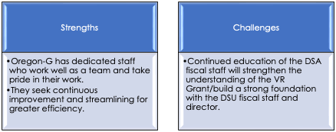

Previous Collaborations

VRTAC-QM has worked closely with NTAC-C specific to the Pre-ETS requirements and reporting. Pre-ETS contracting, staff time, and the overall Pre-ETS process for reporting are three joint focused areas where collaboration has occurred, as well as to the CMS function and period of performance management.

Future Plans

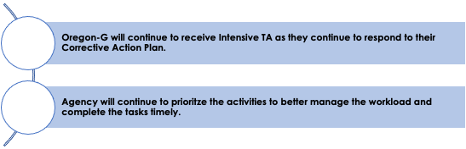

### Pennsylvania Combined

Reason for TA Request

The agency requested intensive technical assistance (TA) on the program & performance side because of difficulty in managing their data, case management system, and policies around the WIOA performance accountability system. In particular, they were not able to track/ report data for the MSG/CA indicators and needed extensive TA to implement new reporting mechanisms in their case management system (CWDS).

On the fiscal side, at the initial request, PA had significant turnover in the fiscal unit, with new staff lacking knowledge and understanding of VR fiscal requirements. Additionally, they desired to reevaluate their fiscal unit structure and staff responsibilities. They requested TA to assist with staff training and evaluation of organizational structure with recommendations for efficiencies. Since their initial request, there has been some additional staff turnover and the return of staff that was previously at PA OVR. The return of some institutional knowledge has greatly reduced some of the ITAA needs.

Interaction with the Agency

The agency’s ITAA identified 15 technical assistance (TA) activities targeting program and performance areas. The TA activities and progress (% complete) are listed below:

Activity Breakdown:

* Training
  + 2.1 Conduct a staff training needs assessment, including a report with staff training needs identified for different job classifications.
  + 2.2 Analyze OVR ability to effectively train, onboard and evaluate staff – i.e., training assessment (current processes, identify gaps, develop plan), includes a completed assessment with implementation strategies and timelines necessary to improve training/evaluation of staff.
  + 2.3 Review, revise and/or develop policies & procedures related to OVR training plan and implementation, which includes completed reviews and draft/revisions with recommendations for OVR training and implementation.
* Performance
  + 2.5 Assist with CWDS data/case management system and program staff to develop/revise data collection processes for the WIOA Performance Indicators, includes completed recommendations.
  + 2.6 Assist OVR in developing strategies for data analysis and data-informed decision-making (e.g., visual analytics, CWDS dashboards, tracking reports) for meeting or exceeding WIOA performance established targets, which includes draft/revised strategies.
  + 2.7 Analyze VR agency readiness/capacity to track and report data for (i.e., RSA-911 and supporting documentation) the WIOA Performance Indicators, which includes an assessment with identified implementation strategies/ timelines.
  + 2.8 Staff training on: performance indicators, education/training programs for Credential Attainment/Measurable Skill Gains, tracking & reporting, data, sanctions, and negotiations, of the WIOA Performance Accountability System
  + 2.9 Review, develop and/or revise, as needed, policies & procedures for the WIOA Performance Accountability System
  + 2.10 Review, develop and/or revise, as needed, written internal controls (including data validation) necessary for the WIOA Performance Accountability System
* VR Regulations and Process
  + 2.11 Assist with OVRs data/case management system and program staff to develop/revise data collection processes for service provision (including CWDS/RSA-911 data mapping), which includes recommendations for processes.
  + 2.12 Assist OVR in identifying areas needing improvement related to regulation and other VR requirements, which includes completed assessment and identified strategies.
  + 2.13 Review, develop and/or revise, as needed, policies & procedures for regulations and other VR requirements identified in the assessment in 2.12, which includes policy/procedure recommendations.
* Pre-Employment Transition Services
  + 2.14 TA regarding funding (activities/positions) between BSE and OVR to support the implementation of the Interagency Agreement (MOU) and services to students with disabilities, using the15% reserve, which includes the recommended contract/agreement.
  + 2.15 Analyze OVR’s ability to accurately track/report VR requirements for students with disabilities (SWD) and pre-employment transition services (potentially eligible SWD), which includes completed assessment/strategies.
  + 2.16 Staff training on allocation of allowable costs (including tracking and reporting).
  + 2.17 Assist OVR in identifying areas needing improvement and/or impact of state and local transition practices, as well as activities through use of agency data/analytics, which includes a completed plan and implementation needs.
* Fiscal
  + 2.18 Conduct training regarding the fiscal requirements for managing the VR grant related to D-RAAN (Documenting 2 CFR 200 principles: Reasonable, Allowable, Allocable & Necessary).
  + 2.19 Provide TA/training to develop the OVRs capacity to correctly manage period of performance, which includes training, TA - fund stream set up, and assignment; identifying the unliquidated and the rollover; unliquidated obligation; field POP violation process; SPY/SFY/FFY Issue - their 310.3 doc and when a contract is a contract/date of obligation.
  + 2.20 Review processes for fiscal reporting and make recommendations for improving accuracy, efficiency and/or automating, which includes documented feedback and recommendations - RSA 17 - review unliquidated and process for reporting unliquidated.
  + 2.21 CWDS 2.0 fiscal upgrade TA
  + 2.2.2 Review and make recommendations to Fiscal policies & procedures, including internal controls.

Fiscal - There have been 11 intensive TA and 9 targeted TA engagements since Oct 1, 2024.

In the first half of Yr4, additional fiscal questions have arisen surrounding case management configuration and period of performance handling, prompting a two day visit to review requirements around the period of performance and obligations. Our findings there initiated a revision to the ITAA agreement and a different focus on the items to work through with the PA OVR team.

During the second half of Yr4, the OVR Director reached out to the VRTAC-QM Fiscal team for in depth fiscal forecasting assistance. This request was facilitated by the last few years where PA made several program changes in response to a significant surplus of grant funds. These changes included reducing the financial needs test, increasing the college training allowance, and expanding pre-employment transition services. However, by the spring of this year, it became clear that the agency might not be able to financially sustain these changes. This realization was driven by the flat funding for VR agencies in the FFY24 grant cycle, as well as mandatory staff salary increases in the unionized state. The sizable salary increases prompted a deeper evaluation of the agency’s financial decisions.

At that point, PA sought assistance from the VRTAC-QM fiscal unit for help with fiscal forecasting. The agency had previously evaluated numbers from the state accounting system in isolation and needed support in understanding the broader program-fiscal implications. The QM fiscal unit helped PA identify critical data elements from their case management system and determine what information was needed to assess future financial capacity.

In July, PA convened its leadership team to present and discuss fiscal projections, factoring in elements, such as reallotment requests and the potential for another year of flat funding. Four scenarios were developed for planning, and the leadership team received a comprehensive fiscal update.

As a result of this collaboration, PA now has an integrated program and fiscal structure in place to better forecast the agency’s financial position. They determined that they could no longer afford certain pre-employment transition services or the increased college training allowance introduced when funds were more plentiful. Additionally, they reconsidered the financial needs test. Overall, the agency is now in a better position to make informed financial decisions and understand the true cost of its operations.

Summary of the Areas in Need of Improvement

|  |  |
| --- | --- |
| **Indicators of Impact** | **Indicator Details** |
| The TA is intended to impact the accuracy of their data, improve their performance indicator outcomes, and for the management team to have a better understanding of the overall reporting requirements, as well as the ability of their CMS to meet these requirements. | * The outcomes will be measured by tracking their data and performance rates from year to year, as well as analyzing quarterly reports/ dashboards and other internal control/ data validation activities to ensure confidence in the system. Though this will be an ongoing activity within OVR, there have been improvements in this area. A key functionality was identified as missing from the CWDS system and will be critical for the Agency to correct going forward to maintain proper period of performance. |
| On the fiscal side, the intent of the TA is to get the CMS (Case Management System) inline with the Statewide Accounting System with respect to obligations, and develop a strong procedure for reporting on the RSA-17. | * Pennsylvania has done a great job of adjusting with new personnel/ continuing services and is now facing defining the requirements to update their case management system. * They are realizing that some policies need to be adjusted and changes made in the CMS to allow field staff to function more efficiently. * The new CFO has been instrumental in getting things back on track and seems to have a deep understanding of the regulations. |

As a result of the TA, the agency has implemented or reworked practices in the following areas:

* Updated policies & procedures and internal controls
* Developed and implemented elaborations in their CMS (CWDS) related to educational tracking (MSG/CA), IPEs, and application & referrals.
* Finalize activities in their CAP
* Fixed duplication and accuracy of SWD tracking and reporting
* Management of the field on all aspects of the performance accountability system to promote better outcomes and tracking of participants
* Train participants in PA OVR
* Improve level of trust and confidence in their data/understanding of continued challenges
* More accurate financial reporting and fiscal forecasting
* The new CFO has really brought the team together in understanding of the grant
* Better communication with the entire staff because of the program staff changes

Results:

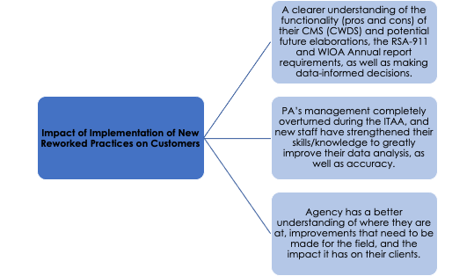

Strengths & Challenges

While providing TA the following have been noted as promising practices and challenges:

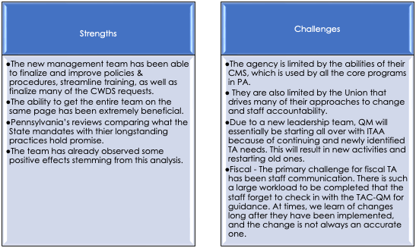

Previous Collaborations

TA was provided to this agency in collaboration with NTACT:C. This joint effort has provided a bridge between education and VR to help with knowledge translation, tracking & reporting efforts, staff training, and compliance related to SWD/Pre-ETS. Within the Fiscal and Resource Management focus area, we had a blended team approach with NTACT:C for the onsite visit in February 2023. TA was also provided in collaboration with the QE. We partnered on developing a statewide training plan, however, QE activities continued to be put on hold while PA focused on crucial management activities.

Future Plans

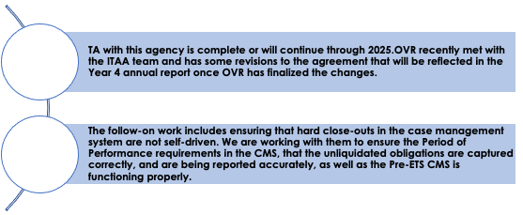

### South Carolina General

Reason for TA Request

SCVRD initially contacted the VRTAC-QM due to their need for technical assistance (TA) and training stemming from their recent RSA monitoring. The ITAA is focused on Program & Performance, Fiscal, and Resource Quality Management.

Interaction with the Agency

During this period, there have been 20 interactions with South Carolina General. These interactions primarily focused on finalizing fiscal and program policies, specifically around cash management, and the period of performance. Both policies have been completed, reviewed by RSA, and approved. Significant progress has been made, with 12 out of 14 corrective actions successfully closed. The agency expects to complete the remaining items by December 2024.

The fiscal team has maintained close communication with the SC-G team regarding systems updates to meet the period of performance requirements. Recent updates to Federal Uniform Grant Requirements will require changes to existing policies in order to align with new federal standards. The agency has been informed of this need and work is underway to address these changes.

Progress on the final corrective actions was delayed due to the need for a learning management system (LMS) to store agency policies, procedures, and staff training materials. While the LMS has been procured, deployment is dependent on the state's prioritization across agencies. To maintain progress and meet the Corrective Action Plan (CAP), the IT department developed an interim solution for storing policies, procedures, and desk aids, ensuring staff access to essential information. This solution was communicated to RSA and will be included in the October 2024 CAP progress report. A recent RSA note confirmed the completion of another item, leaving only one item outstanding on the CAP.

The agency has also implemented or revised policies in the following areas:

* Period of Performance
* Cash Management
* RSA 17 update with the new DCL

In addition, four members of the agency's team have been delegated to the 2024 cohort of the VRTAC-QM’s Case File Review Community of Practice (CoP). This initiative offers an opportunity to collaborate with 17 other agencies, sharing tools/resources for case file review, quality assurance, and internal control. As part of the CoP, the agency will work to develop or improve policies, procedures, or instruments related to its case file review process. The agency will also work closely with VRTAC-QM’s CoP leads to refine goals, establish milestones, and address concerns relevant to their project. The final CAP deliverable is expected in the first quarter of year 5.

Summary of the Areas in Need of Improvement

Completion of the remaining CAP items.

In addition, for continuous improvement purposes, the agency should ensure a strong internal control system to support all operational, reporting, and compliance activities. The agency should be intentional about designing an internal control system that can address risks and evaluate the effectiveness of agency activities from a multidimensional perspective. This will not only help to bridge the gap between policy and procedure, but also bridge any gaps that may exist between the various functional areas (e.g., program and fiscal, data analytics and training/staff development). The agency’s Policy and Internal Control Unit ensured that each department developed formal internal controls to filter into the agency’s collective internal control system. The comprehensive system should consider the following areas:

|  |  |
| --- | --- |
| **Areas** | **Description** |
| Control environment | Identify, develop, and maintain objectives. |
| Risk Analysis | Identify and evaluate barriers to meeting objectives. |
| Control Activities | Design/implement actions to prevent, detect, and correct  errors/anomalies. |
| Information and Communication | Develop processes and systems to deliver, update, and store applicable information. |
| Monitoring and Review | Establish and manage processes to measure progress. |

The agency has implemented or reworked practices in the following areas:

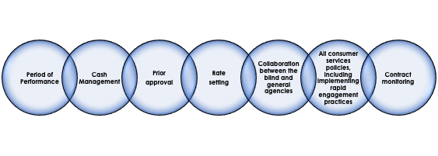

Results:

This is currently a work in progress and will be better reflected in the next report. The work so far has been fundamental. We are now at a stage where staff are receiving training and all these elements are actively being put into practice.

Strengths & Challenges

While providing TA the following have been noted as promising practices and challenges:

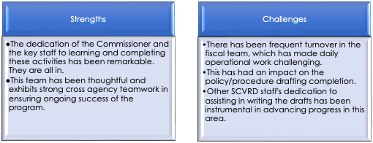

Future Plans

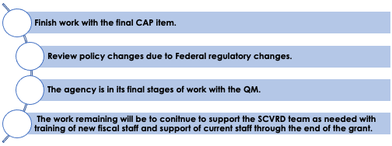

### South Carolina Blind

Reason for TA Request

SCCB initially contacted the VRTAC-QM due to their need for technical assistance (TA) in the Fiscal focus area. A final ITAA was signed in November of 2023.

Interaction with the Agency

There were 75 TA interactions during this period and the Fiscal team carried out 44. Meetings were set up to scope out fiscal forecasting, spending strategies, and fiscal policies & procedures development. Once work was started, the fiscal director resigned, and all work halted to a stop. The Agency Commissioner revised the position and successfully recruited a new accounting officer with federal grant management experience. Work has restarted, but there have been some starts and stops related to filling positions within the fiscal unit itself.

Three onsite visits were held during this year:

**First Visit:** We reviewed the AWARE system and the Statewide Accounting System (SWAS) to assess their interface and identify any gaps. We also evaluated the systems' compliance with the period of performance and obligation dates. Other areas of focus included RSA-17 reporting, fiscal forecasting & spending strategies, fiscal policy development, creating an action plan, and work schedule for the year.

**Second Visit:** This visit concentrated on providing fiscal fundamentals training for field staff, delivered in two waves to ensure full participation. The training introduced a decision-making framework based on cost principles, referred to as A-DRAN: Allowability = Documented, Reasonable, Allocable, and Necessary, to aid staff in informed decision-making.

**Third Visit:** A session was held with the newly appointed Fiscal Director and other new staff to review the period of performance & SWAS setup, ensuring proper configuration, understanding, and compliance with fiscal regulations.

In addition, the team discussed its fiscal position. They considered sending back a million in reallocation, but did not do so. They also successfully spent down the entire 2023 grant and no funds will lapse to the U.S. Treasury.

Also, the QM team is actively addressing numerous questions about current practices and how they can be improved. SCCB is rebuilding the program from the ground up after years of neglect, which has created significant operational challenges. Great strides have been made in their understanding of this complicated grant. Re-evaluation of prior federal reports to ensure accuracy of match and maintenance of effort occurred. New fiscal staff completed the Grant Tracker for previous fiscal years to enable evaluation of historical trends, fiscal forecasting, and policies & procedures are beginning to be re-evaluated.

Summary of the Areas in Need of Improvement

All areas of the ITAA need to be addressed. The work stopped for most of this period due to the departure of the fiscal director. A new director has been hired and work is restarting.

Strengths & Challenges

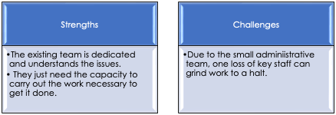

Previous Collaborations

N/A.

Future Plans

Continue the work identified in the ITAA.

### Virginia General

Reason for TA Request

VA-DARS approached VRTAC-QM with an invitation to participate in a SWITCIE project. VR-DARS was looking specifically for TA around a funding concept called Value-Based Purchasing (VBP). This is a concept gathering momentum in the medical sector. The foundation of VBP is to adequately compensate providers who deliver quality services that lead to a quality outcome. It addresses the inadequacies of traditional fee-for-service or milestone payments, which often disincentivize providers who provide quality services efficiently.

*Interaction with the Agency*

The technical assistance has included detailed presentations on VBP to stakeholders that include providers, VA-DARS program administrators, and partner agencies. The TA sessions occur monthly. In addition, Lisa Mills and VRTAC-QM staff meet regularly with VA-DARS administrators to strategize upcoming technical assistance. The goals of the TA are: to build a relevant model based upon VBP principles with input from stakeholders; pilot and evaluate the VBP model; pilot and evaluate the model for service providers who deliver Customized Employment (CE), Individual Placement Support (IPS), and Supported Employment (SE). PowerPoint presentations are created for each presentation. Summaries of the comments from the presentation are included in subsequent presentations.

**Products Completed**: A Drafted Model of a rate structure to be approved by VA-DARS and CE providers. This model was developed with input from the agency and providers over several working sessions.

ITAA Activities Checklist:

|  |  |
| --- | --- |
| **Activity** | **Completion Status** |
| Conduct a training that provides an orientation/overview for Values Based Budgeting to SVRA, other funders, and providers | 100% |
| Assist VR leadership in the development of a workgroup and task-based, time-bound agenda for determining values and quality indicators agreed upon by funder(s) and providers. | 100% |
| Review, develop and/or revise, as needed, policies & procedures for determining the cost of services by providers | 50% |
| Develop/ implement a protocol and project plan developing a Value Based Purchasing rate setting and methodology/model for CE, SE and IPS | 75% |

Strengths and Challenges

The following have been noted as promising practices and challenges:

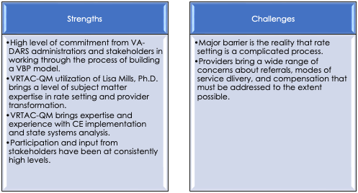

Future Plans

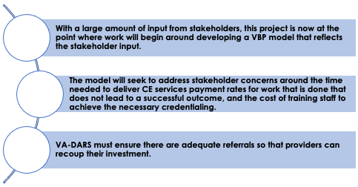

### Washington Blind

Reason for TA Request

Washington DSB initially reached out for TA related to their Corrective Action Plan because of their monitoring. During discussions with them, they branched out in their TA requests to include areas not identified in their monitoring. Leadership was concerned that the isolation and remote work resulting from COVID adversely impacted the culture of the organization and may have resulted in a loss of focus on their primary mission. They also wanted to strike a balance between the need to gather/report data and the need to effectively counsel their participants.

WA needs significant support in tracking, reporting, and data validation of their system, particularly regarding WIOA performance measures. They also needed support in policy, internal controls, and staff training.

Interaction with the Agency

Recently, we conducted a refresher training with all DSB staff on performance indicators, primarily focused on MSG and Credentials. This training included understanding around federal requirements, foundation of sustainable careers, career pathways, understanding of MSG/credential calculations in performance, definitions, scenarios to test their knowledge, an overview of the State/Agency’s performance PY22, and current standing. In alignment, we have been working with the agency to develop tools to help them forecast performance throughout the year, in order to assist in meeting performance goals. In addition, we have been working with staff to analyze the case management system and data in order to ensure accuracy in reporting by data validation.

Previously, we conducted a staff training needs assessment and started a year-long leadership training with their staff. This was done in addition to addressing the other program and performance areas included in their work plan.

We analyzed the reporting to ensure coding was accurate and reflective of the work at DSB. Also, we helped with policies for staff and have helped with several trainings.

Summary of the Areas in Need of Improvement

The intended goals are to assist the agency to develop their leadership staff, develop a succession plan, complete a staff training needs assessment, conduct strategic planning, and develop or revise need policies & procedures. The agency agreed to purchase the book, “The Leadership Challenge” for all leadership staff. The agency initially shifted to pursue other priorities and put any leadership training on hold to focus on reporting and data validation.

The intended goals are to increase accuracy and validity of their data to truly reflect the work being done at DSB. Some of these goals are driven by their CAP and due to the State not meeting their performance measure in the area of credential attainment. However, DSB is performing well, and the performance failure appears to be mostly due to the general agency’s performance. We are validating that this is true and that DSB is functioning well.

As a result of the TA, the agency has implemented or reworked practices in the following areas:

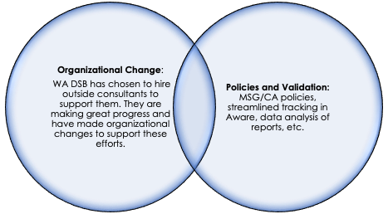

As a result, the impact on customers served has been:

* Development of a five-pronged approach plan for organizational change with the assistance of an outside consulting agency.
* Policies for MSG and credential attainment.
* Increased data analysis understanding and development of usable data reports to track agency progress.
* Streamlined tracking in Aware for educational information.

Strengths & Challenges

While providing TA the following have been noted as promising practices and challenges:

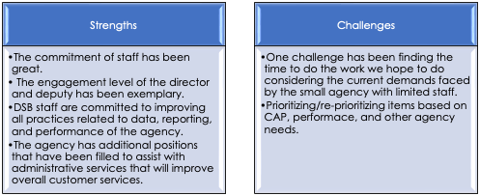

Previous Collaborations

QM partners very closely with NTACT:C in providing technical assistance around students with disabilities, pre-employment transition services, fiscal, tracking, and reporting in this area.

Future Plans

We will continue working with the agency on their policies & procedures, internal controls, and other priorities as they identify them.

### Washington General

Reason for TA Request

Washington DVR engaged with VRTAC-QM in January 2024 to request intensive technical assistance (TA) following the identification of key challenges during RSA monitoring and internal evaluations. The agency’s focus areas include the implementation of WIOA performance accountability requirements, accuracy & validity in data reporting, and development of policy, procedures, and internal controls to improve performance outcomes.

Interaction with the Agency

During Year 4, VRTAC-QM has supported Washington DVR through a combination of intensive and targeted TA activities. This included virtual meetings, regular check-ins, collaborative workgroups, and onsite visits (including one in partnership with RSA regarding the credential attainment rate performance failure) that aimed at building agency capacity to address its needs effectively.

Key focus areas included:

|  |
| --- |
| * WIOA Performance Accountability: Providing guidance to align policies, procedures, and internal controls with federal regulations. |
| * Data Accuracy and Reporting: Analyzing/enhancing DVR’s ability to track and report RSA-911 data accurately. |
| * Staff Training: Delivering targeted training on credential attainment and other WIOA performance indicators. |
| * Case Management System (CMS): Developing recommendations to address RSA-911 errors/anomalies within the CMS to support valid and accurate data submissions. |
| * Performance Improvement Plan (PIP): VRTAC-QM supported both DVR and OCB in developing their PIP (similar to a corrective action plan) in order to take all the steps necessary to correct past data/set up a system of success moving forward. Through TA from RSA, TA from VRTAC-QM, and all of the hard work of the agency, they passed all of their performance indicators, including CA, for PY2023 and are no longer on a PIP. |

Summary of the Areas in Need of Improvement

|  |
| --- |
| * Data and Reporting: DVR requires enhanced internal controls and systematic training to ensure data validity/compliance with federal reporting standards. |
| * Performance Accountability: A streamlined approach to aligning operations with WIOA indicators is critical to improving outcomes such as credential attainment and measurable skill gains (MSG). |
| * CMS Functionality: Addressing ongoing CMS challenges is essential for maintaining accurate/efficient case management and reporting. |
| * Staff Training: Staff training/culture shift is imperative to shared understanding of both the intent and requirements of WIOA, as well as the success of their clients. |

Indicators of Impact-The TA provided by VRTAC-QM aims to achieve the following impacts:

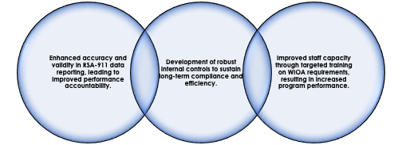

Results:

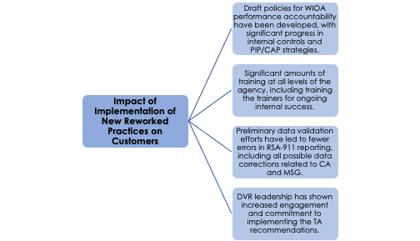

Strengths & Challenges

While providing TA the following have been noted as promising practices and challenges:

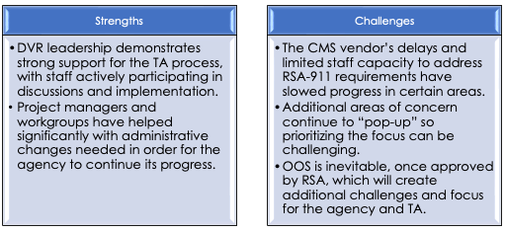

Previous Collaborations

N/A.

Future Plans

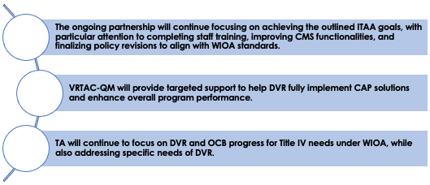

### Wyoming Combined

Reason for TA Request

Initially, DVR contacted the QM for various targeted technical assistance activities to ground the new VR administrator in VR's fiscal responsibilities. The work changed when the agency was selected for monitoring in 2022. The ITAA focused on the organization's Fiscal and Resource Quality Management.

Interaction with the Agency

Over the past fiscal year, Wyoming VR engaged in **112 technical assistance** (TA) activities, with the **fiscal team leading 53** of them. Two onsite visits took place during this period.

**December 2023 Onsite Visit:**The December visit focused on developing the **Federal Financial Reporting** policy & procedures for RSA 17 and SF 425 reports. In addition, this visit focused on crafting a corrective action plan (CAP) in response to RSA findings. During the visit, an Excel workbook was designed to help the agency track ongoing communications and activities for each CAP item. Wyoming VR submitted its first CAP report in January 2024 and RSA provided feedback by the end of March. RSA responded positively to the **rate-setting** and federal financial reporting policies, but additional adjustments were necessary. Specifically, the team needed to develop a comprehensive **grants management manual** rather than just completing the previously agreed-upon procedures for cash management, Federal Financial Reporting, and the period of performance. Work on the **rate-setting** and **contract monitoring** procedures continued, with a pilot of the new contract monitoring process in May. Feedback from this pilot led to revisions. A new contracts lead at the Designated State Agency (DSA) has been collaborating with the VR team to incorporate federal requirements into the contracting process and to create a contract agreement specifically for authorization-only purchases. This work was completed, and a final draft was submitted to RSA for the July 2024 CAP report.

The **Quality Management (QM)** team has reviewed Federal Financial Reports for each reporting period, ensured accuracy and consistency, and provided feedback. This ongoing review process enhances knowledge retention and maintains the integrity of the financial reporting system.

Wyoming VR implemented a new case management system two years ago, and the QM team has provided ongoing strategic support to ensure the system meets all Federal and State compliance requirements. Wyoming has held the CMS vendor accountable and set expectations for regular communications and progress updates. This year there were significant improvements in the system’s reporting features and overall functionality. Additionally, the vendor made personnel adjustments to enhance communication and provide more effective support to the agency, ensuring that the system continues to evolve in alignment with Wyoming VR’s operational needs.

**July 2024 Onsite Visit:**In July, the second onsite visit addressed RSA’s feedback, which called for developing an entire **grants management manual**. The DSA’s fiscal team had undergone staff changes, bringing in a new member with extensive experience in policy and procedure development. A draft manual was prepared. During the visit, the team spent two days reviewing gaps/ structuring the manual to link policies, procedures, and resources in alignment with CAP requirements to meet the needs of the fiscal unit. The completed **grants management manual** was submitted with the July 2024 CAP report and just received RSA’s feedback. RSA had some excellent suggestions for improvement, which will be worked on in the upcoming submissions.

In recent years, the QM team has provided extensive technical assistance to Wyoming VR, focusing on strategies to fully secure additional **State General Revenue Funds** to match their federal grant. The leadership of the designated state agency was supportive. As a result, the agency successfully obtained the necessary funds to meet the full grant match for the upcoming Federal Fiscal Year. Additionally, they secured four new positions dedicated to **pre-employment transition services** (Pre-ETS)—a significant achievement, as increasing full-time equivalent (FTE) staff in state agencies is often challenging. These additional funds will allow the program to improve the services provided to consumers.

The QM team also collaborated with Wyoming to analyze fiscal and programmatic factors to inform a sound **reallotment decision**. Over the past two years, the fiscal and program teams have worked together effectively, refining their analysis processes and making informed decisions. While they did return some funds, the amount was $1 million less than initially anticipated. Moving forward, Wyoming is poised to retain full funding due to securing the complete **cost share** for the grant, ensuring a stronger financial position for the agency.

Products developed:

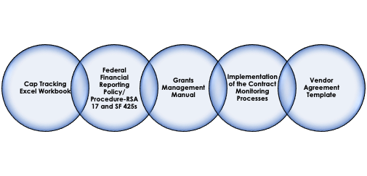

Summary of the Areas in Need of Improvement

There will be continued focus on the areas of the CAP, including implementation of vendor agreements. As a result of the TA, the agency has implemented or reworked practices in the following areas:

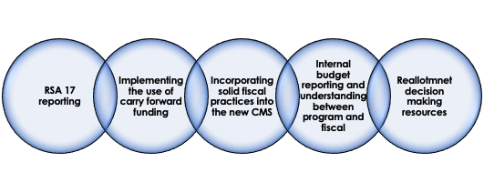

Results:

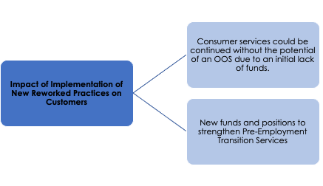

Strengths & Challenges

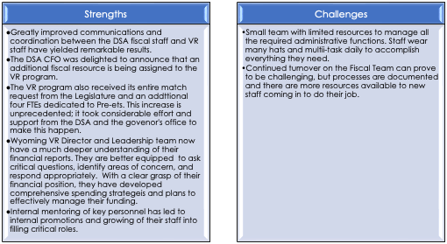

Previous Collaborations

The NTACT: C has been involved with the Pre-ETS side of the program and the QM program team is doing significant work on internal controls and performance.

Future Plans

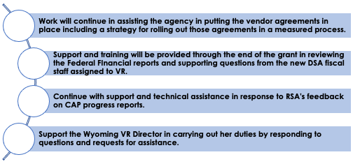

## SWOT assessment tools development and assessments conducted

There have been 24 SWOT analyses conducted through the end of Year 4. The assessment tool developed, reviewed and approved by RSA remains the tools that we use in conducting SWOTs. The SWOTs have been conducted via Zoom and also in-person. The assessments are very helpful when developing the ITAAs and have helped to illuminate areas of TA need not specified in the original request from the VR agency.

## Program Evaluation:

The comprehensive annual program evaluation report contains all of the detailed program evaluation information for progress and impact through the end of Year 4.

# Targeted TA

The requests for, and delivery of, targeted TA remain constant and has now touched all 78 VR agencies through the end of the third year of the project. Table 2 identifies the targeted TA for the fourth quarter of Year 4. The totals for the project are found in the update on project measures later in the report. Targeted TA reached a new high of 68 agencies (87%) receiving targeted TA in one quarter this quarter because of the plethora of communities of practice that are currently operating.

## Number of events by type, topic, agency and number served:

Table 2: Targeted TA and Training during the 4th Quarter of Year Four

| **Targeted TA in Year 4 Quarter 4** | | |
| --- | --- | --- |
| **Agency** | **TA or Training Topic Area** | **Number Receiving TA** |
| Alabama Combined | NRLI; ITS CoP; financial management CoP; prior approval, purchasing and BEP | 9 |
| American Samoa Combined | Fiscal basics training | 2 |
| Arizona Combined | Fin. Man. CoP: ITS CoP; Monitoring Cop; Case file CoP; CMS data collection | 13 |
| Arkansas Blind | Financial Management CoP; Case file CoP; Reporting; CMS data collection, data analytics; reporting and staff training | 9 |
| Arkansas General | Financial Management CoP; ITS CoP; Rapid Engagement CoP; grant management training; CMS data collection and reporting | 18 |
| California Combined | NRLI; fiscal management CoP; fiscal reporting; ITS CoP; Rapid Engagement CoP; Match-MOE | 20 |
| CNMI Combined | CRA; fiscal basics training; reporting; purchasing | 7 |
| Colorado Combined | Monitoring CoP; NRLI; fiscal management CoP; ITS CoP; Rapid Engagement CoP | 24 |
| Connecticut Blind | DSA-DSU | 1 |
| Connecticut General | ITS CoP; Financial management CoP; Rapid Engagement CoP; P&P; Purchasing; DSA-DSU; monitoring; fiscal reportingx2 | 14 |
| Delaware Blind | Data analytics for program improvement | 2 |
| Delaware General | Fiscal Management CoP; Rapid Engagement CoP; ITS CoP; Case file CoP: P&P review and revision; DRAN-training; CMS data collection; Data analytics for program improvement | 17 |
| Florida Blind | CRA; Monitoring CoP; financial management CoP; ITS CoP | 5 |
| Florida General | Fiscal management CoP; ITS CoP; Rapid Engagement CoP; ITS CoP; Case file CoP; DRAN training; | 112 |
| Georgia Combined | Financial management CoP; Monitoring CoP; ITS CoP; Rapid Engagement CoP; Case file CoP; Purchasing | 18 |
| Guam Combined | P&P review and revision from CAP; fiscal basics training | 7 |
| Hawaii Combined | Financial Management CoP; Rapid Engagement CoP | 5 |
| Idaho Blind | P&P and internal controls for VR program and WIOA performance measures | 1 |
| Idaho General | Financial Management CoP; Rapid Engagement CoP; ITS CoP; fiscal TA | 11 |
| Illinois Combined | Monitoring CoP; fiscal management CoP; Rapid Engagement CoP; ITS CoP; contract monitoring; pre-ETS fiscal; General QM; RSA monitoring; Data analytics | 36 |
| Indiana Combined | ITS CoP; | 3 |
| Iowa Blind | NRLI; Financial Management CoP; reporting; pre-ETS fiscal; IPE policy review for rapid engagement; Community partnerships | 6 |
| Iowa General | Financial management CoP; Rapid Engagement CoP; | 3 |
| Kansas Combined | Financial Management CoP; ITS CoP; Rapid Engagement CoP; policy review; Community partnerships | 15 |
| Kentucky Combined | NRLI; fiscal management CoP; | 5 |
| Louisiana Combined | Monitoring CoP; ITS CoP; Financial management CoP; Rapid Engagement CoP | 4 |
| Maine Blind | Pre-ETS fiscal | 3 |
| Maine General | ITS CoP; Rapid Engagement CoP | 2 |
| Maryland Combined | NRLI; ITS CoP; Financial Management CoP; pre-ETS fiscal; DSA-DSU; | 13 |
| Massachusetts Blind | NRLI | 1 |
| Mass. General | Rapid Engagement CoP; ITS CoP; | 2 |
| Michigan General | Fiscal management CoP; ITS CoP; Rapid Engagement CoP; Monitoring CoP; Contracting; Monitoring; CMS fiscal | 36 |
| Minnesota Blind | NRLI; ITS CoP; Data analytics for program improvement; Contracting and P of P | 6 |
| Minnesota General | NRLI; Fiscal management CoP; ITS CoP; Rapid Engagement CoP; Case file CoP; P&P and internal controls; DRAN and purchasing; | 13 |
| Mississippi Combined | NRLI; Pre-ETS fiscal; Contracting | 7 |
| Missouri Blind | fiscal management CoP; | 1 |
| Missouri General | NRLI; ITS CoP; Financial Management CoP; P&P review; | 10 |
| Montana Combined | NRLI; Financial Management CoP; Contracting | 8 |
| Nebraska Blind | NRLI; Financial Management CoP; Community partnerships; program improvement; training on WIOA performance | 48 |
| Nebraska General | ITS CoP; Financial Management CoP; Rapid Engagement CoP | 5 |
| Nevada Combined | Financial management CoP; Pre-ETS fiscal; Leadership development | 7 |
| New Hampshire Combined | ITS CoP; Financial management CoP; Rapid Engagement CoP | 4 |
| New Jersey Blind | Rapid Engagement CoP; Case file CoP; Reporting | 3 |
| New Jersey General | ITS CoP; Monitoring CoP; Reporting | 13 |
| New Mexico Blind | Financial management CoP; | 3 |
| New Mexico General | NRLI; fiscal management CoP; ITS CoP; Case review CoP; Rapid Engagement CoP; | 8 |
| New York General | ITS CoP; Monitoring CoP; Financial management CoP; Monitoring CoP; Reporting; Monitoring; P&P internal controls; data analytics; PEQA | 51 |
| North Carolina Blind | Purchasing; Match/MOE | 2 |
| North Carolina General | ITS CoP; Rapid Engagement CoP; DSA-DSU; financial management CoP | 3 |
| North Dakota Combined | ITS CoP; financial management CoP; Rapid Engagement CoP; Case file CoP; General QM; Purchasing; | 16 |
| Ohio Combined | ITS CoP; Rapid Engagement CoP; Case file CoP | 4 |
| Oklahoma Combined | Rapid Engagement CoP; financial management CoP | 2 |
| Oregon Blind | Monitoring CoP; Financial management CoP; CMS fiscal | 5 |
| Oregon General | NRLI; ITS CoP; Financial management CoP; Rapid Engagement CoP; Case file CoP; DSA-DSU | 7 |
| Pennsylvania Combined | NRLI; Financial management CoP; ITS CoP; Rapid Engagement CoP; Case file CoP; OOS | 15 |
| Puerto Rico Combined | ITS CoP | 1 |
| Rhode Island | Financial management CoP; Rapid Engagement CoP; Match/MOE; Rapid Engagement; General QM | 22 |
| South Carolina Blind | NRLI; Financial management CoP; ITS CoP; CMS data collection; data analytics; Reporting; P&P and internal controls | 17 |
| South Carolina General | NRLI; Case file review CoP; Reporting; CAP response and work plan; program improvement; program exit; WIOA performance reporting | 18 |
| South Dakota Blind | Financial management CoP; | 5 |
| South Dakota General | ITS CoP; financial management CoP; | 9 |
| Texas Combined | Monitoring CoP; ITS CoP; financial management CoP; Period of performance; CMS fiscal; | 21 |
| Utah Combined | Monitoring CoP; Monitoring | 31 |
| Vermont General | NRLI; Financial management CoP; eligibility; | 4 |
| Virginia Blind | NRLI; ITS CoP; Financial management CoP | 4 |
| Virginia General | Rapid Engagement CoP; Pre-ETS fiscal | 11 |
| Washington Blind | Fiscal management CoP; Financial management CoP; ITS CoP; QA; P&P and internal controls; reporting; | 15 |
| Washington General | NRLI; Financial Management CoP; Rapid Engagement CoP; ITS CoP; case file review CoP; | 7 |
| West Virginia Combined | NRLI; ITS CoP; Financial management CoP | 3 |
| Wisconsin Combined | NRLI; Financial Management CoP; ITS CoP; Rapid Engagement CoP | 5 |
| Wyoming Combined | Fiscal management CoP; P&P and internal controls; DSA-DSU; staff training on WIOA performance | 81 |
| **Totals = 71 agencies;  87 targeted TA events (separated by semi-colon in list above). CoPs only counted once per community type.** | | **908** |

A total of 71 SVRAs received some form of targeted TA during the fourth quarter. There were 908 VR staff that received the TA directly, though this is not an unduplicated count. Since the inception of the VRTAC-QM, we have provided at least targeted TA to all 78 SVRAs (100%). There has been a total of 1,622 targeted TA events since the QM began and 13,302 SVRA staff that have participated in these events (not an unduplicated count).

## Targeted TA of Note in Year 4, Quarter 4:

1. In preparation for the Pacific Island Training Academy that occurred in November, the island VR programs were provided with fiscal basics training. American Samoa, Guam and CNMI participated.
2. THE CRA project in Florida with Florida DBS is going well. Staff from NDI have been meeting with the agency on a regular basis to ensure all is going well. A documented success story has been shared with the bank regulators.
3. The fiscal team provided in-person training on documenting the reasonableness, allowability and necessity of purchased services as well as fiscal grants management. There were 85 people in attendance.
4. We continue to work closely with Guam on their CAP. This work focused on findings 2 and 3. We focused on case records reviews, quality assurance, and rate setting. Sent the agency our rate setting guide and several case record review documents from other VR agencies for help. They will send revised P&P for review and comments as they complete them.
5. We began working on a targeted basis heavily with Idaho General this quarter due to financial issues in the agency. This quickly elevated to an intensive TA agreement that was completed this quarter.
6. Nebraska Blind’s management team reached out to request Agency-wide training, specifically in the area of internal control. The training outlined and covered the following objectives: internal control in the context of the VR program, the intersection of fiscal and program and performance control, common findings and concerns from RSA monitoring, and opportunities for effective implementation. There were 45 people that attended the training.
7. Conducted a two-and-a-half-day leadership retreat with the Executive Leadership team for Nevada BVR. We covered numerous topics on the program/performance side and the fiscal side. The leadership team was interested in examining their operation and culture to determine if there are areas that they can improve. Shared many best practices and quality management strategies and practices intended to improve performance and client outcomes.
8. In Rhode Island, QM team members provided a day-long training on learning change based on the work by John Kotter. RI-C is on a CAP for not meeting the standard for timely eligibility determination. The focus of the training was to look at the stage of organizational change and apply it to service process improvement that will at first be related to improving the timeliness of eligibility determinations with a long-term goal of expedited eligibility determinations.
9. Provided an in-person training to Wyoming Combine don WIOA performance. This training followed several virtual meetings with the agency’s leadership to identify the areas where staff were struggling to understand the WIOA performance measures, reporting and data validation.

## VR Grants Management Training Certificate

The VR Grants Management Certificate program was active and running at full steam in Year 4. Here are the totals to date:

**Courses and Enrollments:**

* 2050: 340 enrolled
* 2080: 325 enrolled
* 2068: 200 enrolled
* Electives: 187 enrolled

**Total Enrollments (Overall):** 1,052

**Courses and Completions:**

* 2050: 222 completed
* 2080: 200 completed
* 2068: 124 completed
* Electives: 111 completed

**Total Courses Completed:** 657

**Certificate Program Completions (All Four Courses):**

* 73 people completed the full certificate program.

Participants can take one elective from a group of courses relevant to the field and to managing grants and complete the certificate. The feedback continues to be that the courses are challenging, but extremely helpful and a must for people managing the VR grant. This training has become a standard requirement now in many VR agencies and will long outlive the VRTAC-QM.

## Communities of Practice:

### ITS CoP:

The Innovating and Transforming Services CoP was very active in Year 4 and discussed several areas of innovative practices. There are 125 ITS CoP members currently representing 44 agencies, though only about one-third of them attend the meetings at a time. We make sure and send out the meeting recordings on Zoom immediately following each session. The topics and presentations included:

1. The public-private partnership that occurs in Florida with ServiceSource. A representative from ServiceSource discussed how the model works in Florida and the intended consequences that are hoped to benefit the VR counselor and agency as a whole. No endorsement of the model was made by the VRTAC-QM, simply a discussion about how to potentially change or modify service delivery systems when resources or staffing are scarce.
2. The AI program SARA was presented and discussed as a way to help remove some of the administrative burden form counselors thought he use of technology – in this case an AI program. The Director from SaraWorks presented and did a demo of SARA and answered questions from CoP members.
3. In February, California DOR presented on their sector strategy model developed for their career pathways DIF grant. This alternate model of service delivery based on the employment goal choice of the consumer utilizing remote technology for service provision builds off the lessons of the pandemic and allows for specialized service delivery and learning.
4. The University of Wisconsin Stout presented in June on their partnership with Wisconsin DVR to do their intake and eligibility process. Presented as an option for agencies as a way to speed up the average time for eligibility and t remove the early process form the counselor, this was an important option for consideration where agencies might be considering ways to help focus counselor efforts on IPE planning and development.
5. In September, Lisa Mills presented on Value-Based Purchasing (VBP). The transformation of rates for VR services is an area that many agencies struggle with, but understand is necessary if they want to improve the quality of services provided by service providers. VPB is one option being piloted in Virginia-General and this was discussed at length during this session.

The feedback from participants is that the ITS CoP has been a helpful venue to discuss what other agencies are doing to innovate and try and transform their service delivery models to be responsive to the post-WIOA environment.

### Rapid Engagement Community of Practice:

**Introduction**  
Rapid engagement is a strategy that accelerates the movement of individuals with disabilities from application to service delivery within State Vocational Rehabilitation (VR) agencies. By streamlining this process, participants are more likely to engage fully in their rehabilitation plans and achieve successful employment outcomes.

The idea of forming a Rapid Engagement Community of Practice (CoP) emerged from Training Coordinators who participate in the Training Coordinators/Directors CoP facilitated by CIT-VR. They sought training, resources, and technical assistance to effectively implement rapid engagement strategies in their agencies.

**Facilitation and Structure**  
This CoP is co-facilitated by the Center for Innovative Training in VR (CIT-VR) at The George Washington University and the Vocational Rehabilitation Technical Assistance Center for Quality Management (VRTAC-QM) at San Diego State University.

* **Meetings:** Held via Zoom at regular intervals. Initially held monthly, the group later shifted to a bi-monthly schedule.
* **Online Community:** A closed group on the VRTAC-QM Training Portal provides a platform for resource sharing, information exchange, and ongoing discussion between scheduled meetings.

**Objectives**

* Provide a platform for exchanging ideas and best practices to promote innovation and excellence in rapid engagement strategies.
* Foster collaboration among State VR agencies to enhance service delivery processes, ultimately improving customer experience and outcomes.
* Connect community members to Technical Assistance Centers for targeted and intensive support in implementing organizational process and system changes.
* Maintain a virtual community through the VRTAC-QM Training Portal’s closed group, facilitating ongoing discussions, resource sharing, and collaboration.

**Timeline**

* **Kick-off Meeting:** December 12, 2022
* **Frequency:** Monthly meetings through April 2023, then transitioning to bi-monthly meetings (third Monday every other month).

**Topics Addressed**

* **Identifying Bottlenecks:** Addressing choke points in eligibility determinations, comprehensive assessments, and the development and implementation of Individualized Plans for Employment (IPEs).
* **Implementing New Strategies:** Establishing baseline data, measuring success, and identifying challenges and opportunities to strengthen rapid engagement.
* **Policy Implications:** Examining the impact of new guidance, including RSA’s release of TAC 24-01, on rapid engagement strategies.

**Membership**  
Currently, **87**individuals representing **40** State VR agencies are involved, including AR-G, CA-C, CT-G, CO-C, DE-G, FL-G, GA-C, HI-C, ID-G, IA-B, IL-C, IN-C, LA-C, MA-G, ME-G, MI-B, MI-G, MN-G, MOO-G, NE-G, NC-G, NH-C, NJ-G, NJ-B, NM-B, NM-G, OH-C, OR-B, OR-G, OK-C, PA-C, RI-C, SC-B, SC-G, SD-C, UT-C, VA-B, VA-G, WA-G, WI-C.

**Meeting Summary**

|  |  |  |
| --- | --- | --- |
| **Date(s)** | **Activities** | **Outputs/*Products*** |
| 11.06.2023  12.18.2023  02.26.2024  04.29.2024  06.24.2024  08.26.2024 | Monthly Meeting (1 hour)  Monthly Meeting (1 hour)  Bi-monthly Meeting (1 hour)  Bi-monthly Meeting (1 hour)  Bi-monthly Meeting (1 hour)  Bi-monthly Meeting (1 hour) | @ 27 participants  @ 27 participants  @ 30 participants  @ 35 participants  @ 29 participants  @ 38 participants |

The Rapid Engagement CoP continues to evolve as a platform for sharing strategies, solutions, and insights to improve VR service delivery and outcomes for individuals with disabilities.

### Fiscal Management CoP:

The Fiscal Management Community of Practice (CoP) is a collaborative virtual space for Vocational Rehabilitation (VR) professionals. It specifically targets the VR Agency Leadership Team and DSA/DSU Fiscal staff. The CoP is designed to guide participants through critical decision-making points throughout the VR grant life cycle.

The interactive meetings allow attendees to contribute to discussions, share insights, and explore best practices. CoP meetings occur on the second Thursday of each month from 3 to 4:30 PM EST. The average number of attendees is 77, with an average of 30 SVRAs represented.

Over the past year, the Fiscal Management Community of Practice (CoP) has addressed a wide range of critical financial management topics relevant to Vocational Rehabilitation (VR) programs. Each monthly meeting provided timely updates, regulatory guidance, and strategic discussions to improve compliance, sustainability, and program efficiency. Key takeaways from these meetings include:

1. **Fiscal Forecasting and Reallotment**: Throughout the year, multiple sessions focused on improving fiscal forecasting techniques and reallotment strategies. VR agencies were encouraged to engage in proactive fiscal planning, avoid financial instability, and optimize fund utilization. The meetings stressed the importance of accurate reporting, especially in relation to RSA-17 reports and the reallotment process.
2. **Regulatory and Policy Updates**: A main focus was on enhancing compliance, fiscal management, and operational efficiency within the Vocational Rehabilitation (VR) program. Key discussions included wellness checks, fund reallocation strategies, fiscal forecasting, and updates on RSA, EDGAR, and UGG changes. Emphasis was placed on improving communication, standardizing practices, and ensuring adherence to federal regulations. Additionally, strategies to navigate fiscal challenges and optimize reallotment funds were addressed.
3. **Guidance on Financial Management Practices**: Key discussions centered on financial management practices aimed at improving compliance, fiscal management, and operational efficiency. These included the importance of regular VR wellness checks, a CMS checklist review, and launching a Fiscal Forecasting Work Group. Strategies for fund reallocation and reallotment were a major focus, emphasizing ensuring accurate reporting and adherence to fiscal compliance standards.
4. **Training and Resources**: Several meetings highlighted the importance of ongoing training for VR agency staff. New training tools and resources to enhance internal controls, policy documentation, and contract management were introduced. The CoP also announced upcoming course schedules and resources for better fiscal forecasting and strategic spending.
5. **Program Management and Sustainability**: Key discussions revolved around ensuring program sustainability by effectively improving spending strategies and managing resources. Agencies were advised on handling cash balances, navigating funding shortfalls, and leveraging reallotment funds. New reporting requirements and fiscal tools were introduced to assist agencies in managing long-term financial health.

Overall, the CoP meetings provided invaluable support to VR agencies, equipping them with the knowledge and resources needed to maintain compliance, optimize fund allocation, and ensure the sustainability of their programs. The emphasis on strategic fiscal management, fiscal forecasting, regulatory updates, and capacity-building initiatives has positioned VR agencies for continued success amidst evolving federal guidelines.

We are excited to focus on implementing a Fiscal Forecasting workgroup this next year. This workgroup, comprised of members from the Fiscal Management CoP, will develop a toolbox of ideas, processes, and reports that can help SVRAs implement ongoing and sound financial practices.

### 2024 Monitoring CoP:

The 2024 Monitoring Community of Practice (CoP) convenes on the third Tuesday of each month. The CoP took time off from May-June based on the RSA break in monitoring due to State Plan responsibilities. Representatives from all eight participating states—Arizona, Colorado, Florida General, Illinois, Michigan, New Jersey, New York, and Utah—regularly attend these meetings. The CoP is co-facilitated by CSAVR and the QM fiscal team, focusing on supporting State Vocational Rehabilitation Agencies (SVRAs) in navigating the federal monitoring process.

The primary goal of this CoP is to help SVRAs effectively prepare for, engage in, and respond to findings from the monitoring reviews conducted by the Rehabilitation Services Administration (RSA). To support this effort, QM creates an **annual workbook** that is updated with each year’s **Monitoring and Technical Assistance Guide** questions. Additionally, two key tools—the **Fiscal Monitoring Tips** and the **Monitoring Checklist**—assist agencies in their preparation.

These resources are designed to ensure that SVRAs are fully equipped for the monitoring process by understanding the specific items RSA will request and being prepared to provide them. For instance, in the fiscal monitoring sessions, centralized fiscal staff responsible for VR program operations must demonstrate familiarity with their state’s procurement processes and be able to answer questions related to the **period of performance**. When staff are unprepared, they may struggle to explain their state’s accounting systems or respond to critical inquiries. By providing agencies with a clear understanding of the questions and their intent, the CoP facilitates deeper, more meaningful discussions during onsite reviews.

SVRAs are also encouraged to maximize the technical assistance offered by RSA during the onsite visits. Preparing a list of their technical assistance needs in advance ensures they make the most of these opportunities.

Additionally, SVRAs undergoing the review process share their observations and insights gained from their experiences. This exchange of information is highly valuable for other states facing the same review team, as it provides practical knowledge and strategies. The states also offer mutual support by fielding questions and sharing advice, helping each other navigate their respective reviews more effectively. This collaborative approach fosters a stronger network of support and enhances the overall readiness of all participating states.

All eight monitoring reviews were conducted, and QM staff supported all eight states being monitored either onsite or virtually.

The 2024 CoP will continue into the next Federal Fiscal Year as SVRAs begin to receive their draft monitoring reports. SVRAs share the monitoring findings with their colleagues and discuss approaches they are taking in response to the report. The 2024 CoP will conclude once all the reports have been distributed.

### Case File Review CoP – Part 2:

The case file review CoP part 2, ended this quarter on 9-18-24. There were eleven agencies represented with a total of 30 participants. The agencies included:

* Arizona Combined
* Arkansas Blind
* Delaware General
* Florida General
* Georgia Combined
* Minnesota General
* New Jersey Blind
* New Mexico General
* North Dakota Combined
* Ohio Combined
* Oregon General
* Pennsylvania Combined

This CoP focused on the quality assurance review of case records and how to develop and implement a QA process to ensure case records contain all of the required information. The CoP was intended to be task-focused and time limited.

### Customized Employment CoP

The 2024 Customized Employment CoP convenes on the last Wednesday on a bi-monthly basis. Currently 27 states are members of the CoP with representatives from both General and Blind VR Agencies, the meetings average representation from 14 states (24 attendees).

The goal of the bi-monthly CE CoP meetings is to facilitate the exchange of information between state agencies that support the improvement of Customized Employment (CE) delivery, sustainability, and program evaluation. This CoP offers state agencies the opportunity to share information, progress, challenges, and questions with other agencies who are implementing CE in their state. Participants report this exchange of information by VR agency CE experts, enhances their ability to deliver and sustain CE services in their state.

The members of the CE CoP participate in an annual facilitated discussion and subsequent survey to determine their priority for the topics that will be covered by the CoP in the upcoming year. The format of the meetings is to have an SME led presentation on the determined topics followed by an open/facilitated discussion.

The meeting topics for 2024 included:

* 2023 Year in Review and Plans for 2024
* Collaboration (Interagency and other partners)
* Rate Setting for Customized Employment
* Building Capacity of Community Rehabilitation Providers
* Customized Employment Training and Mentoring

Additionally, for each meeting the agenda includes state-specific updates and a review of any new questions or resources that have been shared by members. Participants on the CoP consistently share state-level resources with one another including but no limited to: examples of internally developed and implemented CE Training curricula materials, CE policy and monitoring tools, Rate setting tools, policies and procedures and CRP procurement documents. This sharing of resources has supported new states with a foundation to build from and created an abundance of resources available to the entire membership. The resources shared are housed on the SDSU Interworks CE COP website and is accessible to all members.

At the end of each year the membership participates in a report out of their achievements for the prior year as well as a facilitated discussion on goals and aspirations that they are setting for the upcoming year. This activity has served as a opportunity for gathering and sharing success stories and the “lessons learned” throughout the year.

Through the open discussions and the questions that arise from members, the staff from VR TAC QM and the partners at VR TAC QE are able to discern future training and technical assistance opportunities

**CE COP quotes for the final report:**

“Connecticut has participated in the Customized Employment CoP for about a year and a half. It has been extremely beneficial and gratifying. One of the first things we learned was that Connecticut is not alone. Many of our sister states are experiencing the same problems. This was helpful in many ways. The first being that state teams can share ideas, pilots, and tricks used to combat the issues we are all facing. It also helped our state team, from leadership to direct service, feel validated. The issues we are facing are difficult, but they are not unique.

Connecticut has used data and examples from the CoP to make recommendations to interagency leadership. One of the most recent being a change to the billing structure for CRPs to allow some upfront funds during Job Development, Negotiation, & Placement. We have also used input from speakers to begin researching improvements to our CE Certification Course. Mainly this includes research about a mentor/practicum component as well as differentiated rate structures for new staff and staff with experience.

There have been multiple occasions where the CE CoP gave our team the opportunity to network and learn from other states. The best example of this is Margie Webb who has met with the CT CE team multiple times to discuss how her state developed it’s CE Course and fidelity model. We have also used the resources on the online platform to inform our decisions. One of the most useful has been the WINTAC spreadsheet with historic CE rates from 2017. We are taking this data and expanding the research. We have begun adding the current rates to track what has changed. In doing this, we are also tracking any rate changes that occurred between the period (multiple states adjusted more than once since 2017). Our connection with the CE CoP will allow us to take this even further by connecting with states that do not publicly display their rates. The CoP facilitators have offered to assist making those connections once we have identified the states where data is missing.

There are so many other examples I could provide of how our state has benefitted from the CoP. It has allowed us to be creative and to realize things don’t have to be done the way they are in Connecticut. There are multiple examples of systems being designed much differently and we have learned from this. However, there are some common themes each state has identified. The CoP facilitators have done a great job guiding discussions and bringing speakers that address these themes. I am glad our state can participate in the CoP and look forward to learning even more as additional states join! “

“The CE COP has been important in learning what other states struggle with in the implementation of CE and providing CE successfully.”

“Being able to discuss with other states the challenges we face with CE and some of the solutions that have worked for them.”

“National data and experience that validates our successes and challenges.”

## Executive Leadership Seminar Series - NRLI

The Executive Leadership Seminar Series, commonly referred to as the National Rehabilitation Leadership Institute or NRLI continues to be in high demand this year with a cohort of 47 participants, the largest cohort in the history of the program representing 24 state vocational rehabilitation agencies. The training consists of four week-long sessions, three of which are in San Diego and one that is in Washington DC. The training remains the chief way that the VRTAC-QM supports leadership training for VR personnel at the highest level. Each of the participants receives one-on-one executive coaching throughout the entire year of the program and works together with a team of 4-5 colleagues to complete a final project related to identifying and improving an area of the VR program. Below is a list identifying the state agencies participating in Cohort Q.

*NRLI Participant List in Year 4*

|  |  |
| --- | --- |
| **NRLI Members by Agency  Cohort Q** | **Cohort Q** |
|  |
| California Combined | 3 |  |
| Colorado Combined | 2 |  |
| Iowa Blind | 2 |  |
| Kentucky Combined | 2 |  |
| Louisiana Combined | 1 |  |
| Massachusetts Blind | 3 |  |
| Maryland Combined | 4 |  |
| Minnesota Blind | 1 |  |
| Minnesota General | 1 |  |
| Missouri General | 3 |  |
| Mississippi Combined | 2 |  |
| Montana Combined | 2 |  |
| Nebraska Blind | 2 |  |
| New Jersey Blind | 1 |  |
| New Mexico General | 3 |  |
| Oregon General | 1 |  |
| Pennsylvania Combined | 3 |  |
| South Carolina Blind | 2 |  |
| South Carolina General | 1 |  |
| Vermont General | 1 |  |
| Virginia Blind | 2 |  |
| Washington General | 2 |  |
| West Virginia Combined | 1 |  |
| Wisconsin Combined | 2 |  |
| **Totals** | 47 |  |

## Program Evaluation:

Full program evaluation results are included in the PE report that follow 30 days after the submission of this report.

# Universal TA

Universal TA and training includes information on outreach activities, website development and analytics, and webinars or conference presentations that are intended for a general audience rather than targeted to a specific VR agency.

## Website Analytics for Year 4

**Website Traffic Overview: 10/01/2020 – 09/30/2024**

| **Overview** | **Counts** |
| --- | --- |
| Unique visitors (Users) | 41,677 |
| Pageviews | 186,209 |
| Visits (Sessions) | 67,801 |
| Returning Visitors | 18.7% |
| New Visitors | 81.3% |
| Page per visit (Pages/Session) | 2.7 |
| Avg. engagement time | 58 s |

**Website Resources Overview: As of 09/30/2024**

| **Resource Types** | **Counts** |
| --- | --- |
| Internal Links | 258 |
| External Links | 958 |
| PDF documents | 314 |
| Word documents | 69 |
| Website links | 789 |
| PowerPoint files | 31 |

**Top 10 Pages Visited: 10/01/2020 – 09/30/2024**

| **Pages** | **Page Views** | **Percentage** |
| --- | --- | --- |
| 1. Home | 37,574 | 20% |
| 1. VRTAC-QM Training | 12,811 | 7% |
| 1. VR Program Fiscal Management | 8,179 | 4% |
| 1. VR Grants Management Certificate | 6,371 | 3% |
| 1. Program & Performance Quality Management | 5,576 | 3% |
| 1. About Us | 5,570 | 3% |
| 1. Fiscal & Resource Quality Management | 4,802 | 3% |
| 1. VRTAC-QM CoP | 4,290 | 2% |
| 1. Resources | 3,695 | 2% |
| 1. Training Portal | 2,469 | 1% |

**Traffic Overview by States – 10 States with Higher Traffic: 10/01/2020 – 09/30/2024**

| **Region** | **Total users** | **New users** | **Engaged sessions** | **Engagement rate** | **Event count** |
| --- | --- | --- | --- | --- | --- |
| 1. Virginia | 3,422 | 3,297 | 4,319 | 80% | 48,373 |
| 1. California | 2,479 | 2,382 | 3,414 | 86% | 59,067 |
| 1. Washington | 1,986 | 1,945 | 2,857 | 85% | 21,631 |
| 1. Florida | 1,561 | 1,504 | 2,839 | 82% | 28,764 |
| 1. New York | 1,644 | 1,552 | 2,583 | 83% | 26,921 |
| 1. Wyoming | 2,431 | 2,399 | 2,302 | 81% | 17,155 |
| 1. Minnesota | 529 | 483 | 1,889 | 79% | 23,889 |
| 1. Michigan | 701 | 669 | 1,823 | 81% | 18,477 |
| 1. Georgia | 769 | 695 | 1,804 | 77% | 24,897 |
| 1. Texas | 1,425 | 1,343 | 1,725 | 84% | 15,286 |

| **Variable** | **Definition** |
| --- | --- |
| Engaged Session | The number of sessions that lasted longer than 10 seconds, or had a conversion event, or had 2 or more screen or page views. |
| Engagement rate | % of engaged session (Engaged session divided by Sessions) |
| Event count | Number of times users triggered an event |

**Distribution List: Year-to-Date**

| **Distribution List** | **# of Subscriber** |
| --- | --- |
| Program & Performance QM | 1384 |
| Fiscal QM | 1333 |
| General QM of Organization | 1338 |
| **Total Subscribers** | 1419 |

**Training Summary: 10/01/2020 – 09/30/2024**

| **Training** | **Enrollment** | **Completed** |
| --- | --- | --- |
| Ethics, Supervision, and Technology (QM2021-0301) | 592 | 263 |
| Managing the Shift (QM2021-0302) | 394 | 124 |
| Resolving Conflict (QM2021-0303) | 485 | 152 |
| Non-Delegable Responsibilities (QM2021-0305) | 253 | 27 |
| SRC (QM2021-0306) | 542 | 121 |
| Data Validation (QM2022-0101) | 174 | 44 |
| Case File Review Systems (QM2022-0102) | 233 | 71 |
| Pre-ETS Tracking (QM2022-0103) | 237 | 43 |
| Data Literacy Training Series - Part 1 (QM2022-0104) | 567 | 192 |
| RSA Data Dashboards (QM2022-0105) | 258 | 9 |
| Credential Attainment Rate (QM2022-0301) | 468 | 128 |
| Coaching Strategies (QM2022-0302) | 294 | 65 |
| The Crossword Puzzle of Management - Managing Up and Across (QM2022-0303) | 292 | 62 |
| Rapid Engagement in Vocational Rehabilitation - Module 1 (QM2022-0304) | 848 | 358 |
| Performance Management (QM2022-0305) | 270 | 110 |
| Onboarding - Lessons Learned (QM2022-0306) | 204 | 67 |
| Advancement in Employment (QM2022-0307) | 252 | 78 |
| Rapid Engagement Module 2: Training for Counselors (QM2022-0308) | 570 | 221 |
| Long COVID: Under What Circumstances Is It a Disability? (QM2022-0309) | 211 | 76 |
| Case Service Report (RSA-911) PD 19-03 Training Series (QM2022-0901) | 72 | 5 |
| Case Service Report (RSA-911) Training for VR Counselors (QM2022-0902) | 143 | 35 |
| Enhancing Team Performance in the Eye of Organizational Storms (QM2023-0301) | 204 | 56 |
| Rapid Engagement in VR Module 3 (QM2023-0302) | 327 | 127 |
| Rapid Engagement in VR Module 4 (QM2023-0303) | 173 | 91 |
| Pre-ETS Program Planning and Set-Aside Determination (QM2023-0901) | 211 | 41 |
| Data: A VR Culture Shift (QM2024-0101) | 168 | 52 |
| VR Data Analytics (QM2024-0102) | 24 | 5 |
| **Total** | **8466** | **2623** |

## Universal TA of Note in the 4th Quarter:

1. We completed and launched the VR Wellness Check in the last quarter of Year 4. This was long anticipated and has been completed by 30 State agencies. There have been 95 individuals from VR agencies that have accessed the tool since its launch.
2. We launched the Cue-M artificial intelligence chatbot for our website at the end of Year 4. Cue-M is intended to make our website more user-friendly ad to help universal TA seekers to navigate quickly and efficiently through our numerous resources.
3. Created a working group of interested parties from agencies to discuss best practices and methods for fiscal forecasting within their own agencies, with the intent of developing a tool for all to use. There were 25 participants.
4. We created and disseminated a provider capacity survey in partnership with CSAVR's Performance and Accountability subcommittee. There were over 1,400 responses. We analyzed the results and created a report that will be available to the public and used for systems change.
5. Patricia Henke from the QM presented at the Nashia conference. Here are the details:

**Optimizing Employment Outcomes: National State of the Art Initiatives Presenters:** Malachy Bishop, PhD, CRC, Professor and Chelsea Brehmer, PhD, CRC, Researcher, University of Wisconsin-Madison; Patricia Henke, MS, CRC, Project Director, San Diego University, Jill Ferrington, MS, CRC, CBIS, Director of Community Integration and Maria Crowley, MA, CRC, Professional Development Director NASHIA

Vocational rehabilitation programs around the country are advancing their methods for outreach, engagement, and other employment strategies – such as self-employment and reaching underserved populations. This session kicked-off with some of the specific initiatives underway, including through national Technical Assistance Centers, and participants learned of opportunities where they may be able to provide specific BI expertise. In light of the significant intersections of brain injury among underserved populations, the time is right to be growing collaborations with employment program partners so that individuals with BI are served effectively as they pursue meaningful employment in their communities. Specific underserved populations highlighted in this session included youth and adults connected to the criminal legal system. These are populations potentially receiving targeted screening interventions and emerging outreach efforts through demonstration and legislatively required Medicaid re-entry support. Once identified, individuals with BI may not only be served through VR but may find themselves eligible for Medicaid waiver and/or general Medicaid services as well. When individuals are concurrently served through these systems, there may be considerations for sequenced services. BI administrators benefit from understanding rules related to the blended approaches states have found effective for maximizing support for people with disabilities. This session will leave participants with strategies for proactive outreach and relationship building with VR.

1. Our podcasts continue to be an important part of our universal TA. AS of this writing, we have exceeded 10,000 downloads for the podcasts. The topics are varied and include several VR-focused innovative and/or best quality management strategies and practices. Table X below includes the title and number of downloads for every podcast we have done to date.

Table 12

*All-Time Downloads for VRTAC-QM podcasts*

| **Title** | **Release** | **Unique Downloads** |
| --- | --- | --- |
| VRTAC-QM Manager Minute: Unlocking the Potential- Elevate Your Skills with Enhanced NCRTM Resources for Counselors, Supervisors, | 2024-08-01 11:46:25 | 72 |
| VRTAC-QM Manager Minute: Navigating Case Management System Upgrades | 2024-07-01 11:33:28 | 83 |
| VRTAC-QM Manager Minute: From Subminimum to Sustainable - Transforming Employment in the Transportation Industry in Minnesota | 2024-06-03 11:20:37 | 81 |
| VRTAC-QM Manager Minute: DIFing the Path Forward - Iowa's Blueprint for Change Bridges Subminimum Wage to Competitive Integrated Employment | 2024-05-01 11:38:16 | 76 |
| VRTAC-QM Manager Minute: CTPIE is reshaping employment in Connecticut! Transitioning people from subminimum wage to competitive integrated employment | 2024-04-01 12:06:17 | 88 |
| VRTAC-QM Manager Minute: DIF and California DOR - Discover how California’s Department of Rehabilitation is revolutionizing job readiness through a sector-specific strategy | 2024-03-01 12:45:36 | 146 |
| VRTAC-QM Manager Minute: Using AI so VR Staff can Better Navigate All the Requirements - Washington General | 2024-02-01 14:24:08 | 227 |
| VRTAC-QM Manager Minute: How to Make VR Thrive! Building a Culture That Withstands the Test of Time at Vermont General | 2024-01-03 13:42:19 | 177 |
| VRTAC-QM Manager Minute: What important question is VR missing when working with our Older Blind and Visually Impaired IL customers? | 2023-12-01 12:47:52 | 153 |
| VRTAC-QM Manager Minute: Career Advancement DIF - How MRC is Turning VR on its Head! | 2023-11-06 13:29:16 | 149 |
| VRTAC-QM Manager Minute: Celebrate the National Disability Awareness Month with a DIF Career Advancement Grant Discussion - The Trifecta Approach with Virginia DARS | 2023-10-02 12:16:00 | 171 |
| VRTAC-QM Manager Minute: Career Advancement DIF Grant - Oregon General is Taking on Tough Stuff and Seeing Results | 2023-09-01 12:00:09 | 170 |
| VRTAC-QM Manager Minute - Maximizing VR Services: Leveraging Resources so Counselors Can Get Back to Counseling - Wisconsin VR- Stout Partnership | 2023-08-08 18:09:22 | 296 |
| VRTAC-QM Manager Minute: (Part 2) - Where did all the staff go? Addressing your Retention Woes - A Conversation with Dr. Jim Herbert -Penn State. | 2023-07-05 11:22:29 | 157 |
| VRTAC-QM Manager Minute: Where did all the staff go? Addressing your Recruitment Woes- A Conversation with Dr. Jim Herbert -Penn State. | 2023-06-09 15:59:13 | 218 |
| VRTAC-QM Manager Minute: How to Survive a Move in VR Fiscal Support Services and Come Up with a Solution that Works for Everyone- Arizona VR | 2023-05-08 19:13:32 | 233 |
| VRTAC-QM Manager Minute: See how persistence pays off for employee pay increases - Scott Dennis Maryland Combined | 2023-04-03 12:41:16 | 225 |
| VRTAC-QM Manager Minute - SARA: Technology Solutions States Have Proven to Work -Alaska VR and SARA | 2023-03-03 16:41:18 | 284 |
| VRTAC-QM Manager Minute: How to take care of your employees so they take care of your business! Damian Schlinger-North Dakota VR | 2023-02-07 15:24:57 | 314 |
| VRTAC-QM Manager Minute: Be Bold - Moving VR Forward with the Idea Guy- David D'Arcangelo-Massachusetts Commission for the Blind | 2023-01-06 17:52:08 | 219 |
| VRTAC-QM Manager Minute: Florida General— Creative Staffing Solutions that Work | 2022-12-06 03:09:16 | 271 |
| VRTAC-QM Manager Minute: Rethinking Agency Organizational Structure- Ideas that work with Dacia Johnson-Oregon Blind | 2022-11-11 16:06:10 | 219 |
| VRTAC-QM Manager Minute: National Disability Employment Awareness Month - See how Self-Employment Serves a Critical Need in Wyoming with Inge Huband and Nicky Harper | 2022-10-04 18:46:05 | 253 |
| VRTAC-QM Manager Minute: Reenvisioning VR Service Delivery with Dee Torgerson- Minnesota General - Meeting People Where They Are At | 2022-09-08 17:12:13 | 242 |
| VRTAC-QM Manager Minute - Listen to VR Legend RoseAnn Ashby, with her VR Reflections- Looking Back and Looking Forward | 2022-08-08 18:21:01 | 278 |
| VRTAC-QM Manager Minute: Moving the Employment Needle to Quality - Learn How the Massachusetts Rehabilitation Commission has Used Engagement and Partnership to Pave the Path to Quality Employment | 2022-07-11 14:42:22 | 278 |
| VRTAC-QM Manager Minute: Everything is Bigger in Texas- Learn How Texas Leverages SSA Reimbursement | 2022-06-12 08:21:12 | 273 |
| VRTAC-QM Manager Minute: Putting Customers First-How Utah Makes Rapid Engagement Work! | 2022-05-09 16:04:48 | 362 |
| Work Incentives Counseling---Finding the incentive to engage in work incentives counseling with Virginia DARS! | 2022-04-08 13:01:54 | 293 |
| VRTAC-QM: Leveraging Employment First initiatives to improve consumer services across agencies in Colorado. | 2022-03-14 15:27:52 | 281 |
| VRTAC-QM Manager Minute: Get in and Get er’ Done! How Ohio Makes VR Work for Customers! | 2022-02-23 16:15:03 | 329 |
| VRTAC-QM Manager Minute: Get in and Get er’ Done! How California Makes VR Work for Customers! | 2022-02-11 18:36:15 | 604 |
| VRTAC-QM Manager Minute: Education and VR - Let’s Talk Collaboration That Works | 2022-01-10 23:08:01 | 208 |
| VRTAC-QM Manager Minute - Monitoring: Surviving and Thriving Before, During, and After the Process | 2021-12-13 16:25:26 | 224 |
| VRTAC-QM Manager Minute: Is Your Fiscal Management Managed? Building a Solid Foundation for Financial Fitness. | 2021-11-14 01:39:29 | 214 |
| VRTAC-QM Manager Minute: New Employment Initiatives and Practices to Move the Needle with David D’Arcangelo and Natasha Jerde | 2021-10-21 19:39:08 | 198 |
| VRTAC-QM Manager Minute: Planning for Success with Succession Planning so the VR Show can go on… | 2021-09-17 19:07:15 | 298 |
| VRTAC-QM Manager Minute: Bridging the Gap Between the DSA and the DSU so that VR’s Mission Doesn’t Slip Through the Cracks. | 2021-08-16 13:19:41 | 241 |
| VRTAC-QM Manager Minute: Unpacking the VR- State Rehabilitation Council Partnership | 2021-07-07 23:30:40 | 257 |
| VRTAC-QM Manager Minute: Selecting and Retaining Top Talent in a Constantly-evolving Field - inside of a Constantly-evolving World | 2021-06-09 15:14:44 | 290 |
| VRTAC-QM Manager Minute: How is VR Going to Look Post-Pandemic? Join Kristen Mackey, Arizona Combined, Natasha Jerde, MN Blind, and Carol Pankow, VRTAC-QM | 2021-05-10 15:03:33 | 267 |
| **Total Downloads** | | **9419** |

## Website Resources:

There are too many resources on the website to include in this report. Here are the totals for the available information on the site:

| **Resource Types** | **Counts** |
| --- | --- |
| Internal Links | 258 |
| External Links | 958 |
| PDF documents | 314 |
| Word documents | 69 |
| Website links | 789 |
| PowerPoint files | 31 |

# Collaboration with other TA Centers

Year 4 was a very strong year for collaboration among the TACs. Our work with the NTACT:C continues to be especially strong, with us having nine joint ITAAs at the end of Year 4. Some highlights of collaboration in Year 4 include:

* Participating as facilitators at the NTACT:C’s Capacity Building Institute
* Presenting at VRTAC-QE’s annual symposium
* Co-facilitating the rapid engagement CoP with CIT-VR
* Conducting joint TA sessions with the NTACT:C and VRTAC-QE
* Coordinating the TAC Collaborative Zoom meetings bimonthly
* Co-facilitating the Innovative and Transforming Services CoP with the VRTAC-QE
* Participating in CANAR with the AIVRS-TAC
* Facilitating presentations at the Summit conference with the Summit Group and the VRTAC-QE

# Special Projects

This section includes information on the progress of our special projects.

## Community Reinvestment Act Project:

**Quarter 4 Activities –**

**Technical Assistance to FDBS Pilot**

In an update to the status of the Florida Division of Blind Services (FDBS) – SouthState Bank Partnership discussed in last quarter’s report:

FDBS completed the initial CRA project focusing on CompTIA training. FDBS continues to have capacity issues, which preclude their ability to pursue additional bank partnerships. However, they have begun the process of hiring additional staff which would allow them to move forward with additional CRA development opportunities. The VRTAC-QM CRA special project team continues to provide support to FDBS through the development of an ITAA which has been sent to Robert Doyle for signature, a case study draft which can be shared with other SVRAs and a success story draft to be shared with SVRAs and banks.

One individual successfully completed CompTIA A + certification and could have begun looking for jobs earning between $45,000 and $50,0000 annually. However, he enjoyed his coursework and instead of looking for work immediately, chose to enroll in CompTIA Network + which will increase his marketable skills and earnings potential. With each certification, the potential salary and career opportunities increased, positioning him for advanced roles in IT security, with potential earnings of $65,000 to $80,000 per year. Once the training is complete, he will work with FDBS business services professionals to tailor his education and resume employment opportunities that match his new skills in a career with a bright outlook for the future.

The VRTAC-QM CRA special project team assisted FDBS in preparing for an in-person event to be held in October where their director will be on a panel to present their work related to the CRA project. This event will be in partnership with bank regulators and other potential CRA funding sources. the “Overcoming Financial Barriers for Persons with Disabilities” panel event may lead to future funding opportunities for FDBS.

The various CompTIA certification courses offered at the Career, Technology and Training Center are designed to be completed within 12 months. Students in this cohort decided to continue into the CompTIA Networking+ certification course.

* + In January 2024, FDBS enrolled an additional three students into the training program.
  + The total number of individuals to date is six participants, supported by the donation and federal match.

**Application of lessons learned with the experience of the First SVRA-Bank Partnership established through this project**

* Along with revising the ‘readiness checklists’ for SVRAs which will be part of the toolkit, we realize the value of providing training to agencies on how to access these partnerships. We are developing this training for year 5 of the grant, not only for FDBS, but for other SVRAs expressing interest in pursuing bank partnerships.
* With the completion of the toolkit, we continue to include needed guidance which we have learned through the experience of working with FDBS. The toolkit provides comprehensive guidance, but also breaks down the steps of the process for developing bank partnerships, so it is amenable and easy to navigate for SVRAs.
* With the findings from the first pilot site, the team has identified the need to determine what makes a good SVRA partner to participate in this pilot. Besides a dedicated staff person, there are other specific characteristics that the team is determining that will be used for future pilots.

**Progress on last report’s projected activities**

As noted in the previous quarterly report, the NDI team began the following steps this quarter:

* Look for **outreach** opportunities with regulator-supported events, similar to the Florida Prosperity Partnership, or affiliations of bank CRA officers that exist in many parts of the country.
  1. Team members met with the Commonwealth of the Northern Mariana Islands (CNMI) representative to continue discussion about a CRA pilot opportunity. Banks that do have a footprint in Saipan do have to meet CRA requirements, so partnering options are limited. Saipan has also had a turnover of leadership which necessitated an engagement with new personnel.
  + The team has initiated contact with North Carolina Services for the Blind to build a relationship with SouthState Bank. Team members are providing technical assistance to North Carolina in developing a proposal for potential funding from SouthState. They are also in communication with SouthState to express North Carolina's interest and will facilitate a meeting between the two parties to discuss the proposal further.
  + Through a connection from SDSU, the VRTAC-QM special project team is also exploring a relationship with Nevada Vocational Rehabilitation.
* Invest in **SVRA preparation.**
* The VRTAC-QM CRA special project team completed the final edits for the SVRA toolkit. The team is working with staff at SDSU in preparation for having the toolkit added to the VRTAC-QM website. It is anticipated that the toolkit will be completed and available for access in Y5 Quarter 2.
* The VRTAC-QM CRA special project team is building off the toolkit information to develop training for current and future SVRA team members that would lead bank partnership initiatives for their agency.
* The VRTAC-QM CRA special project team has taken steps to have deliberate and targeted discussions with interested SVRAs prior to the connection with financial institutions and the development of an ITAA to ensure the SVRA understands the roles and expectations of the program.
* These steps are being addressed through the examples included in the toolkit, and through training and technical assistance. The VRTAC-QM CRA special project team is working with FDBS and SouthState to develop a case study which can serve as an example for other SVRAs.
  + Draft clear **examples of partnership opportunities** with agency for bank consideration
  + Within the SVRA, establish the **ability to accept donation timely** (if an offered donation cannot be quickly accepted, it will likely be lost)
  + For the POC, develop an understanding of the **benefits of partnership for the bank**
  + Look for opportunity to **promote public recognition for the bank contribution**
  + **Start small and look for opportunities to grow** the partnership

**Expanded outreach to additional SVRAs for project participation**

While continuing to incorporate lessons learned from the initial SVRA – Bank partnership in this special project and finishing up the content of the toolkit nearly completed for RSA review, the VRTAC-QM CRA special project team has established a strategy to reach out to other SVRAs to explore bank partnership opportunities. The initial success in bank partnership with FDBS has stimulated planning to expand bank partnerships. SouthState Bank has expressed their interest in developing partnerships with additional SVRAs, along with other banks that have become aware of SouthState Bank’s experience.

The team is excited to see the completion of the SVRA toolkit and is looking forward to promoting it through various channels for other SVRAs to implement, once it is available.

**Outreach to financial institutions**

NDI staff presented information on the pilot to a variety of key stakeholders from the financial services and federal financial regulatory agencies during the quarter. Presentations were made to NCRC, Federal Reserve Bank system and FDIC.

* NDI staff met with federal financial regulators to discuss opportunities and update them on the pilot project in Florida and California (California regional office oversees CNMI). Regional staff with FDIC and OCC will be co-hosting an event in October in Palm Beach, Florida where Florida Division of Blind Services will be sharing information on the pilot with other banks. This is a substantial opportunity for the federal regulators to host this event.

NDI staff also researched and discussed with federal regulators about the CRA requirements in Saipan. Banks that do have a footprint in Saipan do have to meet CRA requirements.

The VRTAC-QM CRA special project team has connected with the federal regulators that regulate banks in CNMI. FDIC is the main regulator of banks in the area. The team hosted a meet-and-greet between FDIC and the SVRA contact in CNMI.

* The VRTAC-QM CRA special project team did a market analysis of the banks that have a footprint in Saipan. There are four bank branches in the area. This does limit the opportunity for the SVRA in the area, but the regulator shared an approach to potential support.
* The VRTAC-QM CRA special project team member and NDI’s Executive Director met with leadership from SouthState bank to discuss further pilot sites. SouthState Bank has committed to supporting two additional sites. The team is working with North Carolina Blind Services as one of these potential sites.

**Review of changes in CRA Regulations**

Review of the new CRA rules continues to be on hold due to pending litigation of the passing of the new rules. Federal regulators have advised that the current rules are the standard they will be enforcing until further notice. NDI staff is currently monitoring the pending litigation of the new CRA rules, but the litigation has zero impact on the current project or the activities outlined in our project.

**Update on goals mentioned in prior reports**

Our team’s work with the FDBS/SouthState Bank partnership has provided experience allowing for improvements in materials and resources that will become a part of the toolkit that will be reviewed by RSA and then posted on the VRTAC-QM site.

We are continuing to work on these objectives for year 5 of this project:

1. Identification of additional SVRAs to engage in bank partnership activity. North Carolina Blind Services and Nevada General Vocational Rehabilitation are two strong candidates for this engagement.
2. The SVRA Toolkit has been completed and is now in the process of being reviewed to make it available for other agencies to replicate the bank partnership model.
3. Presentation of the toolkit and subsequent training to VR agencies during the fifth year of project operation
4. Develop case examples/ individual stories that can be shared as outcomes of SVRA and bank partnerships.

**General Team Recommendations**

For sustainability, SVRAs need to understand how to talk to banks and write proposals to banks. While the support of the TA center remains, support should be provided to build SVRA expertise and experience in this area through technical assistance, training and the development of resources/tools. These will include:

* Establish an MOU or clarify commitments required in Bank Partnership for the SVRA in an ITAA, which also outlines the responsibilities of VRTAC-QM in this activity
* Publish and promote the SVRA-Bank Partnership Toolkit
* Identify additional SVRAs to engage in bank partnerships
* Develop training for SVRA professionals to learn how to develop bank partnerships, utilizing the Toolkit as a supporting resource
* Develop a community of practice for key SVRA professionals

**Next steps/goals for next quarter**

The VRTAC-QM CRA special project team will:

* Work with RSA and SDSU toward publishing and promoting the Toolkit for SVRAs to use in establishing bank partnerships
* Continue to work with FDBS and Saipan, as needed, to provide technical assistance
* Work with North Carolina Blind Services and Nevada Vocational Rehabilitation regarding their interest in developing bank partnerships in their respective states.

It continues to be a pleasure for our team at National Disability Institute to work with the Rehabilitation Services Administration, San Diego State University’s Interwork Institute and all other partners with the VRTAC-QM, in our role in this special project.

## SARA Project:

**Year 4 Highlights**

During Year 4, SaraWorks focused on expanding its footprint in the VR community and further improving its product offerings to support service delivery. Key accomplishments include:

* **Expansion to New Agencies:**
  + Delaware
  + Idaho General
  + Wyoming
* **Partnership Development:**
  + Continued negotiations with Libera to enable Wyoming VR integration
  + Made progress on partnerships with Geographic Solutions (GeoSol) and Alliance to reduce IT burdens for agencies.
* **New Feature Releases:**
  + Introduced new consumer facing application making interaction with Sara more intuitive
  + Deployed revamped text-messaging capabilities and integrations for automated follow-ups.
  + Deployed text message and email templates to increase agency communication efficiency
  + Launched version 2 of Sara eSign functionality

**Current VR Agencies Using Sara**

SaraWorks continued to support a growing list of VR agencies during Year 4. Below is an updated summary of agency utilization:

* **Alaska VR:** Continued use for appointment scheduling, text/email communication, surveys, and automated follow-ups. Transitioned to the cloud version of Aware.
* **Texas VR:** Enhanced integration with RehabWorks for electronic signatures and video appointments, serving 1,300 staff and 129,059 active clients.
* **Nevada VR:** Launched appointment scheduling enhancements and co-enrollment tracking with other state departments.
* **Maryland VR:** Implemented Sara for Pre-ETS and referral modules, making it the first agency to adopt these features.
* **South Dakota VR:** Expanded integration with CMS (VR FACES).
* **Kentucky VR:** Uses Sara for appointment notices/reminders, video appointments, text/email communication, surveys, automated follow-ups, and document uploads. Enabled electronic case notes for the first time through Sara integration. Transitioning integration to new GeoSol CMS.
* **Mississippi VR:** Two-way integration with Aware CMS. Leveraging Sara for appointment scheduling, text/email communication, and document uploads. Preparing a large-scale text messaging project.
* **New Hampshire** VR: Went live with Sara’s integration with the cloud version of Aware in Q1 2024. Features include appointment scheduling and Alliance’s new API integration.
* **Delaware VR:** Newly onboarded agency utilizing Sara for appointment reminders, text messaging, and automated follow-ups. Integration with Aware completed. Working on establish integration with 3rd party sign-on authentication.
* **Idaho VR:** Newly onboarded agency with a focus on implementing Sara’s text/email communication features and client surveys. Integration with AWARE.
* **Wyoming VR:** Newly onboarded agency leveraging Sara for appointment scheduling and case note automation. Preparing for advanced integrations with Libera’s new inFormed CMS.
* **California DOR:** Uses Sara for appointment notices/reminders, text/email communication, and automated follow-ups for their PSP program.
* **Veterans Administration** VR&E: Branded as “e-VA” for VR&E, integrates with multiple VA systems, and uses Sara for auto-scheduling appointments, text/email communication, surveys, and document uploads

**Year 4 Goals Accomplished**

* **Text Messaging Expansion:** Sara remained the only solution capable of automatically creating case notes from text messages and syncing them with agency systems of record.
* **Video Appointment Adoption:** Adoption of Sara Video as a HIPAA-compliant tele-counseling platform grew by 35% across agencies.
* **Data Automation:** Automatic generation and integration of case notes from emails and text messages streamlined workflows and reduced administrative burden. Sara averaged 737,000 case notes generated per month during 2024.

**Year 5 Plan for SaraWorks:**

**Strategic Goals:**

1. **Expand Adoption to New Agencies:**
   * Onboard Hawaii, New Jersey General, Arizona RSA, Rhode Island
   * Complete integration with GeoSol’s VOS CMS for Kentucky VR.
2. **Strengthen Partnerships:**
   * Finalize partnership agreements with Libera, Geographic Solutions, and WellSky to enable seamless integrations with state CMS systems.
   * Advance Phase 2 of the Alliance partnership to incorporate feedback into the “plug-and-play” API offering.
3. **Enhance Product Features:**
   * Release a new configuration tool that will enable agencies to make changes to the Sara configuration as they see fit.
   * Introduce drag and drop e-Sign functionality for pulling pre-filled PDF docs from a CMS into the Sara environment for the eSign process
4. **Focus on Agency Impact:**
   * Implement a Sara Community of Practice and customer advisory board.
   * Collaborate with Maryland VR to refine Pre-ETS and referral module features.

**Planned Activities:**

* **Training and Onboarding:** Continue providing tailored training sessions and resources for new agencies, ensuring smooth adoption of Sara.
* **Customer Feedback Initiatives:** Launch quarterly feedback surveys to gather insights from current agencies to shape product development.
* **In Person Shadowing:** Shadow staff at Nevada VR to gain a better understanding of configuration needs.

**Key Metrics for Year 5 Success**

* Increase the number of VR agencies using Sara by 18%.
* Achieve a 25% reduction in average onboarding time for new agencies.
* Improve user satisfaction scores by implementing requested features from agency feedback.
* Expand adoption of electronic signature features by 40%.

SaraWorks is committed to supporting VR agencies in delivering efficient, impactful services through continuous innovation and collaboration. The achievements of Year 4 set the stage for even greater progress in Year 5.

# Significant program activities, outputs, products and outcomes anticipated by September 30, 2024

All project objectives, activities and targets were achieved as contained in the Year 4 work plan with one exception. The establishment of two CRA sites was not complete. We are hopeful that this will occur in year 5.

# Challenges, Opportunities and Emerging Issues

We have noted the following emerging issues that RSA should be aware of as we work towards the final year of the VRTAC-QM:

The financial position of many VR agencies changed in the last year. What was a surplus of funds under Covid has become a much tighter financial picture for many agencies. The outreach conducted during the pandemic has paid off in terms of more applicants and participants but is worrying agencies faced with possible budget shortfalls. This has already changed the nature of the fiscal TA we provide, which is now focused on fiscal forecasting and planning.

Recruitment and retention continues to be a challenge for VR agencies. We concluded our pilot in this area in Year 4 and this work led to some best practices information available on our website.

We continue to develop helpful tools such as the contracting guide and the rate setting methodology guide to help VR agencies manage fiscal concerns. These are reviewed by RSA prior to release and modified according to their feedback.

# Section B: Work Plan

The Work Plan is included in Table 3

Table 3

*Year 5 Work Plan*

|  |  |  |
| --- | --- | --- |
| **Year 5 Work Plan** | | |
| **Domain: Knowledge Development** | | |
| **Activity** | **Outcome** | **Projected Completion** |
| Conduct research on issues related to the quality management of the VR program and develop related TA and training | Completed research and informational or training products available to VR agencies on emerging topics related to quality management. Continue research on rapid engagement, staff vacancy rates and CSPD. | Complete by mid-year report |
| **Domain: TA and Training** | | |
| **Activity** | **Outcome** | **Projected Completion** |
| Management Concepts grants management training available to all SVRAs | At least 270 instances of courses completed by SVRA personnel | End of Q4 |
| QM Executive Leadership Seminar Series (NRLI) training completed for the existing cohort | Leadership skills and knowledge increased for participants and capstone projects completed. | Existing cohort completes in Q1 Year 5. |
| Begin new NRLI cohort | Complete three of the four meetings by project end | Third week-long meeting complete by 9-30-25 |
| Deliver universal TA to SVRAs | Readily available information and resources on quality management strategies and practices on the website and through podcasts, social media, webinars and conference presentations. | Ongoing in Q1-4 |
| Deliver targeted TA to SVRAs | SVRA staff increase their knowledge of quality management practices and strategies and implement them to improve service delivery and outcomes. | Continuous throughout the year. Targeted TA numbers increase with available CoPs. |
| Conclude existing CoPs | Conclude all existing CoPs | by 9-30-25 |
| **Activity** | **Outcome** | **Projected Completion** |
| Develop micro and other trainings on QM topics | Fiscal and program trainings completed and on website | Continuous in Q1-4 |
| Provide intensive TA and training on quality program and fiscal management | Continue existing TA and conclude activities as much as possible by project end. | Q4 |
| Conclude as many exiting ITAAs as possible prior to project end | Conclude or wrap up all ITAAs | 9-30-25 |
| Maintain the SARA pilot projects in 3 agencies | Project active in 3 sites | ongoing |
| Conduct the CRA pilot projects in 2 States | Pilots active | Q4 |
| **Domain: Coordination and Dissemination** | | |
| **Activity** | **Outcome** | **Projected Completion** |
| Collaborate with VRTAC-QE and other TACs to support learning and KD and KT. | Number of TACs and other projects contacted and engaged | Ongoing |
| Conference presentations with special focus on Y5 | Completed presentations at CSAVR, QE Symposium and the Summit conference | Ongoing throughout the year |
| **Domain: Program Evaluation** | | |
| **Activity** | **Outcome** | **Projected Completion** |
| Ongoing PE using quant. and qual. methods | Completed eval. methods | Mid-year and project end. |

# Project Measures Update

The progress of the VRTAC-QM in meeting our project measures and GPRA measures is included in the tables below. These measures are entered into G5 as well but are included here as well for ease of reference.

Table 4

*Project Measures*

|  |  |  |  |  |
| --- | --- | --- | --- | --- |
| **Project Measure 1: Number of ITAAs signed and in progress during the project year** | | | |  |
| **Project Year** | **Original Target** | **Target with Supplement** | **Actual** |  |
| 1 | 3 | 3 | 4 |  |
| 2 | 5 | 7 | 8 |  |
| 3 | 5 | 7 | 6 |  |
| 4 | 5 | 7 | 6 |  |
| 5 | 18 | 24 | NA |  |
| **Total** | | | **24** |  |
| **Project Measure 2: Number of ITAAs completed during the project year** | | | |  |
| **Project Year** | **Original Target** | **Target with Supplement** | **Actual** |  |
| 1 | 0 | 0 | 0 |  |
| 2 | 1 | 1 | 1 |  |
| 3 | 2 | 2 | 1 |  |
| 4 | 6 | 6 | 5 |  |
| 5 | 9 | 15 | NA |  |
| **Total** | | | 7 |  |
| **Project Measure 3: Number of SWOT assessments and reports completed** | | | |  |
| **Project Year** | **Original Target** | **Target with Supplement** | **Actual** |  |
| 1 | 3 | 3 | 4 |  |
| 2 | 5 | 7 | 9 |  |
| 3 | 5 | 7 | 9 |  |
| 4 | 5 | 7 | 2 |  |
| 5 | 0 | 0 | NA |  |
| **Total** | | | 24 |  |
| **Project Measure 4: Number of courses taken by SVRA towards the VR Grants Management Certificate program through Management Concepts** | | | |  |
| **Project Year** | **Original Target** | **Target with Supplement** | **Actual** |  |
| 1 | 0 | 0 | 0 |  |
| 2 | 270 | 270 | 389 |  |
| 3 | 340 | 340 | 268 |  |
| 4 | 360 | 360 | 395 |  |
| 5 | 380 | 380 | NA |  |
| **Total** | | | **1052** |  |
| **Project Measure 5: Number of targeted training and TA events that QM provided and the numbers of participants during the project year. Note: There was no target number set for events, only participants. Data is included for both in this table.** | | | | |
| **Project Year** | **Original Target Number of Participants** | **Target Number of Participants with Supplement** | **Actual** | |
| **Events** | **Participants** |
| 1 | 100 | 100 | 358 | 3,138 |
| 2 | 125 | 250 | 402 | 2,362 |
| 3 | 125 | 250 | 515 | 3,932 |
| 4 | 140 | 300 | 347 | 3,970 |
| 5 | 100 | 200 | NA | NA |
| **Total** | | | **1,622** | **13,302** |
| **Project Measure 6: Number of universal training and TA deliverables on QM completed and are available to SVRA personnel through publications, webinars, and VRTAC-QM website during the project year (includes, trainings, tool kit items, guides, resources and links. Year One includes WINTAC resources available by link. Year 2 and 3 is QM only)** | | | |  |
| **Project Year** | **Target** | **Target with Supplement** | **Actual** |  |
| 1 | Not set | Not set | 359 |  |
| 2 | Not set | Not set | 117 |  |
| 3 | Not set | Not set | 81 |  |
| 4 | Not set | Not set | 1,862 |  |
| 5 | Not set | Not set | NA |  |
| **Total** | | | **2,419** |  |

Table 5

*Project Measures 7 and GPRA Measures*

|  |  |  |  |  |
| --- | --- | --- | --- | --- |
| **Measure** | **Number** | **Target Percent** | **Number** | **Percent** |
| Project Measure 7: Number and percentage of VR agency personnel reporting that the training and TA is high in quality, relevant, and useful to their work | NA | 75% | 803 | 94% |
| Project Measure 7a: Intensive TA: Number and percentage of VR agency personnel reporting that the training and TA is high in quality, relevant, and useful to their work | NA | 75% | 266 | 91% |
| Project Measure 7b: Targeted TA: Number and percentage of VR agency personnel reporting that the training and TA is high in quality, relevant, and useful to their work | NA | 75% | 79 | 94% |
| Project Measure 7c: Universal TA: Number and percentage of VR agency personnel reporting that the training and TA is high in quality, relevant, and useful to their work | NA | NA | 458 | 96% |
| **GPRA Measures** | | | | |
| **Measure** | **Number** | | **Percent** | |
| GPRA Measure a: Number and percentage of participating State VR agencies reporting improved coordination and collaboration with Federal, State, or local organizations as a result of the training and technical assistance | 49 | | 86% | |
| GPRA Measure b: Number and percentage of VR agency personnel reporting that the training and TA is high in quality, relevant, and useful to their work | 803 | | 94% | |
| GPRA Measure c: Of State VR agencies that received training and TA, the percentage change in consumers achieving an employment outcome compared to the prior year | 42 | | .0014% increase | |
| GPRA Measure d: Of State VR agencies that received training and TA, the number and percent of agencies that achieved their negotiated level of performance for the measurable skill gains indicator in the VR Program Year. | 39 | | 67.3% | |
| GPRA Measure e: The number and percentage of participating State VR agencies that adopt quality management strategies and practices as a result of training and technical assistance provided under this grant. | 59 | | 83% | |

# Section C: Budget

The financial reports for all budgets are submitted separately.